

Hardware Accelerated SSVEP based Brain to Computer Interface

Luke Slemon

National University of Ireland Galway

Electronic and Computer Engineering Project Report

EE443

Abstract:

This project proposes the use of a Field Programmable Gate Array (FPGA) when implementing a Brain to Computer Interface (BCI) in order to accelerate the processing of EEG signals with the aim of detecting Steady State Visually Evoked Potentials (SSVEP). Brain to Computer Interfaces are control systems which utilise a subject’s neural activity for sending commands to an external peripheral, for example a wheelchair or prosthetic limb. These systems are a promising solution for helping those suffering from debilitating injuries or ailments such as ALS or paralysis. One such method of controlling these Brain to Computer Interfaces is the use of SSVEPs by presenting a flashing stimulus to a subject.   
The SSVEP manifests as electrical activity in the occipital cortex of the brain oscillating at the same frequency of the stimulus. SSVEPs are the easiest form of Evoked Potentials within the brain to implement a system with, making it easier to implement such a system with an FPGA. FPGAs are a network of interconnected logic gates that can be reconfigured to perform complex computations, data handling, and signal processing, making them ideal for use in Brain to Computer Interfaces. Their reconfigurability and ability for parallel processing make FPGAs a viable option for higher performance BCIs. Experimental results show this to be false and that FPGAs don’t offer a real advantage over Software implemented Brain to Computer Interfaces.

**Declaration**

I declare that the research, design, development, and documentation is all my own except where stated.

**Signature…………………..**

**Date…………………………**

This declaration constitutes an assertion that full and accurate references and citations have been included for all material, directly included and indirectly contributing to, the thesis

Contents

1. Tables 3

2. Figures 3

3. Glossary 3

4. Online Repositories 3

5. Acknowledgments 3

6. Introduction 3

7. Background 7

a. Brain to Computer Interface 8

i. Steady State Visually Evoked Potentials (SSVEP) 9

ii. Processing 11

b. Field Programmable Gate Array 16

i. ZYNQ System on Chip 20

ii. PYNQ Framework 25

iii. AXI Interface 28

c. Societal Impacts 32

8. Architecture 33

a. Hardware Implementation 37

i. Top Level Design 37

ii. FFT Hierarchy 43

iii. FFT Channels 43

iv. FIR Filter Hierarchy 51

v. FIR Filter Channels 52

b. Hardware Drivers 55

i. BCI Overlay 55

ii. FIR Hierarchy 57

iii. FIR Channel 58

iv. FFT Hierarchy 59

v. FFT Channel 59

c. Testing and Debugging 60

i. Output Comparison Tests 61

ii. Runtime Comparison Tests 65

9. Signal Processing Algorithms 66

a. Epoching 67

b. Filtering 68

c. Feature Extraction 70

d. Feature Classification 70

e. Four Channel Model 71

10. Conclusions 71

11. Appendices 71

12. References 71

# Tables

1. Table 7.1 Results from Benchmark acquired from Christopher Cullinan’s work
2. Table 7.2 Resource count between previously utilised FPGA devices.
3. Table 8.1 General Purpose IO Register Space
4. Table 8.2 Direct Memory Access Address Space.
5. Table 8.3 Scaling schedules and the difference they cause between Software and Hardware FFT output
6. Table 9.1 Classes and their associated energy values for a particular frame while a subject focuses on a 7.5Hz stimulus
7. Table 9.2 Accuracies of Hardware and Software implementations.
8. Table 9.3 False positives generated while both systems process white noise signals

# Figures

1. **Figure 6.1 SSVEP based Brain to Computer Interface**
2. **Figure 6.2 Proposed BCI Solution with Hardware Accelerator.**
3. **Figure 6.3 Processing steps for detecting the SSVEP**.****
4. **Figure 7.1 Brain to Computer Interface**.****
5. **Figure 7.2 P300 based Brain to Computer Interface**.****
6. **Figure 7.3 Panel of Stimuli where each flashing stripe is associated with a room**.****
7. **Figure 7.4 Power Spectrum of EEG recordings while subject focuses on different flashing stimuli.**
8. **Figure 7.5 Magnitude Response of Filter with stimulus frequencies and harmonics marked.**
9. **Figure 7.6 The Power Spectral Density of the signal over 512 samples**
10. **Figure 7.7 8-point DFT decomposed into smaller DFT operations to form FFT, where ∑ denotes DFT**
11. **Figure 7.8 FPGA architecture showing the network of logic blocks and their connections.**
12. **Figure 7.9 An FPGA implemented Counter, where each component is a combination of different Logic blocks.**
13. **Figure 7.10 CPU based Signal Processor vs FPGA based Signal Processor**
14. **Figure 7.11 High Level ZYNQ system on chip architecture**
15. **Figure 7.12 High level SoC Layout of ZYNQ**
16. **Figure 7.13 Logic based Non-Recursive Filter**
17. **Figure 7.14 Lower Level ZYNQ SoC Processing System Architecture**
18. **Figure 7.15 Programmable Logic Slice**
19. **Figure 7.16 DSP48E1 Resource Slice**
20. **Figure 7.17 Jupytr Notebooks webserver hosted on the PYNQ board.**
21. **Figure 7.18 Putty SSH connection to PYNQ OS**
22. **Figure 7.19 Example Hardware Overlay demonstrating Hardware structure**
23. **Figure 7.20 Example of DMA Interface**
24. **Figure 7.21 AXI Interconnect Multi-Master/Multi-Slave**
25. **Figure 7.22 Processing System AXI Interface Ports**
26. **Figure 7.23 AXI Writing Transaction between Master and Slave**
27. **Figure 7.24 AXI Reading Transaction between Master and Slave**
28. **Figure 7.25 AXI VALID/READY handshake.**
29. **Figure 8.1 High Level System Architecture for Hardware Accelerated Brain to Computer Interface.**
30. **Figure 8.2 Processing Core interacting with the Peripheral Interface.**
31. **Figure 8.3 General Purpose Interface.**
32. **Figure 8.4 High Performance AXI transaction in the context of the Brain to Computer**
33. **Figure 8.5 Top Level Brain to Computer Interface System on Chip.**
34. **Figure 8.6 Configuration Menu for the ZYNQ Processing System IP Block**
35. **Figure 8.7 AXI Interconnect**
36. **Figure 8.8 Address Space occupied by IP blocks from GPIO example.**
37. **Figure 8.9 Simple example of a General Purpose IO interfaced with the ZYNQ PS using the AXI Interface.**
38. **Figure 8.10 General-Purpose IO IP Block internals**
39. **Figure 8.11 FFT Hierarchy containing the Four channels and two interconnects for the General Purpose and High-Performance Interfaces.**
40. **Figure 8.12 FFT Channel containing the Direct Memory Access Components and the FFT Processing Core.**
41. **Figure 8.13 FFT Processing Core IP Block.**
42. **Figure 8.14 FFT Configuration Channel Transaction Format.**
43. **Figure 8.15 FFT Input / Output Data Channel Transaction Format.**
44. **Figure 8.16 FFT Core implemented in Hardware**
45. **Figure 8.17 Direct Memory Access**
46. **Figure 8.18 Direct Memory Access Data routing data between the DDR and the FFT.**
47. **Figure 8.19 Memory Mapped to Stream Conversion**
48. **Figure 8.20 Stream to Memory Mapped Conversion.**
49. **Figure 8.21 FIR Filter Hierarchy containing the four filter channels and the Interconnects for routing them.**
50. **Figure 8.22 FIR Filter Channel containing three DMAs interfaced with the FIR Filter Compiler.**
51. **Figure 8.23 FIR Filter IP Block**
52. **Figure 8.24 FIR Input and Output Data Channels. The output channel uses a portion of the unused bits to handle post filtering bit growth.**
53. **Figure 8.25 Typical FIR Filter with delayed values and coefficients a(k).**
54. **Figure 8.26 Symmetric Filter implementation.**
55. **Figure 8.27 UML Class diagram with all driver classes and object relations between them.**
56. **Figure 8.28 UML Sequence Diagram showing the steps required to configure the FIR Channels.**
57. **Figure 8.29 UML Sequence diagram displaying the steps taken to filter a frame of EEG data.**
58. **Figure 8.30 UML Sequence diagram displaying the steps required to configure an FFT Core.**
59. **Figure 8.31 UML Sequence diagram displaying the steps required to perform an FFT on a frame of data.**
60. **Figure 8.32 The original 600Hz signal embedded in a noisy signal.**
61. **Figure 8.33 Magnitude Spectrum generated by the Hardware FFT of a 600Hz sine wave within a noisy signal.**
62. **Figure 8.34. Magnitude Spectrum generated by the Software FFT of a 600Hz sine wave within a noisy signal.**
63. **Figure 8.35 Magnitude response of the FIR Filter according to the generated coefficients specified by a lower cut off frequency of 595 Hz and upper cut off frequency of 605 Hz**
64. **Figure 8.36 Filtered Signal generated by Hardware implemented FIR Filter**
65. **Figure 8.37 Filtered Signal generated by Software implemented FIR Filter**
66. **Figure 8.38 Frequency Spectrum of Hardware Filtered Signal.**
67. **Figure 8.39 Comparison of execution times between the Hardware and Software implementations of the FFT and FIR.**
68. **Figure 9.1 Signal being broken down into frames.**
69. **Figure 9.2 Epoch structure for BCI with event related data occurring.**
70. **Figure 9.3 Unfiltered Epoch of EEG data to be processed.**
71. **Figure 9.4 Magnitude Response of Filter used in BCI.**
72. **Figure 9.5 Filtered Signal**
73. **Figure 9.6 Original Signals Power Spectrum**
74. **Figure 9.7 Power Spectrum of signal post filtering.**
75. **Figure 9.8 Method in the class BCIOverlay which implements the SSVEP detection algorithm**
76. **Figure 9.9 Method in BCIOverlay that extracts and classifies SSVEPs.**
77. **Figure 9.10. Light belonging to class 4 asserted as a result of feature classification.**
78. **Figure 9.11. First 30 samples of EEG data recorded on channels P7, P8, O1, and O2**
79. **Figure 9.12. First thirty samples after being multiplied by 100, moving two decimal places from the original samples into the integral part of the samples.**
80. **Figure 9.13. Code snippet for beginning execution of SSVEP detection algorithm.**
81. **Figure 9.14. Electrode Placement for SSVEP detection according to the 10-20 model**
82. **Figure 9.15. Power Spectrum for Channels P7, O1, O2, P8.**
83. **Figure 9.16. Multi-Channel SSVEP detection Algorithm.**
84. **Figure 9.17 Execution times in seconds for each implementation to process an entire frame.**
85. **Figure 11.1 Improved SSVEP based BCI**

# Glossary

* **ALS**  Amyotrophic Lateral Sclerosis
* **AMBA**  Advanced Microcontroller Bus Architecture
* **APU** Application Processing Unit
* **AXI**  Advanced eXtensible Interface
* **BCI**  Brain to Computer Interface
* **BRAM**  Block Random Access Memory
* **CPU** Central Processing Unit
* **DFT** Direct Fourier Transform
* **DMA** Direct Memory Acess
* **DSP**  Digital Signal Processor
* **EEG** Electroencephalography (Electrical Neural Activity)
* **EMG** Electromyography (Electrical Muscle Activity)
* **EOG** Electrooculography (Electrical Eye Activity)
* **FFT**  Fast Fourier Transform
* **FIR**  Finite Impulse Response
* **FPGA**  Field Programmable Gate Array
* **GP** General Purpose
* **GPIO** General Purpose I/O
* **GPU** Graphics Processing Unit
* **HP** High Performance
* **I/O** Input / Output
* **LDA**  Linear Discriminant Analysis
* **MUX** Multiplexer
* **PL**  Programmable Logic
* **PS**  Processing System
* **PYNQ** Python Productivity with ZYNQ
* **RAM** Random Access Memory
* **ROM** Read Only Memory
* **SOC** System on Chip
* **SSVEP**  Steady State Visually Evoked Potentials

# Acknowledgments

First and foremost, I would like to express my sincerest gratitude for all the work **Dr. Fearghal Morgan** has invested into this project with me. His insights into System on Chip development were extremely valuable and helped develop a foundation and understanding of how these systems operated. His guidance helped point me in the right direction. His willingness help investigate potential solutions was very beneficial in helping me complete this project. I appreciate all of the hard work he put into helping me along the way.

I would like to thank **Mr. Liam Kilmartin** for offering his experience with Signal Processing. From first year he has been a valued mentor and has helped with more than just my Final Year Project.

I would like to thank **Mr. Myles Meehan** for all his assistance for the last three years. Any problems I met regarding projects and lab work he was a tremendous help.

I would like to thank **Mr. Martin Burke** for aiding me in not just my final year project, but previous projects and assignments.

# Introduction

The project that this report outlines was initiated by an interest in how a person’s own neural activity within the brain can be harnessed to control a device. Coupled with an interest in developing digital systems for accelerating mathematical operations, an idea emerged to marry this acceleration with brain wave processing systems for faster detection of events. The objective of this project is to address the need for a smaller, more energy efficient processing unit to be implemented in a Brain to Computer Interface (BCI) for better manoeuvrability to replace full desktop PCs and Laptops. BCI are systems developed in order to help improve the quality of life of those suffering from locked in syndrome, loss of limbs, ALS or paralysis. By analysing the electrical activity of the brain, researchers can decode specific events caused by either external stimuli or spontaneous activity within the brain. These decoded events can then be used for generating an output to control a system. Steady State Visually Evoked Potentials (SSVEP) are an example of such events decoded in the brain caused by a subject focusing on a single flashing stimulus.

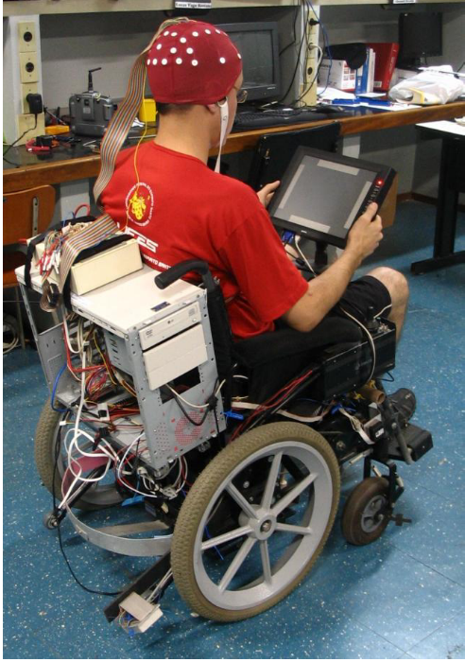

Figure 6.1. SSVEP based Brain to Computer Interface[1]

In previous works regarding a Brain to Computer Interface, a full desktop PC or laptop has been utilised to read in the signals, perform the signal processing, and classify the signals[1] as seen in Figure 6.1. In the example of a BCI controlled Autonomous wheelchair, the Desktop needs to be secured to the wheelchair, which can be cumbersome and difficult to manoeuvre, especially if this wheelchair is to be utilised in a home environment. Apart from the PC’s weight and occupation space, a PC also consumes large amounts of energy because of the system’s large components, for example CPU, GPU, RAM, and hard-disk.

A Field Programmable Gate Array (FPGA) would be a more practical choice for real world applications because of its lower occupation space, weight, and power consumption. In addition to this, FPGAs tend to be utilised for computational acceleration [2] because of their ability to execute parallel operations[3], which would ensure it could perform the necessary real time processing required for a BCI.

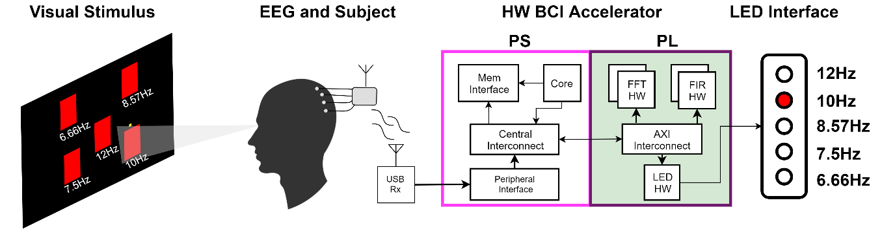

Figure 6.2. Proposed BCI Solution with Hardware Accelerator.

The PYNQ Z2 System on Chip used for implementing the Brain to Computer interface in this project is a smaller compact board for introducing developers to the realm of digital design. This development environment allows developers to easily create digital systems and drivers to interact with these systems. The Zynq 7000 series chip embedded in this board has a dedicated Processing System along with a Programmable Logic fabric. The Programmable Logic fabric of the board allows Hardware designers to create IP blocks for performing specific operations, be it mathematical or memory handling. Python scripts can be quickly developed to then interact with these IP blocks and allow software developers to access the components created by the hardware developers. The proposed Brain to Computer Interface detailed in this project utilises neural activity encompassed within the occipital cortex (visual cortex of the brain)[4]. The neural activity of this region is responsible for processing any visual stimulus the brain receives. With electrodes placed on the occipital cortex of the brain as seen in Figure 6.2, the subject will then be presented with a screen of flashing stimuli. Each stimulus will flash at different frequencies, and the user must focus one stimulus at a time. Focusing on these stimuli will cause resonant activity in the occipital cortex, known an a Steady State Visually Evoked Potential (SSVEP)[4]. Detecting and decoding these Steady State Visually Evoked Potentials can allow subjects to then control an external device by focusing on different stimuli. In this context when a subject focuses on the stimulus flashing at 10 Hz the 2nd LED on the LED interface should light up.  
The process of detecting and decoding these Evoked Potentials is handled by the Hardware Brain to Computer Interface Accelerator which executes the necessary processing steps to extract these events from the noisy EEG signals.   
The Hardware Accelerator will be implemented on the aforementioned PYNQ Z2 System on Chip. The Programmable Logic will be the core of this project as it is where the Hardware Accelerators will be implemented on the PYNQ Z2 SOC.

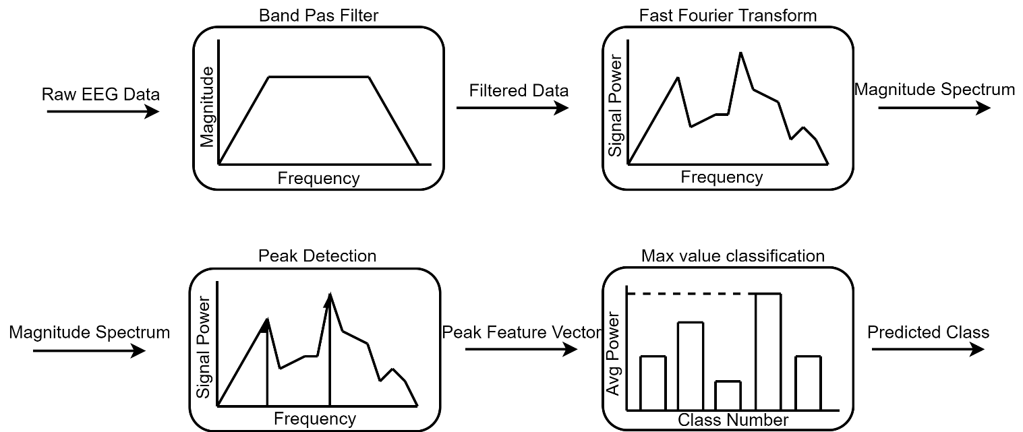

Figure 6.3. Processing steps for detecting the SSVEP

The primary steps required to detect these events within the brain are first Filtering for removing any noise in the brain that could otherwise affect the detection and decoding of these events. Post Filtering, the signals will need to be passed through a Fast Fourier Transform in order to transform the signals to the Frequency domain for spectral analysis of the data (more on this later in the report). Both of these operations can be computationally expensive, which is why the Programmable Logic is utilised to accelerate the operations required to execute these steps, because of its inherent ability to execute parallel operations[5].The background literature review following this introduction will investigate further how Brain to Computer Interfaces work, what FPGAs are, and how the PYNQ Framework is a great tool for introducing developers to the world of System on Chip and Digital System Design.

The implementation chapters of the report will outline how the system works starting at a high level introduction to the Hardware Accelerated Brain to Computer Interface, and incrementally working down to the lower levels. Demonstrations of how each component operates in isolation and how they interact with surrounding components will help the reader to understand how the overall system works. Finally, all tests will be outlined in order to demonstrate the systems operability.

After system implementation, the algorithms executed on this system will be outlined for the reader to understand how exactly a raw EEG signal can be processed and decoded to allow someone to control a device with their brain. Each processing step will be executed on software first to demonstrate the affects of filtering and converting to the frequency domain. Following a clear demonstration of how the algorithms extract key features from the signals, the software and hardware implementations will be compared to determine if the system detailed in this report is truly a faster implementation than past systems.

Finally, an evaluation of these benchmark tests, the system implementation, and the project as a whole will outline what was successful, what failed, what caused these failures, and what could be done to overcome these failures in the future.

# Background

This chapter outlines what Brain to Computer Interfaces are, how they work, and who are they typically designed for. The backbone of this project, the PYNQ framework, will be heavily investigated in this chapter, what it is, how it works, how it can be integrated into the Brain to Computer Interface, and the benefits of using this system over any other FPGA based system.

Two very separate areas of engineering, Brain to Computer Interfaces and Field Programmable Gate Arrays (FPGA) are investigated in this project. Current projects involving Brain to Computer Interfaces are heavily research based, with more of an emphasis on understanding how the brain reacts to stimulus[6] or how the brain controls motor activity[7]. The aim of this project is to focus primarily on the implementation of a Brain to Computer Interface using a Field Programmable Gate, basing my understanding of how these systems operate on previous works.

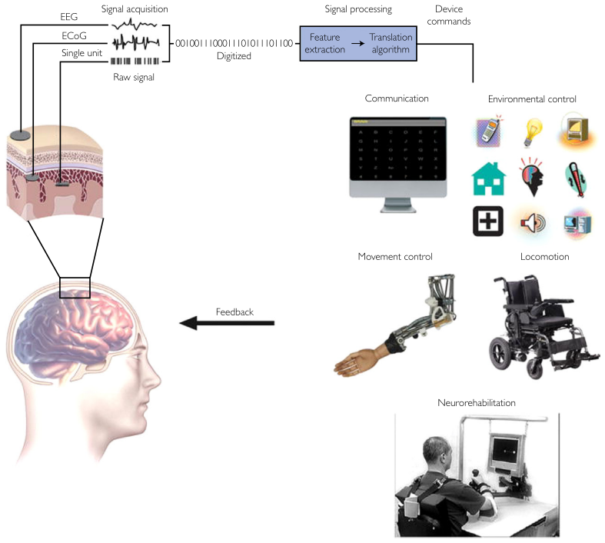

Figure 7.1 Brain to Computer Interface[8]

## Brain to Computer Interface

Brain to Computer Interfaces are control systems utilising the neurological activity recorded from EEG acquisition systems as seen in Figure 7.1. The recorded EEG signals are processed in order to detect specific events which can be utilised for controlling a device or application. The acquisition of these signals can be non-invasive with electrodes worn on the head, partially invasive where the electrodes are implanted on the surface of the brain, or invasive where the electrodes are embedded within the brain tissue. The more invasive the electrodes, the more accurate the signals, but the higher the risk of scar tissue and further health complications[8]. Typically, acquisition of EEG signals is non-invasively performed by wearing a cap with electrodes, which is much safer than the alternatives, but there are restrictions with regards to bandwidth and signal clarity. The bone, skin and hair can act as natural impedances against the recorded signal data[8].

All recorded signals will contain noise that needs to be removed from the signal using varying techniques such as temporal filtering, where any frequencies above 30Hz are removed[9]. Relevant neural information for use in Brain to Computer Interfaces are found in lower frequencies bands typically below 30Hz.

Post filtering, the signal is clearer for extracting signal characteristics which should help distinguish certain events in the brain from one another. Characteristics such as power within a specific frequency band, time triggered EEG amplitudes, or firing rates of particular cortical neurons[8] can be extracted and used to classify user intent. Correlating these signal characteristics with user intent can then help with determining if the occurrence of these events is caused by user actions, or if they are spontaneous.

These extracted features can be represented in a compact form (a vector) and they can be fed to classifiers which should decide which class this collection of features belong to. Once these features are classified, then an output can be generated which corresponds to the particular classification.

An example of a Brain to Computer Interface is a P300 speller where a subject is presented with a matrix of alphanumeric characters as seen in Figure 7.2. Each letter will be highlighted individually one after another. When the letter the subject wants is highlighted, they make a conscious decision to choose that letter. By consciously choosing/focusing on a letter, a P300 Event Related Potential (ERP) will be evoked in the brain. This event occurs as a positive peak roughly 300ms after a rare event/ stimulus (hence the name P300) [10], the rare event being the subject choosing to focus on a particular letter when it is highlighted.  
In order to detect these inflections in the EEG, all Muscle artefacts, Eye Artefacts, and temporal noise caused by surrounding neural activity is filtered out to ensure the P300 can be clearly detected.   
Feature extraction will then involve using signal characteristics such as a time triggered EEG amplitude 300ms after the stimulus is presented. By comparing the EEG signal frames 300ms after a stimulus is presented against other frames of the signal, and against the presence of other stimuli, a P300 event could be detected and the user’s intent to select a letter can be decoded.

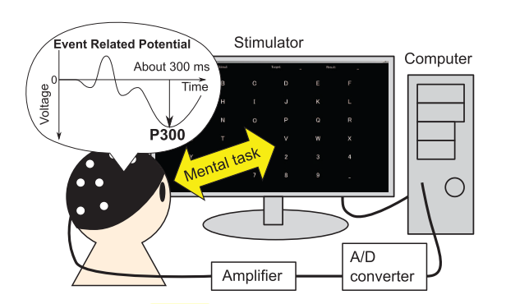

Figure 7.2. P300 based Brain to Computer Interface[10]

The P300 Brain to Computer Interface is just an example of how these systems work. There are numerous other paradigms used in previous works to demonstrate the power of these systems and outline how useful these systems can be in helping those who are unfortunate enough to suffer a serious neurological disease or have the misfortune of losing a limb. Brain to Computer Interfaces have the capacity to gift those people with a higher quality of life.

One such paradigm which has its benefits as being one of the simple systems to implement is a Brain to Computer Interface which monitors the Subject’s Occipital Cortex (Visual Cortex of the brain) for Steady State Visually Evoked Potentials.

### Steady State Visually Evoked Potentials (SSVEP)

Steady State Visually Evoked Potentials are oscillatory electrical responses detected in the occipital and parietal cortexes of the brain[4]. These potentials are elicited in response to a subject focusing on a stimulus flashing at a particular frequency. While focusing on these flashing stimuli, the electrical activity in the occipital and parietal cortexes will begin to resonate at these flashing frequencies and their harmonics[4].

In the context of Brain to Computer Interfaces, each flashing stimulus could be associated with a specific task, message, or instruction. These systems could allow someone with severe cerebral palsy to navigate around their home by focusing on a single flashing symbol in order to select which room they wish to travel to as seen in Figure 7.3.

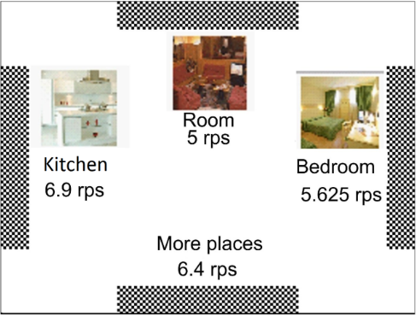

Figure 7.3 Panel of Stimuli where each flashing stripe is associated with a room [1].

Steady State Visually Evoked Potentials are credited with having the fastest Information Transfer Rates with roughly 101.66 bits/min[1] versus the P300’s Information Transfer rate of 50.61 bits/min[11]. Information Transfer Rate (ITR) is an evaluation method for measuring the performance of a Brain to Computer Interface[12]. As well as superior Information Transfer Rate, SSVEPs can be more easily detected because of their high Signal to Noise Ratio because of how the signal Power is more heavily concentrated within the frequency bands surrounding the stimulus frequencies[13]. Spectral Analysis of the recorded data should show a higher concentration of power in these frequency bands as seen in Figure 7.4. The steps required to measure the power within these bands is far less complicated than the necessary steps required to extract a P300[14].

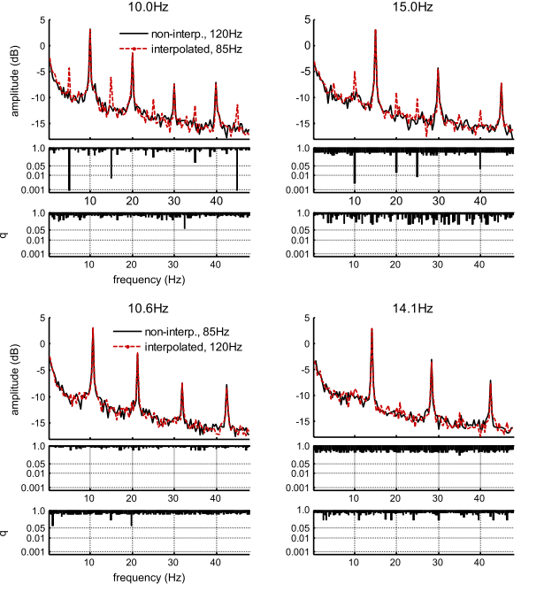

Figure 7.4. Power Spectrum of EEG recordings while subject focuses on different flashing stimuli.

For the purpose of implementing a Brain to Computer Interface on an FPGA, a simple paradigm would make designing the system less complex. The Steady State Visually Evoked Potentials Brain to Computer Interface only requires two computationally expensive steps for extracting features, Filtering the signal to remove the noise, and then converting the signals to the Frequency Domain for spectral analysis.

### Processing

For a Brian to Computer Interface to generate an output based on a subject’s action, the recorded signals must first be processed. This action of processing, should clean the signals, making the features easier to extract, then extract the primary signal characteristics utilised in distinguishing between user actions and temporal activity within the brain.

#### Filtering

EEG signals are extremely volatile meaning any changes in bodily position, or any fluctuations in facials muscles can cause an increase in noise and unwanted artefacts in the signal[15]. Most commonly there are strong EMG and EOG artefacts in the signals caused by muscle movement, and eye movement[16]. However, these EMG artefacts occupy high frequencies, whereas the neuronal information required for this Brain to Computer Interface is typically below 30Hz[16]. However, in these lower frequencies there can be evidence of EOG artefacts, especially those caused by eye blinks. By applying a bandpass filter to the signals, the higher frequency components occupied by the EMG artefacts and a portion of the low frequency artefacts will be removed.

Filtering the signal can also work to enhance the frequency components that are occupied by the Steady State Visually Evoked Potentials. By applying a band pass filter to the signal, the magnitude spectrum of the signal can be reshaped in order to amplify the frequency bands of interest and attenuate the irrelevant frequency bands[16]. Reshaping the magnitude spectrum of the signal as seen in Figure 7.5 then makes it far easier to detect the SSVEP post transformation to the frequency domain[16] because the distribution of power of the signal is now concentrated around the stimulus frequencies and their first harmonics.

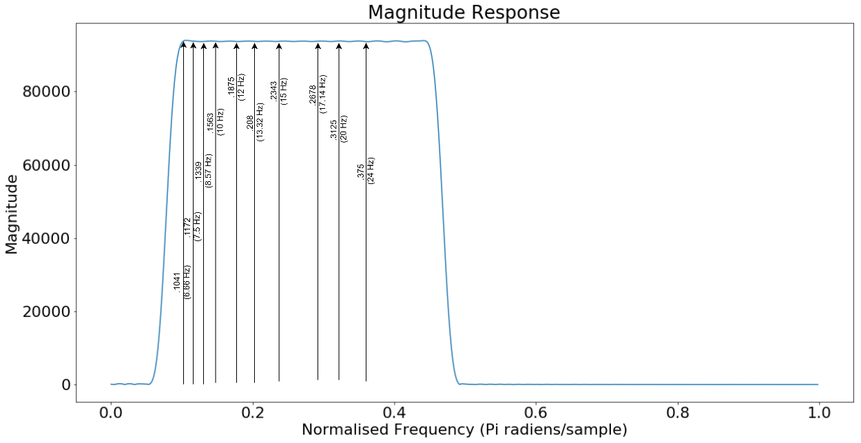

Figure 7.5 Magnitude Response of Filter with stimulus frequencies and harmonics marked.

A Finite Impulse Response filter was chosen over an Infinite Impulse Response because it only uses inputs to the filter[17] as opposed to the Infinite Impulse Response which uses previous outputs as well as inputs. As well as greater stability, Finite Impulse Response filters can have linear phase, meaning the filter is symmetric about the centre coefficient[17], meaning only half of the coefficients are used for filtering the signal. These coefficients are used as weights for the samples at each stage of the filter. By halving the number of coefficients required to filter the data, there are less computations required, which should further accelerate the process of detecting the SSVEP when implemented in Hardware.

$eeg_{filtered}[n]= \sum_{k=1}^{K}{a\left[k\right]eeg[n-k]}$ (7.1)

Eq. (7.1) describes the FIR filter, where eeg is the input signal at the nth sample, and a[k] are filter coefficients.

#### Feature Extraction

After the signals have been filtered, any key parameters and characteristics of the signal are extracted in order to determine if there are any signals which correlate with user intent. These parameters and characteristics are the features of the signal which help with signal classification. There are two categories of features which can be extracted from a signal [16]:

1) Non-transformed features which can be the amplitude, energy, or power of the time series data.

2) Transformed features which can be the power within a specific frequency band or the amplitude spectra.

For the case of Steady State Visually Evoked Potentials, there should be increased concentration of power caused by the electrical activity synchronising with the stimulus frequency[16]. Spectral analysis, which is a process of estimating how power is distributed over frequency for a finite length of signal[16], is performed on the filtered signal. By visualising the distribution of the signal power over frequency as seen in Figure 7.6, the frequency bands with the highest concentration of power should correspond with the fundamental and 1st harmonic of the Stimulus frequency the Subject was focusing on.

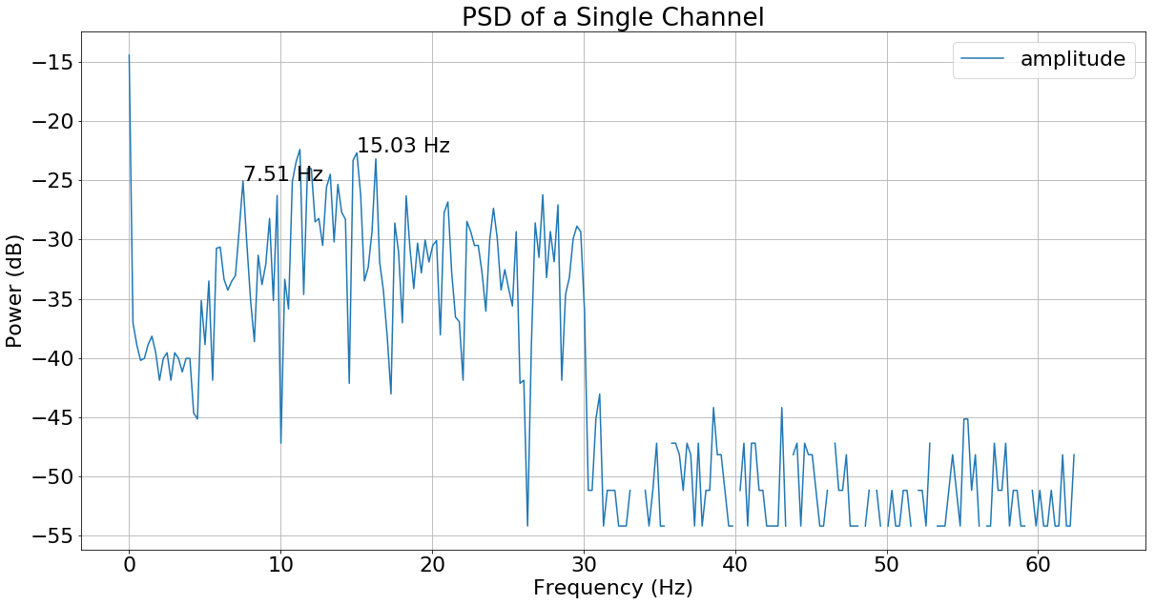

Figure 7.6 The Power Spectral Density of the signal over 512 samples

The Power Spectral Density of the EEG signals was estimated by use of a periodogram. The backbone of the periodogram is the Discrete Fourier Transform (DFT) which works to express a sequence of real numbers as a sequence of complex numbers, where each complex number represents the amplitude and phase of the signal[18]. The Discrete Fourier Transform is described as:

$$DFT\left(k\right) = \sum_{n=0}^{N-1}{x\left(n\right)e^{-jn(\frac{2π}{N}k)}}= \sum_{n=0}^{N-1}{x\left(n\right)}W_{N}^{kn}(7.2)$$

$$DFT\left(k\right)=\left[\begin{matrix}W_{2}^{0} & W_{2}^{0} \\ W_{2}^{0} & W_{2}^{1}\end{matrix}\right]\left[\begin{matrix}x(0) \\ x(1)\end{matrix}\right] (7.3)$$

Where k is the Fourier Transform sample position ($k=0,1,2,⋯,N-1)$, x[n] is the nth sample, and $e^{-jn(\frac{2π}{N}k)}$ are the weights that each sample is multiplied by for each value of k. To determine where in the spectrum the frequency component, f, occurs we have:

$$f=\frac{k\left(sampling Freq/2 \right)}{N} (7.4)$$

The output of the DFT(k) function will be of complex nature, allowing it to represent both amplitude and phase as mentioned before. Taking this property into consideration, the magnitude of each complex output is also the amplitude of that frequency component in the signal.

Averaging the squared magnitude of the output offers an estimation of the power concentrated within each frequency bin (periodogram). This estimation can be described as[16]:

$$PSD\left(k\right)=\frac{1}{N}{\left|DFT\left(k\right)\right|}^{2} (7.5)$$

Where N is the number of samples in the frame and DFT is the Discrete Fourier Transform.

Computationally the DFT itself can be expensive due to the number of multiplications required to multiply an input vector by a matrix of coefficients[19] as seen in Eq. (7.3).  
O(N2) computational complexity is required to multiply a vector N by a matrix N x N, which is impractical for large numbers of samples N[20]. This need for a more efficient implementation brought the Fast Fourier Transform to light.

The Fast Fourier Transform is an implementation of the Discrete Fourier Transform which takes advantage of the fact that there are re-occurring coefficients being calculated. These re-occurring calculations are caused by the coefficient periodicity Eq. (7.6) and symmetry Eq. (7.7)[19]:

$$W_{N}^{kn}= W_{N}^{k(n+N)}= W_{N}^{(k+N)n} (7.6)$$

$$W_{N}^{kn+\frac{N}{2}}= {-W}_{N}^{kn} (7.7)$$

Where $W_{N}^{kn}= e^{-jn(\frac{2π}{N}k)}$ from Eq. (7.2). In the previous example Eq. (7.3), the coefficient $W_{2}^{0}$ is calculated 3 times.

Coupled with the periodicity and symmetric properties of the DFT, the number of Multiplications can be further reduced by decomposing the full DFT calculation into two smaller DFT calculations, one with the even input data, and another with the odd input data[20]. By ensuring the number of samples N = 2d ,for any integer d, the DFT can be decomposed recursively until there is a sequence of 2-point DFTs.

The following derivation represents the decomposition of a single DFT Eq. (7.2) into two smaller DFT operations:

$$FFT\left(k\right)= \sum_{n=0}^{\frac{N}{2}-1}{x\left(2n\right)}W_{N}^{k2n}+\sum_{n=0}^{\frac{N}{2}-1}{x\left(2n+1\right)}W_{N}^{k\left(2n+1\right)} (7.8)$$

$$2n=even n, 2n+1=odd n$$

$$W_{N}^{k2n}= e^{-j(\frac{2π}{N}2kn)}=e^{-j(\frac{2π}{N/2}nk)}=W_{N/2}^{kn} (7.9)$$

$$W_{N}^{k(2n+1)}= e^{-j(\frac{2π}{N}k)(2n+1)}={e^{-j(\frac{2π}{N}k)}e}^{-j(\frac{2π}{N/2}nk)}=W_{N/2}^{n}W_{N/2}^{kn} (7.10)$$

$$FFT\left(k\right)= \sum_{n=0}^{\frac{N}{2}-1}{x\left(2n\right)}W_{N/2}^{kn}+W_{N/2}^{n}\sum_{n=0}^{\frac{N}{2}-1}{x\left(2n+1\right)}W_{N/2}^{kn} (7.11)$$

$$FFT\left(k\right)= G\left(n\right)+W_{\frac{N}{2}}^{n}H\left(n\right) \left(7.8\right)$$

Where G(n) is the N/2-point DFT with even input, and H(n) is the N/2-point DFT with odd input. Both of which only need to process half of the inputs each reducing the computations. By further decomposing the each of these two DFTs, the vector-matrix multiplication complexity is further reduced.

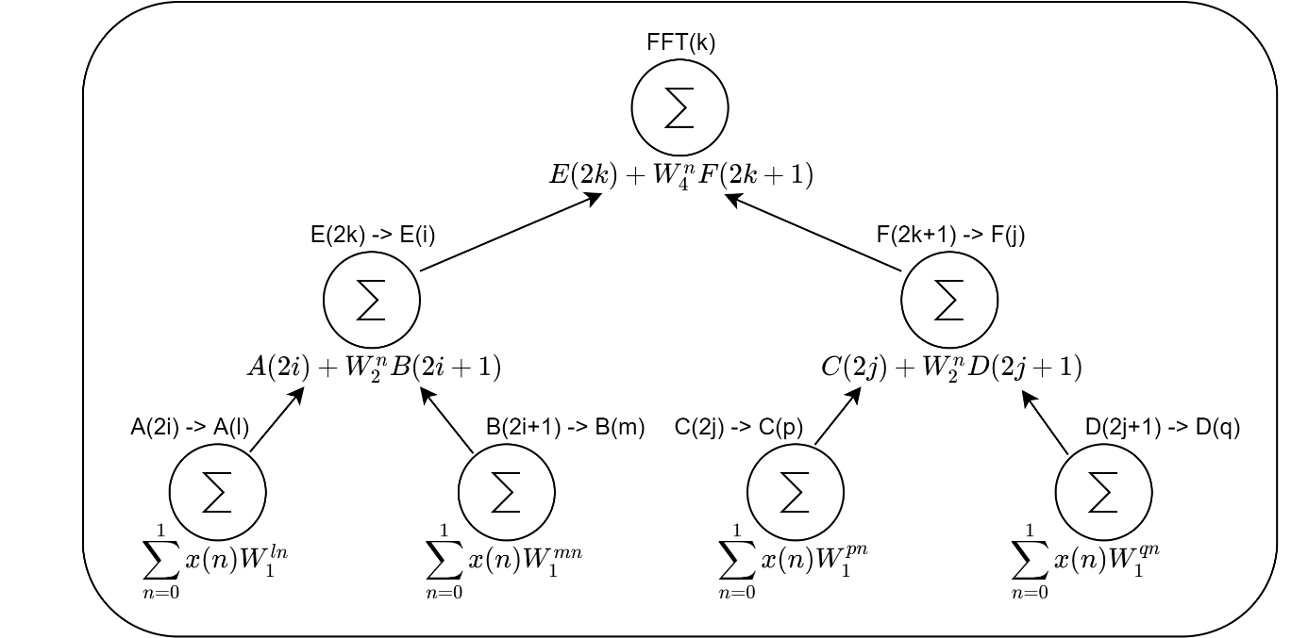

Figure 7.7 8-point DFT decomposed into smaller DFT operations to form FFT, where ∑ denotes DFT

The DFT requires N2 multiplications because it multiplies an input vector x[n] with a matrix of coefficients as seen in Eq. (7.3)[20]. The Fast Fourier Transform requires log­2N decompositions[20] for example, 8-point DFT decomposed to two 4-point DFTs, then new DFTs decomposed to two 2-point DFTs, leaving four 2-point DFTs to be calculated. After the DFT has been broken down to the three separate stages as seen in Figure 7.7, each stage then requires 8 operations, where the bottom layer has four 2-point DFT operations. The two outputs of each 2-point DFT is then merged on the next stage to form two 4-point DFTs, then finally the four outputs of each 4-point DFT are merged to form the final 8-point DFT. The result of this decomposition offers a computational complexity of O(Nlog2N) which is far more practical for much larger values of N.

#### Classification

Once the band powers surrounding the stimulus frequencies and their first harmonics have been extracted from the signal, they must be classified in order to determine if the subject is focused on a stimulus. Typically, Linear Discriminant Analysis (LDA) or Support Vector Machine (SVM) which use statistical analysis and machine learning methods are used for classifying signals based on their features[9]. However, for the scope of this project a simple thresholding scheme which compares one feature against others will be used.

Thresholding schemes generate an output when the max feature value exceeds a specific threshold. The class associated with this feature will be the predicted class for this test. In the context of SSVEP, the energy at the stimulus frequencies will be compared to each other and the frequency with the max energy that also exceeds a certain threshold will be the predicted class output.

## Field Programmable Gate Array

Currently, conventional BCI systems utilise full desktop PCs or laptops for running Python or MATLAB scripts to perform the necessary steps required for decoding brain signals into user actions.[21],[1].  
As previously stated, utilising a desktop computer or laptop for a Brain to Computer Interface can be difficult to implement in the real world. Desktops can be heavy meaning they can make a BCI controlled wheelchair more cumbersome. Secondly, they take a lot of space as seen in Figure 6.1.

An alternative to using a PC would be a Field Programmable Gate Array, a silicon device comprised of numerous logic blocks with configurable connections between them[2] as seen in Figure 7.8.

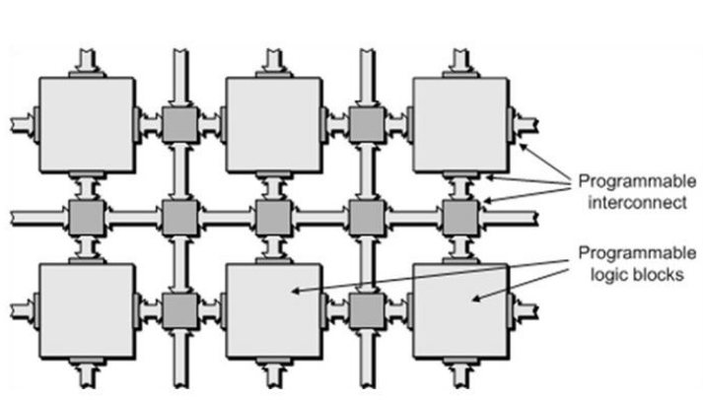

Figure 7.8 FPGA architecture showing the network of logic blocks and their connections[2].

Each logic blocks can be individually configured to perform one of a range of logical operations, for example AND, OR, XOR, etc. Such simple logical operations can be combined using the configurable connections between them, leading to more complex systems such as a counter, memory block, or even a CPU as seen in Figure 7.9.

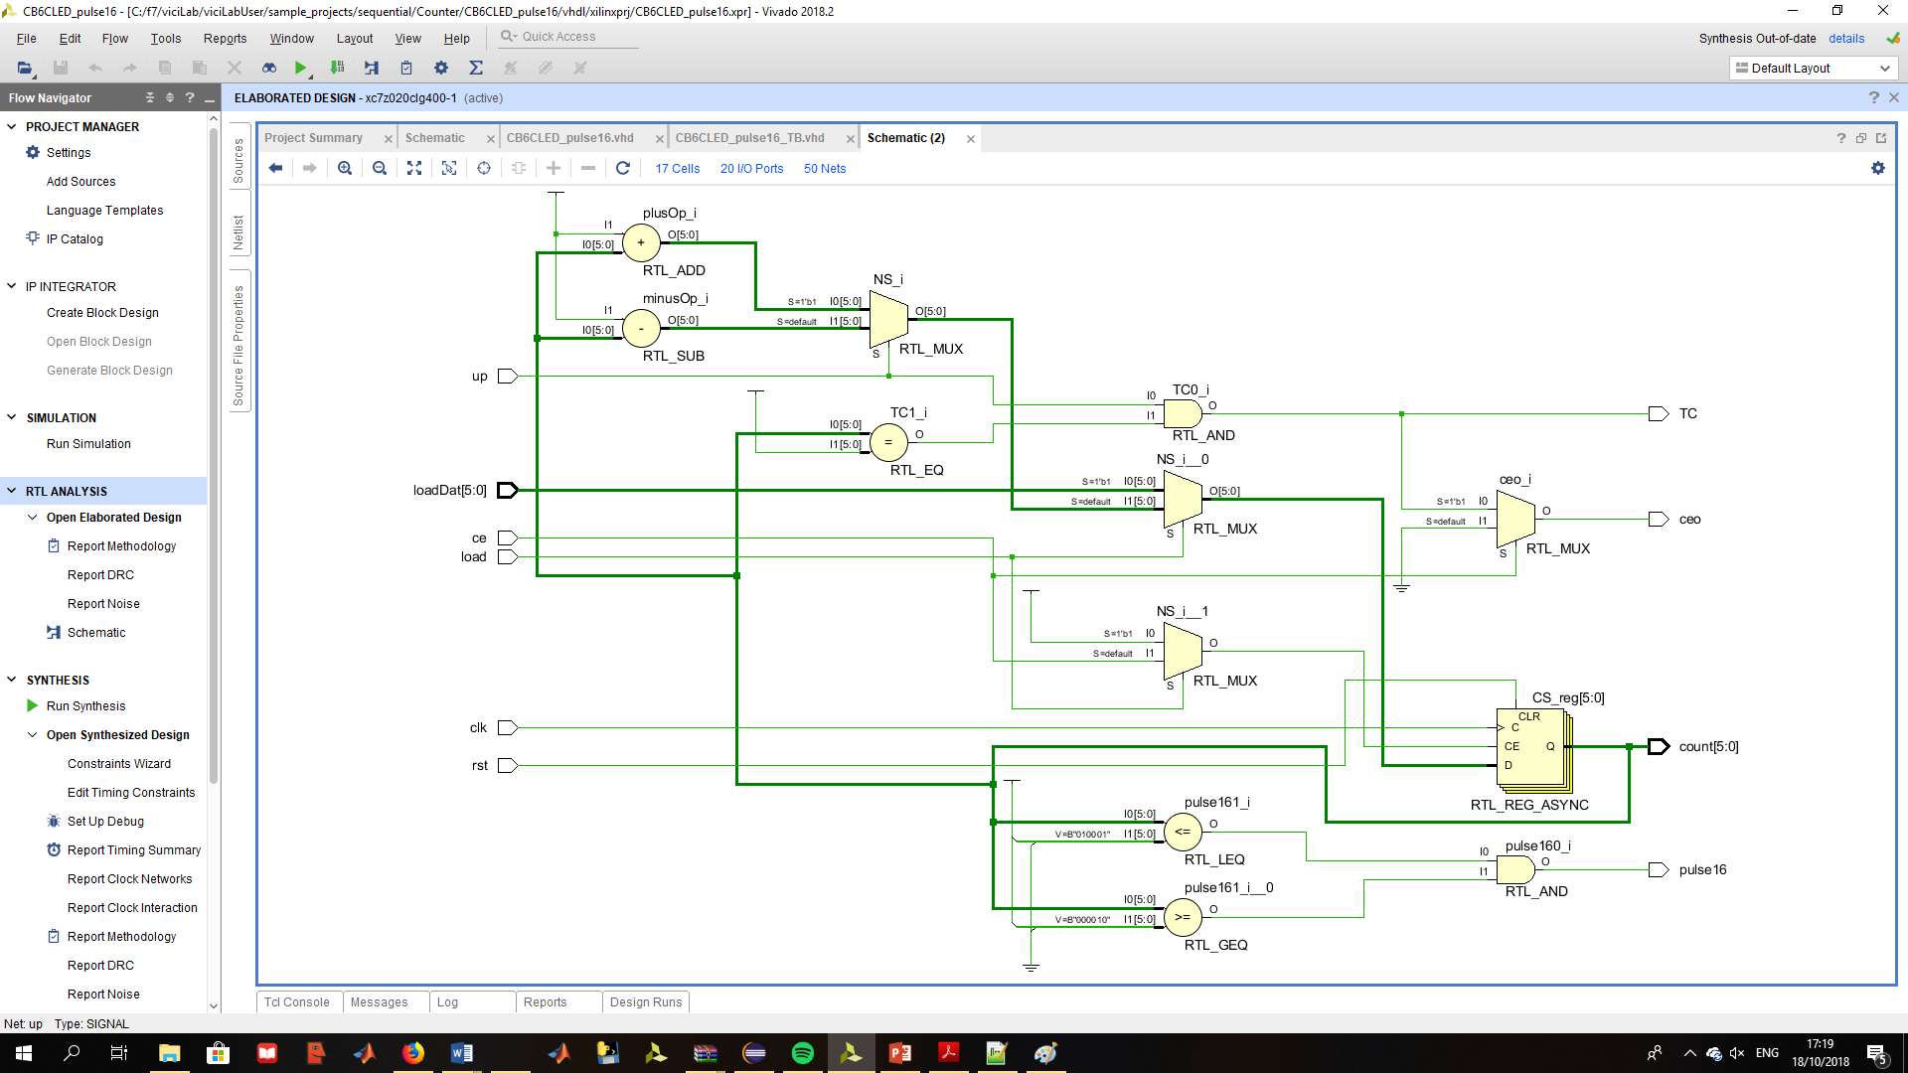

Figure 7.9 An FPGA implemented Counter, where each component is a combination of different Logic blocks.

Due to this reconfigurability of the logic blocks, FPGAs can be very flexible when designing complex systems allowing quick prototypes to be developed and tested. Coupled with their inherent flexibility, and configurable connections between the logic blocks, more than one task can be executed at once, allowing FPGAs to benefit from parallel processing. Figure 7.10 demonstrates the benefit of parallel processing, where a sequential processor requires 2000 clock cycles for a throughput of 1000 kilo samples per second (KSPS) whereas a parallel processor such as the FPGA can get 600 mega samples per second (MSPS) with a lower clocking frequency and a single clock cycle.

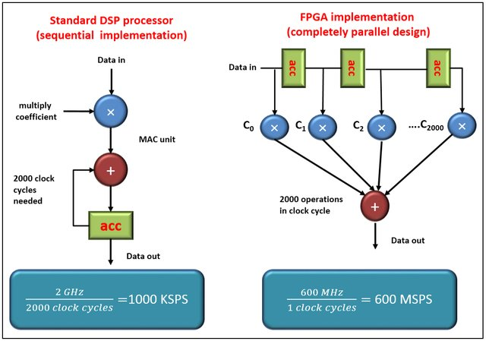

Figure 7.10 CPU based Signal Processor vs FPGA based Signal Processor[22]

Sequential processors are slower because they require nearly three clock cycles per instruction (fetch the instruction, decode the instruction, then execute the instruction). Coupled with this slower execution rate, sequential processors can also only execute one task at a time, whereas an FPGA can execute numerous tasks per clock cycle.   
  
When creating processing systems which are small enough to be easily embedded into an environment, the Raspberry Pi is a popular choice because of its physical size, processing power, and creative and helpful community of developers. Raspberry Pis have been used in Image Processing, Object detection, and Machine Learning applications, again making it more than capable of being embedded within a Brain to Computer Interface. However, the processor within a Raspberry Pi is a sequential processor which again is slower than an FPGA.

|  |  |  |  |  |  |  |  |  |  |  |
| --- | --- | --- | --- | --- | --- | --- | --- | --- | --- | --- |
| **FFT Benchmark 262,155 Points** | | | | | | | | | | |
| **Benchmark** | CPU | | | | | | | | GPU | FPGA |
|  | 2 Threads | 4 Threads | 8 Threads | | 12 Threads | | 24 Threads | | Max Threads | Virtex-5 |
| **FFT** | 76.17 ms | 45.41 ms | 31.63 ms | 27.85 ms | | 31.36 ms | | 8.13 us (Execution)  69 ms  (Loading) | | 2.59 ms |
| **Table7.1. Results from Benchmark acquired from Christopher Cullinan’s work**[2] | | | | | | | | | | |
|  | | | | | | | | | | |

Another alternative processor for performing computationally expensive operations is a Graphics Processing Unit (GPU) which was introduced to handle shading and dynamic 3D models in video games[23]. Such intense operations would require a device that can handle parallel operations with ease, which would make the GPU a clear contender against the FPGA for performing filtering operations and generating Fourier Transforms. However, in a paper which performs a benchmark between the FPGA, GPU, and CPU[2], the FPGA was the clear winner because of the loading times required for the GPU to load the data into the processing cores from the external memory. The GPU far surpassed the FPGA for execution time as seen in Table 7.1, but the bottle neck caused by loading in the data significantly curbed its performance.

Given this information, an FPGA should be more than capable of executing the necessary steps required for extracting and decoding Steady State Visually Evoked Potentials in a Brain to Computer Interface. In previous works where FPGAs have been used to implement a Brain to Computer Interface[14], [24], [25], each specific device has a certain number of resources which constrain how much operations it can perform. Table 7.2 outlines the number of resources each previously used FPGA has available, making it easier to justify using the PYNQ-Z2 for this project.

As a comparison between all three aforementioned devices, an FFT benchmark was utilised to test the processing speed each device[2].

|  |  |  |  |  |
| --- | --- | --- | --- | --- |
| Device | LUTs | DSP slices | Flip-Flops | RAM |
| Spartan-6 (LX9)[14] | 5,720 (6 input) | 16 (18x18 multiplier, adder, accumulator) | 11,440 | 1.6Mb |
| Virtex-5 (LX50)[5] | 28,800 (6 input) | 48 (18x25 MACs) | 28,000 | 1.7Mb |
| Altera Cyclone II[25] | 18,752 (4 input) | 150 (18x18 multipliers) | 18,752 | 1.1Mb |
| Zynq 7000[24] | 53,200 (6 input) | 220 (18x25 MACs) | 106,400 | 3.3Mb |
| **Table 7.2. Resource count between previously utilised FPGA devices.** | | | | |
| The PYNQ-Z2, a development board for software developers looking to take advantage of the acceleration digital hardware has to offer, is built around the ZYNQ 7000 System on Chip. With little prior knowledge of how digital systems operate or how to design them, the PYNQ-Z2 is good starting point. | | | | |

### ZYNQ System on Chip

ZYNQ is a new generation of all programmable System on Chips developed by Xilinx to be more flexible than the average FPGA. This System on Chip supports a dual core Arm Cortex A9 processor coupled with a traditional FPGA fabric as seen in Figure 7.11. In the past there have been instances where cores have been coupled with a programmable logic, but the ZYNQ 7000 has a core capable of running a dedicated Linux Operating System and the Programmable Logic is based on the 7-series FPGAs developed by Xilinx[26]. To make the interface between both of these systems as seamless as possible, an industry standard AXI interface is utilised which allows for high bandwidth, low latency, and robust data transfers between the Processing System and Programmable Logic.

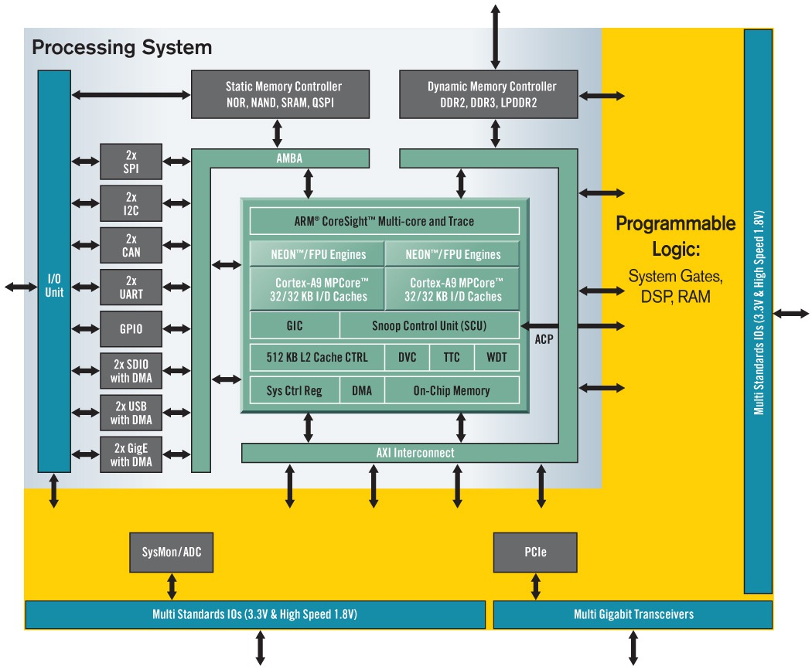

Figure 7.11. High Level ZYNQ system on chip architecture[27].

System on Chips (SoC) are not a new concept spearheaded, by the ZYNQ 7000, they have been utilised in the past in embedded systems, mobile and computer processor design. Instead of designing systems where there is a dedicated chip for logic, a dedicated chip for arithmetic, a dedicated chip for memory, and a chip for handling peripheral interfaces, SoC designs try to implement full functionality within a single chip as seen above in Figure 7.11. This helps to reduce cost because, a) there are less resources spent manufacturing dedicated chips, b) data transfers are more secure because all transfers are handled within chips instead of on PCB tracks, and c) lower power consumption since there are less chips to be powered.

SoC architecture is comprised of a processing core, a memory block, and peripherals communicating with each other and the core using an interconnect[26]. In the ZYNQ environment, both the Processing Core and the Memory Blocks are located within the Processing System, and all of the Peripherals are located within the Programmable Logic as seen in Figure 7.12. The main interface for communication is the interconnect which brings the Processing Core and the Peripherals together. Each peripheral is a functional component outside of the Processing System (PS) which can work to either be a co-processor, a collection of additional memory elements, or a core to interact with external interfaces such as buttons, switches, LEDs, etc. Hosting these Peripherals in the Programmable Logic (PL) allows for greater flexibility because of the logic fabrics reconfigurability.

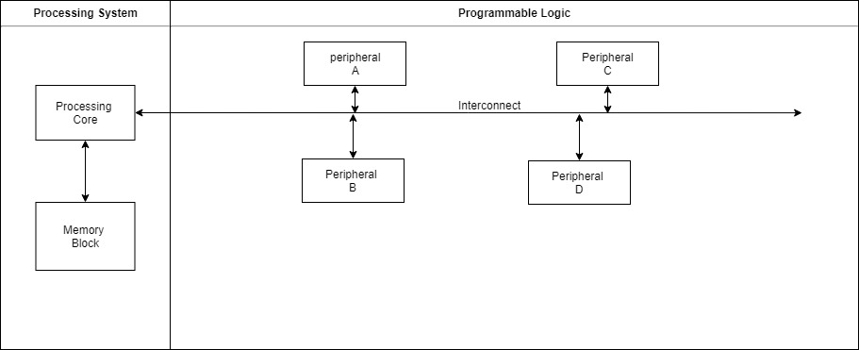

Figure 7.12. High level SoC Layout of ZYNQ

The advantages of using the System on Chip approach to designing projects over ASIC design are the added flexibility, quick time to market, ease of prototyping and upgradability. ASIC designs, on the other hand, are more suited for high-volume product applications such as Phone and PC chip designs where there is no need to perform hardware updates. Over time, ASIC products such as Phone and PC chips need to be updated to newer models due to their limited lifespan, and once they are designed for a specific role, due to their low flexibility they can’t easily be repurposed for a different task. SoC are more ideal for a low-medium volume market where there is a definite requirement for the devices to be easily upgradable over time to save production costs[26].

When designing ZYNQ projects there are lots of potential for design reuse, due to the PL’s reconfigurability and the PS’s code base. When designing a new system, for example a video processor, there is no need to design and create brand new IP resources. IP Blocks are the components designed within the programmable logic serving a specific purpose, be it transacting handling or data processing. There is a community of Hardware designers which already have pre-tested IP blocks for various tasks available, as well as Xilinx’s own repository of IP resources. By using a variety of different IP blocks to create a system, the end product becomes more modular as seen in Figure 7.13, and the design doesn’t need to be restricted to a single task. By adding an extra memory block for the output, a recursive filter can be created, and by making more than one instance of this system, more than one signal channel can be filtered, harnessing the parallelism offered by the PL.

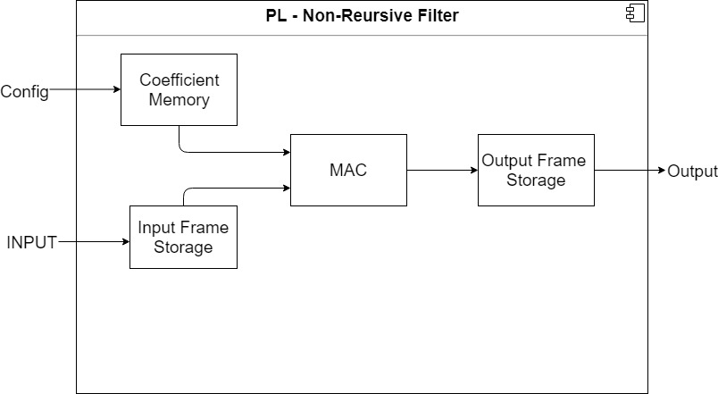

Figure 7.13. Logic based Non-Recursive Filter

By not “re-creating the wheel” and using pre-designed IP blocks, there is an added level of abstraction where designers can develop systems which require less explicit design input[26], helping to avoid time lost understanding how the lower level systems operate, further accelerating the development process.



Figure 7.14 Lower Level ZYNQ SoC Processing System Architecture [26]

Looking at the ZYNQ SoC PS in Figure 7.14, it is clear that the chip itself is a complex collection of cores, memory caches, memory cores, interconnects, external peripheral interfaces, and clock generation circuitry.

The primary component in this system is the Application Processing Unit (APU) which hosts the two cores that run the OS and all software applications. This core is where all system configurations like clock frequencies, memory allocations, and instruction sets are created using the dedicated Software Development Kit (SDK) which provides all the necessary components for developing software to be deployed on the ARM processing cores. Fortunately, the PYNQ framework (discussed next) handles this, further abstracting the lower level functionality.

The external interfaces provided by ZYNQ for interfacing the PL with PS and PL with external components help to make communication easier and remove the need to create dedicated drivers. Primarily the Multiplexed Input/Output (MIO) is utilised for interfacing the PS with external peripherals such as USB and Ethernet. The Extended MIO (EMIO) is utilised as a path from the external component directly to the PL, in order to avoid latencies caused by waiting for the PS to pass the data to the PL.

The Programmable Logic in the ZYNQ ecosystem is composed primarily of Combinational Logic Blocks, Slices, and IO Blocks as seen in Figure 7.15. Combinational Logic Blocks (CLB) are composed of two Logic Slices, with an interconnect interfacing all elements. Logic Slices hold the resources for implementing the combinational and sequential logic circuits implemented in the PL. Each Slice comprises 4 to 6 input lookup tables (LUT) and 8 flip-flops.

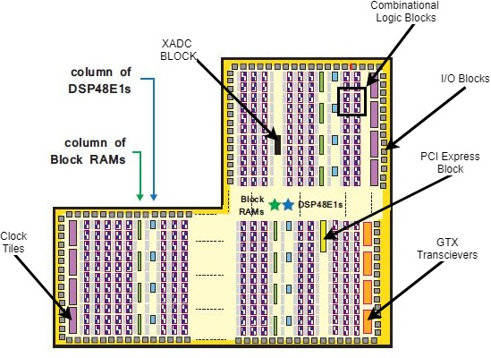

Figure 7.15 Programmable Logic Slice [26].

Coupled with the general logic fabric there are the special Block RAM (BRAM) and DSP48 blocks which are utilised for more specialised tasks than the logic slices.

The BRAM resources are utilised for applications with more dense memory requirements and have the ability to be implemented as Random Access Memory(RAM) blocks, Read Only Memory(ROM) blocks, or First in First out(FIFO) buffers[26]. Utilising BRAM allows for large amounts of data to be stored locally on the device, allowing for faster data transactions between components as opposed to using the external memory. Larger capacity BRAMs can be created by combining two or more BRAM resources.

The DSP48 resources are utilised for high-speed arithmetic on medium-long word lengths. The standard layout of the DSP48 supports pre-adders/subtractors, multipliers, post-adders/subtractors or logic, and a pattern detector depending on the configurations used. Each slice as seen in Figure 7.16 has a set word length which can be reshaped for smaller word lengths, or similar to the BRAM, more than two DSP48 resources can be combined to handle Complex arithmetic and DSP filters[28].

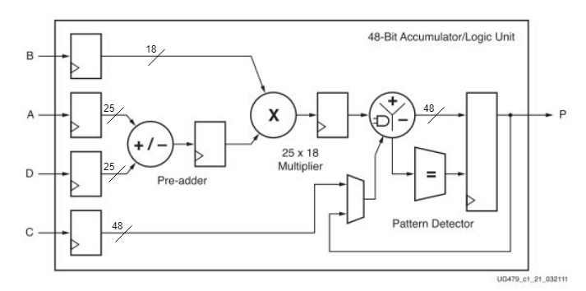

Figure 7.16 DSP48E1 Resource Slice[28]

When developing systems with SoC resources, it is best to identify the computationally complex operations with the potential for parallel computing and have these operations implemented within the Programmable Logic.

### PYNQ Framework

PYNQ is an open source framework developed by Xilinx which combines the productivity of Python with the acceleration provided by the Programmable Logic fabric in the ZYNQ System on Chip. By coupling the Processing System (PS) with the Programmable Logic (PL), allows the creation of more efficient, deterministic, and responsive systems[29]. To abstract the lower level hardware and intra-chip communications, Python has been utilised because of its ease of use. Python has numerous libraries which can make prototyping hardware-based applications far easier.

All Python applications utilising PYNQ are developed in a Web-based editor called Jupytr Notebooks which uses an IPython kernel built on a Ubuntu based image running on the ZYNQ Processing System[29]. In order to access this web-based editor, a remote connection is made to the device either over ethernet or wireless as long as the device is connected via ethernet to the router. By navigating to the IP address or hostname of the device in a web browser, a Jupytr Notebooks Python Integrated Development Environment (IDE) is opened as seen in Figure 7.17.

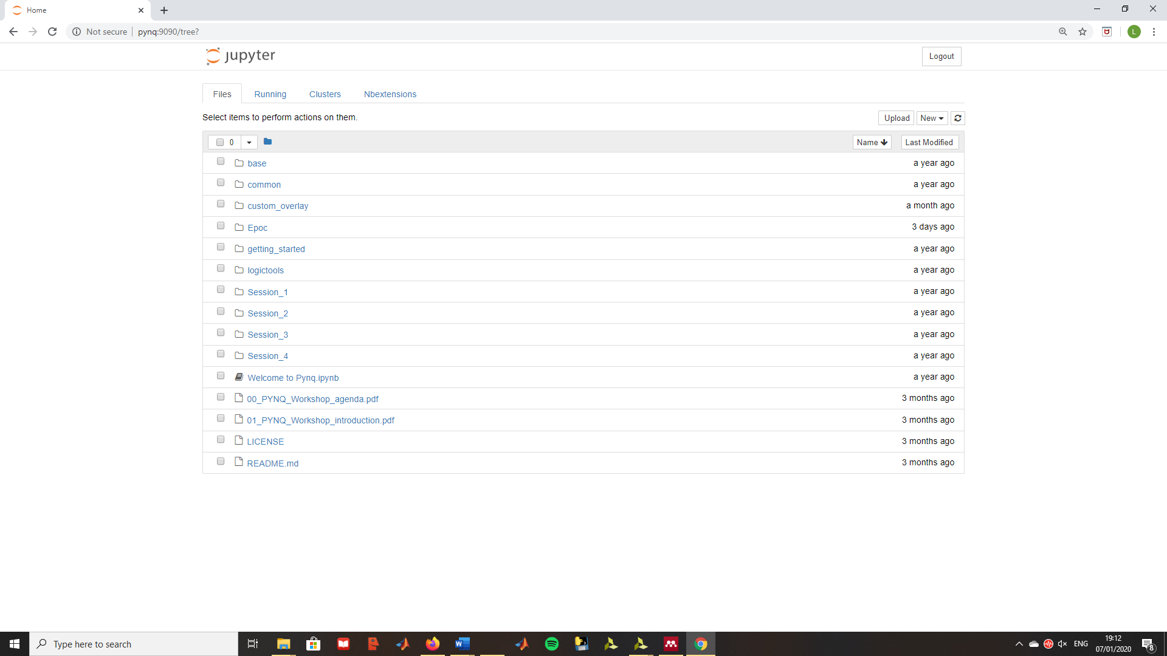

Figure 7.17. Jupytr Notebooks webserver hosted on the PYNQ board.

When transferring files to and from the Device, PYNQ comes with a samba server which provides file transfers and access to printers for Windows Clients. This service makes it easy to create hardware files and send them to the board without needing to open an SSH connection. However, if necessary a remote connection can be very useful for gaining access to the underlying Linux OS as seen in figure 7.18.

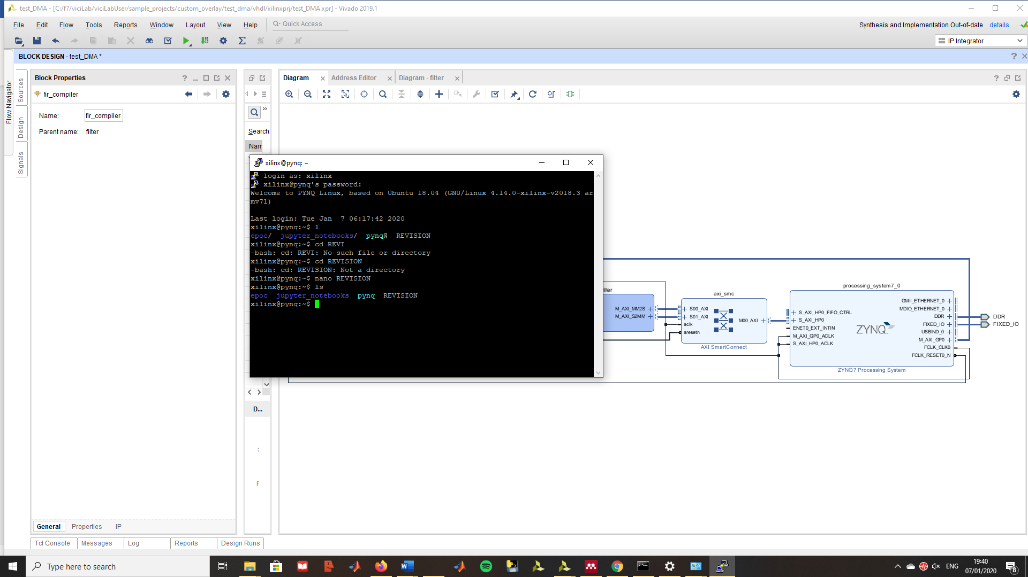

Figure 7.18. Remote connection terminal to PYNQ OS.

When creating Python applications as mentioned before, a browser-based editor is used for development. For accessing the underlying hardware within the programmable logic, an Overlay is created, which is a Python Object that reads in the bit and TCL files generated in Vivado. Vivado is the primary tool utilised in developing Hardware Overlays as seen in Figure 7.19. These Objects are utilised to abstract the hardware from the higher-level code, allowing software designers to access the Hardware components like Python methods within an Object[30]. ZYNQ based projects require both a binary/bit file from Vivado, and PS configuration settings for system clock and clocks within the PL. PYNQ projects don’t require the PS to be configured because the PYNQ image which is used to boot the board configures the PS at runtime[30].

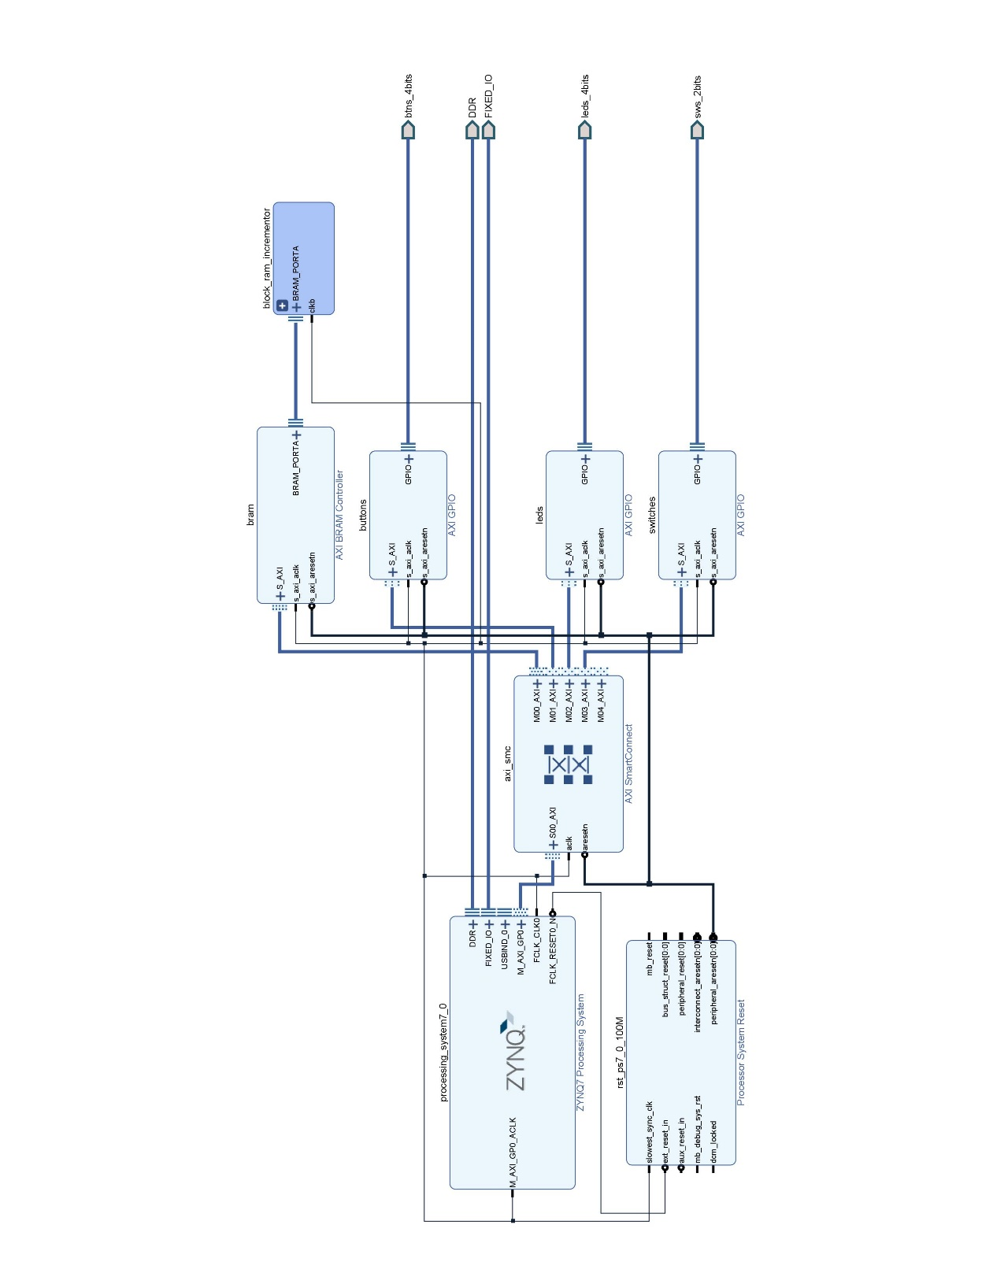

Figure 7.19. Example Hardware Overlay demonstrating Hardware structure

For communicating between the PS and PL, there are a range of interfaces supplied by the PYNQ framework. The most basic interface to utilise is the GPIO which allows communication with the PL without adding the IP to the system memory. This is unlike the memory mapped IO interface, which requires each IP component to be assigned a range of addresses. Similar to GPIO, Interrupts are another method of interface which requires no memory mapping, but it is not bi-directional. The PS can only receive interrupts from devices within the PL to work as events alerting the PS that a process has finished, or an error has occurred. Finally, there is a streaming interface which makes use of a Direct Memory Access (DMA) component for handling the data transfer between the PS DRAM and the IP as seen in figure 7.20. For large amounts of data, the DMA streaming interface is the preferred method of communication because the transmission of data is offloaded to the DMA, allowing the PS to continue with other tasks, and therefore will not slow down the system.

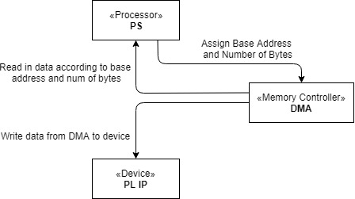

Figure 7.20. Example of DMA Interface

### AXI Interface

The Advanced eXtensible Interface(AXI) is a microcontroller bus protocol based on the AMBA protocol[26] developed by ARM in 1996. The newest variation, AXI4, is utilised in the PYNQ framework for interfacing between IP blocks within the Programmable Logic fabric, as well as handling the interface between the Processing System and the Programmable Logic.

AXI4 has 3 different variations[31];

* AXI4   
  Ideal for high performance bursts of memory mapped transactions.
* AXI4-Lite  
  Ideal for single burst memory mapped transactions.
* AXI4-Stream  
  Ideal for high-speed data streaming without an address channel. Allows for unlimited bursts of data to be transferred from master to slave only, not vice versa.

These three variations are implemented upon a set of key features[26]:

* Addressing and control phases are performed on separate channels to the data phase.
* Bursts of bytes allow unaligned data transfers.
* Define base address and perform burst transactions to following addressed locations.
* Read and Write channels are kept separate allowing for bi-directional duplexing.

AXI provides enhanced flexibility to projects utilising its protocols because there isn’t just a general protocol, there is a different variation for different applications, as stated above. The AXI4-Lite interface, for example, can be utilised to send single bursts of data to control registers within a DMA, whereas the AXI4 interface can be utilise for writing bursts of data to memory mapped locations within a BRAM. Both of these interfaces require an address channel, however the AXI4-Lite interface only reads from or writes to a single memory mapped location, whereas the AXI4 interface will provide the base address for the first word and the slave must calculate the addresses for the words that follow[26].

By standardizing all IP blocks in a development environment to utilise the AXI4 interface, developers need only understand a single protocol for developing their systems.

AXI offers greater availability to developers because not only do they have access to IP resources developed by Xilinx, they can also share IP resources to a wide community of ARM developers.

AXI4 is described as an interface between Master and Slave IP Blocks which are connected together using a single interconnect. Interconnects are responsible for:

* handling data width conversions when the input for a slave is smaller than the bus transferring the data from the PS to the Interconnect.
* clock rate conversion for scenarios when the Slave operates at a slower rate than the PS.
* handling addressing between Slaves and Masters as seen in Figure 7.21.
* FIFO buffering up t0 512 bytes utilising Block RAM.
* handling protocol conversion between AXI4 and AXI4-Lite.

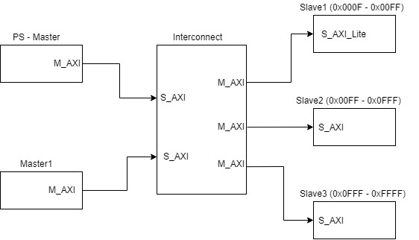

Figure 7.21. AXI Interconnect Multi-Master/Multi-Slave

AXI interfaces are used within the Processing System and Application Processing Unit for communications between the various memory controllers, cores and MIO interfaces. Most importantly for developers they are also used for interfacing the PS to the PL[26]. The interconnects shown in Figure 7.22 are each assigned to a different type of PS-PL interface port and are connected to a central interconnect within the PS which handles the memory mapping transfers.

The ports for the PL-PS interface are;

* AXI_GP  
  General purpose 32 bit data ports for handling low transfer rates between the PL and PS. There are 2 Master ports and 2 Slave ports
* AXI_HP  
  High performance Port ideal for high transfer rates between the PL and memory elements in the PS, as well as the DDR memory interface. Utilises FIFO buffers for handling bursts.
* AXI_ACP  
  A single asynchronous connection between the PL and PS allowing the PL access to the APU caches.

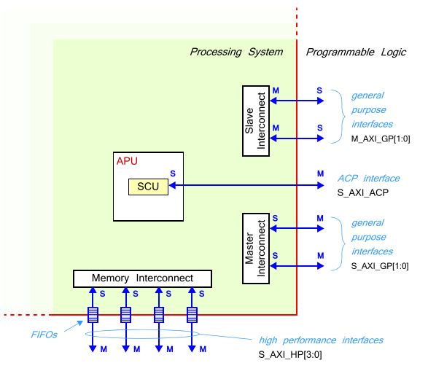

Figure 7.22. Processing System AXI Interface Ports[26].

The AXI4 and AXI4-Lite interfaces consists of 5 channels, three of which belong to the Writing operations and the remaining two belong to the Reading operations, allowing for full duplexed, bi-directional data transfers[31].

Writing Data;

* Address Channel  
  Sent at the beginning of the transaction, specifying base address for communications, the number of data transfers in the transaction, and the number of bytes in each transfer.
* Data Channel  
  Begins after address transaction terminates. Sends data to the Slave device, and will flag WLAST when the final transfer has begun.
* Response Channel  
  Informs the master of transaction status.

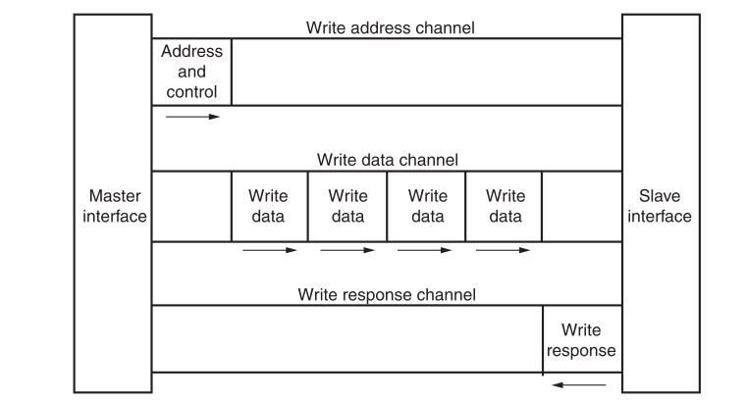

Figure 7.23. AXI Writing Transaction between Master and Slave[31].

Reading Data;

* Address Channel  
  Same as writing data.
* Data Channel  
  Same as writing data.

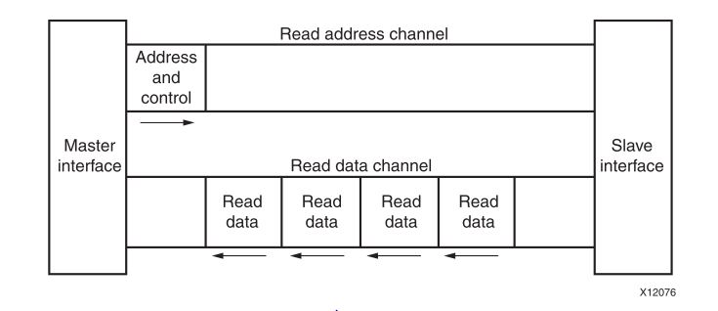

Figure 7.24. AXI Reading Transaction between Master and Slave

All channel transactions require a handshake sequence in order to proceed. The handshake allows both the Master and the Slave to control the initiation of the transaction utilising the VALID/READY signals. The Master generates the VALID signal alerting the Slave that it is ready to begin transferring data. The Slave generates the READY signal alerting the Master that it is ready to begin transferring data. The transaction will only begin when both signals are asserted. Figure 7.25 shows a Master presenting data and asserting VALID, and it must remain unchanged until the Slave finally asserts READY, allowing the data transfer to begin[32].

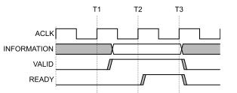

Figure 7.25 AXI VALID/READY handshake.

## Societal Impacts

Brain to computer Interfaces have the potential to have a wide societal impact. Such systems can be used to improve the quality of life for not only those who are suffering from diseases such as ALS or paralysis, but also family members. If a patient is fixed to their bed, have difficulty performing simple tasks such as changing the channel on the television, or can no longer communicate with ease, these systems can be utilised to assist with such issues. For example, an SSVEP based Brain to Computer Interface can be utilised to control a remote control by focusing on a single flashing stimulus. By enabling a patient to have control over something as simple as this gives them less of a feeling of inadequacy.

Family members, and nurses can also benefit from the use of these systems. There may not need to be a nurse present with the patient at all times for moving them around, they won’t need to text for them, or control their televisions. Instead the patient can have more control of their own lives and the nurses need only be about for medication, potentially feeding, and getting into and out of bed. As for family members, they can now maintain communication with their loved ones and feel as if they are present in a more sociable capacity as opposed to a caring capacity.

There could be some potential risks involved with using a Brain to Computer Interface with a patient. Seeing as machine learning can be somewhat unpredictable, there can be issues with the output of the system which is used to control a wheelchair for example. If the system for example misclassifies the recorded signal as being a stop command instead of a forward command, the wheelchair could be left stranded in the middle of the road where an accident can occur, affecting more than just the wheelchair occupant. When developing such systems, there should then also be other control systems to help avoid such errors, i.e. a camera to classify oncoming traffic.

BCIs can also prove beneficial for more than just helping patients with severe disability or illness. These systems can also be utilised to as wearable for fully able-bodied users, for example a sensor for seizure detection in epileptic or autistic patients [7,8], or potentially it could be used in hazardous environments as an extension of ones limbs.

By implementing the entire system onto an FPGA such as the PYNQ-Z2 board, there is the potential to consume less energy than if the system was implemented on a laptop or PC. Imagine if every single patient who required one of these systems had a laptop or desktop PC running constantly for processing the data. The energy consumed by these devices could prove to have negative effects on the environment in the long-term. However an FPGA is capable of performing the necessary processing steps required for a BCI with greater energy efficiency[34], which should lead to lower energy consumption. The affects wouldn’t be great enough to have any major impact, but any attempt to reduce consumption helps.

# Architecture

This chapter will provide an outline of the System on Chip architecture for the Hardware Accelerated Brain to Computer Interface detailed in this project. Starting with a high-level description of the system, each section will incrementally step deeper into the design, introducing new components and, how these components interact with each other and how they fit into the overall design.

The system outlined in Figure 8.1, is a high-level representation of the final architecture implemented on the ZYNQ-7000 chip. Figure 8.1 presents the internal components of the ZYNQ Processing System which were utilised, the IP blocks and processing cores implemented within the Programmable Logic, and finally, the external memory and component interfaces. Each of the components within the Processing System and Programmable Logic have their own personal addresses, which help with memory mapping transactions between components using the AXI interface.

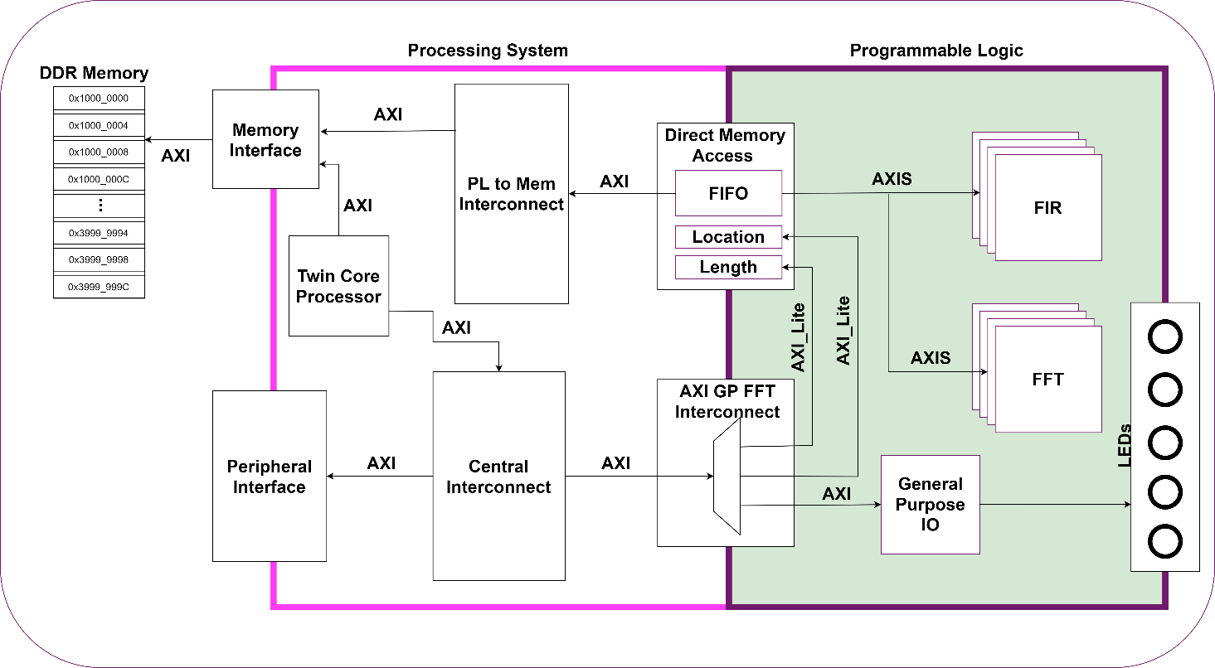

Figure 8.1 High Level System Architecture for Hardware Accelerated Brain to Computer Interface.

The Processing System contains the twin core processor which is responsible for handling the Linux Operating System, the main entry point for all developers. All software applications and device drivers are executed on this processor, and any hardware designs to be implemented as an overlay within the Programmable Logic need to be instantiated here.

This processing core allows developers to interact with the surrounding components by using AXI transactions which will route data to specified location. Like most operating systems, the Linux OS running on the processor will handle communications with external peripherals such as USB and ethernet, allowing developers to use simple python libraries to interact with them. In order to read from USB for example, a developer needs only to open a stream between their application and the serial port they wish to communicate with, and the low-level source code abstracted by library will handle the transactions required.

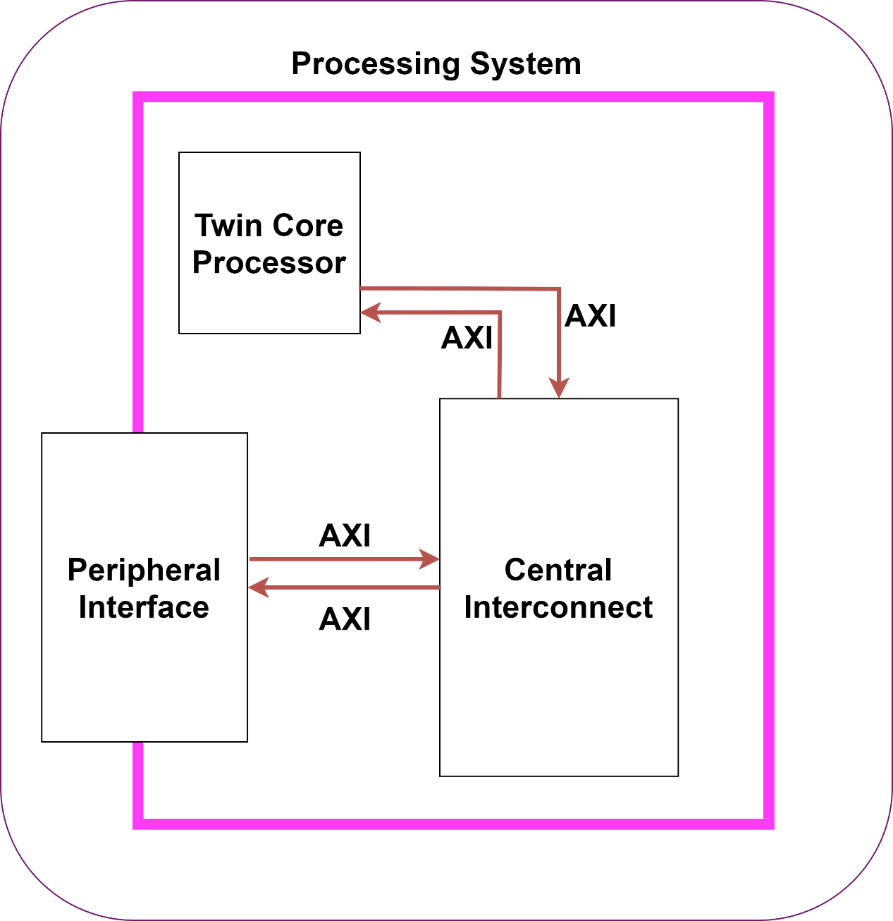

Figure 8.2 Processing Core interacting with the Peripheral Interface.

However, unlike most processors with a Linux OS, this processing core has a dedicated connection to a Programmable Logic which allows developers to harness the capabilities of hardware acceleration for their projects. Such a unique factor requires a different approach to interface with it. In the previous example shown in Figure 8.2 of the core interacting with the Peripheral Interface in order to communicate with USB devices, the source code abstracted by the library handles the transactions between both entities.

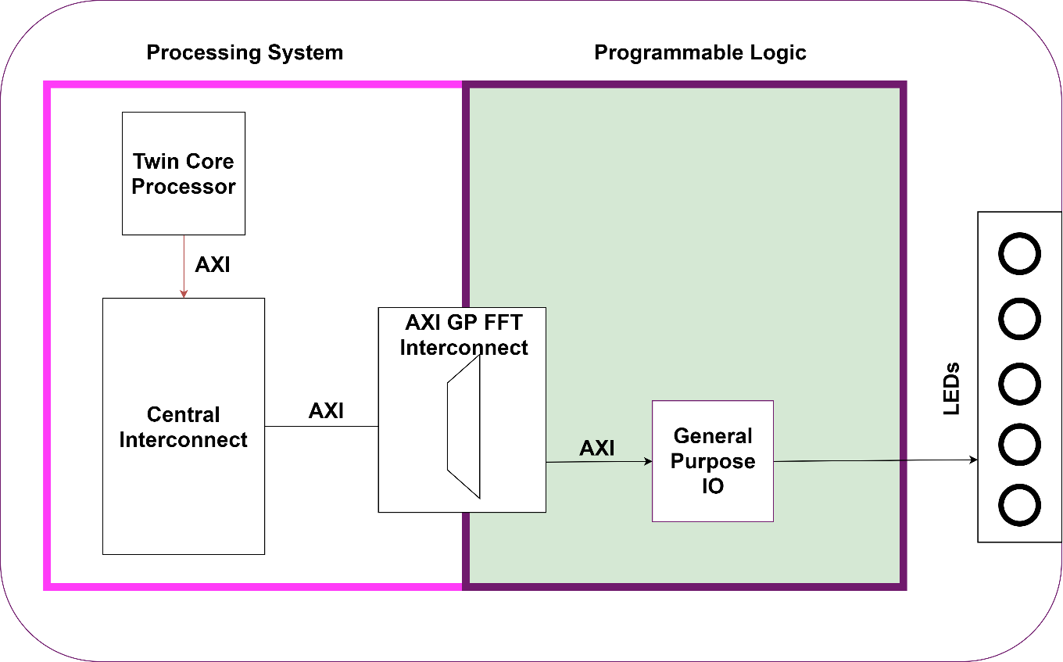

Figure 8.3 General Purpose Interface.

When interacting with the Programmable Logic, developers instead need to handle the transactions explicitly by specifying the address of the component they wish to interact with and the data they wish to send to it. In this case the central interconnect as seen in Figure 8.3 will route the transaction to the Programmable Logic, where the AXI Interconnect will then route the transaction to the IP block at the specified address. In the context of the Hardware Accelerated Brain to Computer Interface, these General-Purpose memory mapped transactions handle switching the LEDs, and configuring the Direct Memory Access components (more on these later).

When using the Programmable Logic to accelerate filtering and Fourier Transform operations, the General-Purpose Interface won’t be capable of handling the high data rates. Instead the High-Performance Interface is utilised, which makes use of a Direct Memory Access for handling the transactions between the Processing System and the Programmable Logic. For streaming data to the Programmable Logic, the core offloads handling data transfers to a Direct Memory Access (DMA) which can read a specified amount of data from a specified location within the external DDR memory.  
  
The starting point for any AXI Stream transaction as seen in Figure 8.4 begins with the developer allocating buffers within the DDR for the DMA to read from and write to, and then directs the DMA to point its read channel to the base address of one and its write channel to the base address of another. The DMA will then read from the Buffer when instructed and stream the data from the DMA channel to the processing core. Once the processing core has completed its operation, it will write the data back to the DMA and which will then write the output of the core over its write channel to the second buffer its pointing to.

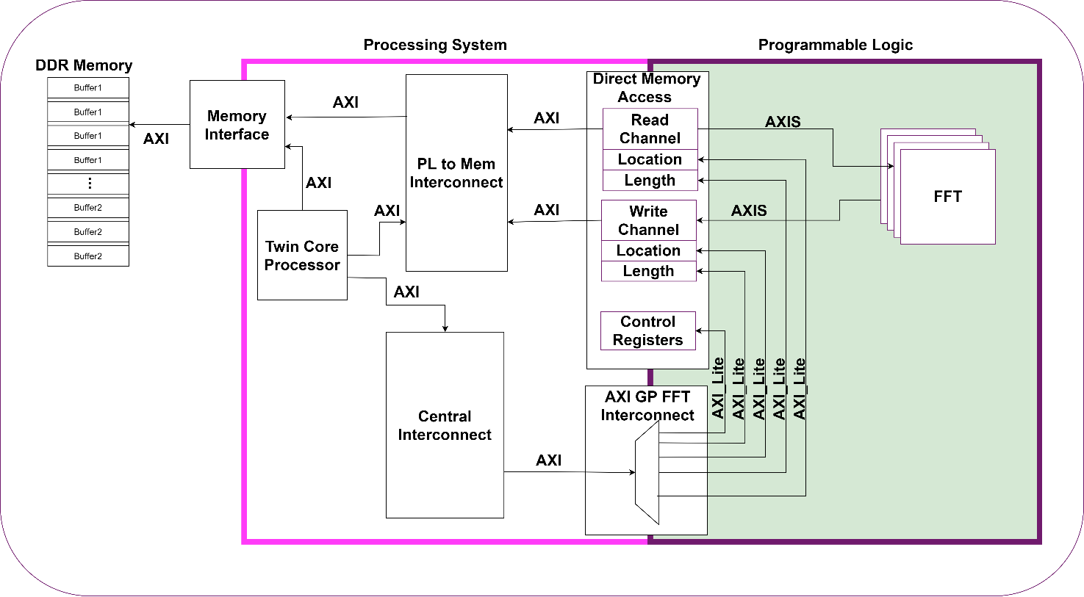

Figure 8.4. High Performance AXI transaction in the context of the Brain to Computer

Interface, the Core would ideally open a stream to the USB port that the EEG receiver is connected to. When new signals are received by the Core, it will then push them to the allocated buffers within the DDR, and once a full sample is ready to be processed, the DMA will be triggered to push the buffers to the Processing Cores within the Programmable Logic. However, without access to an EEG acquisition device, pre-recorded SSVEP experiments were utilised[35]. These datasets were instead stored on the SD card, and the experiment data was read frame by frame from the SD card using the same peripheral interface as the USB receiver.

## Hardware Implementation

The development of the Hardware Accelerated Brain to Computer Interface was an incremental process which required each component to be implemented in isolation in order to understand how it operates. Starting with simple designs that have no relevance to the project, these were helpful in understanding the Vivado design suite, how to use these tools implement the different AXI interfaces.

### Top Level Design

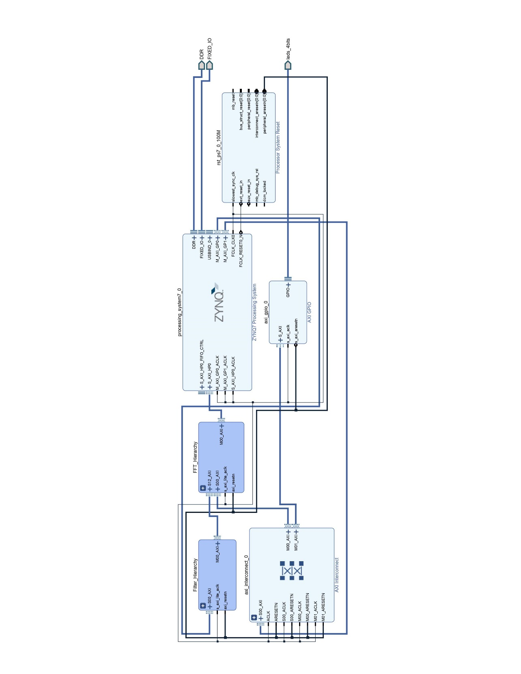

Figure 8.5 Top Level Brain to Computer Interface System on Chip.

Beginning with the top level of the System on Chip in Figure 8.5, there are the two Hardware Accelerator Hierarchies, the ZYNQ processing system, General Purpose I/O for handling the LEDs, and an AXI Interconnect which routes the transactions to different destination addresses.

The ZYNQ processing system IP block is a component representing the Processing System within the ZYNQ chip. All PS-PL interfaces, peripheral interfaces, clocking rates, interrupts, and memory controllers are configured within this IP block using the GUI in Figure 8.6. All configuration settings for this block will be visible within the generated bit file required for programming the hardware, allowing the developers to alter these configuration settings depending on how they want their programs to interact with the hardware overlay.

For this project, the ZYNQ IP block is configured to utilise a single High-Performance Port to facilitate the streaming of data from the External Memory to the Hardware Accelerators and two General Purpose ports used for handling memory mapped transactions between the ZYNQ processing system, and GPIO LEDs block, and the Hardware Accelerator hierarchies. For the clocking rates, the ZYNQ block is configured to use 100Mhz as its Programmable Logic clock, to ensure that any samples that arrive are processed at the highest rate possible, within the constraints of the chip.

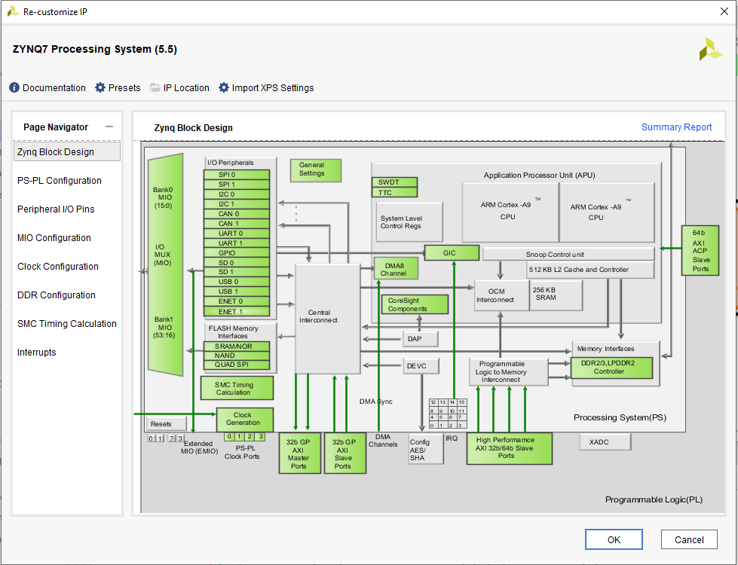

Figure 8.6 Configuration Menu for the ZYNQ Processing System IP Block

The next component within the Top Level is the AXI Interconnect which is utilised for routing AXI transactions between the ZYNQ Processing System and other IP Blocks within the system. Think of these components as being similar to routers within the IP (Internet Protocol) network that the internet is structured around. Each of these Interconnects can be placed throughout a system, and their job is to route the incoming transactions from the Master components to the specified Slaves.

The Interconnect as seen in Figure 8.7 is capable of receiving transactions of any size and clock rate to be routed between components. Instead of having different bus lengths to match the transaction widths, having a standard width of 32 or 64bits allows any transactions size smaller than these standard lengths to be routed.

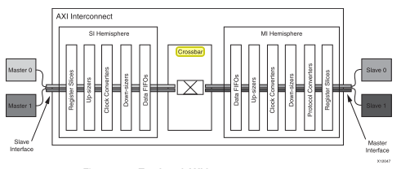

Figure 8.7. AXI Interconnect[31]

All transactions that are received are intercepted by the Crossbar module at the centre of the Interconnect, which is responsible for the routing of the data, address, and response channels.

The addresses for each component must first be specified within the Vivado editor as seen in Figure 8.8. By consulting this table of addresses, the crossbar knows that any transactions with addresses between 0x4120_0000 and 0x4120_0FFF belong to the GPIO component, where the extra address numbers may correspond to different registers within the component.

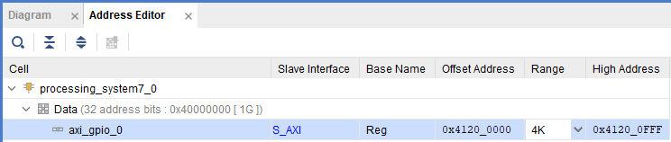

Figure 8.8. Address Space occupied by IP blocks from GPIO example.

A simple example of an AXI Interconnect in operation in Figure 8.9 shows how a General-Purpose IO (GPIO) block is interfaced with the ZYNQ Processing System.

The Interconnect will receive any transactions from the ZYNQ PS with an address channel and a data channel. The address channel will tell the interconnect’s crossbar component where it would like to be routed to. The data channel will contain the data the PS wants to send to the GPIO block. When the crossbar has routed the data, the transaction will pass through the MI hemisphere where the data width will be converted to match the width of the GPIO block.

The GPIO requires a bus length of 8bits, and the Processing System has a standard bus length of 32 bits. The AXI interconnect will read the 32 bits from the transaction received from the PS, and it will only forward on the least significant 8 bits (the first 8 bits it receives) to the GPIO.

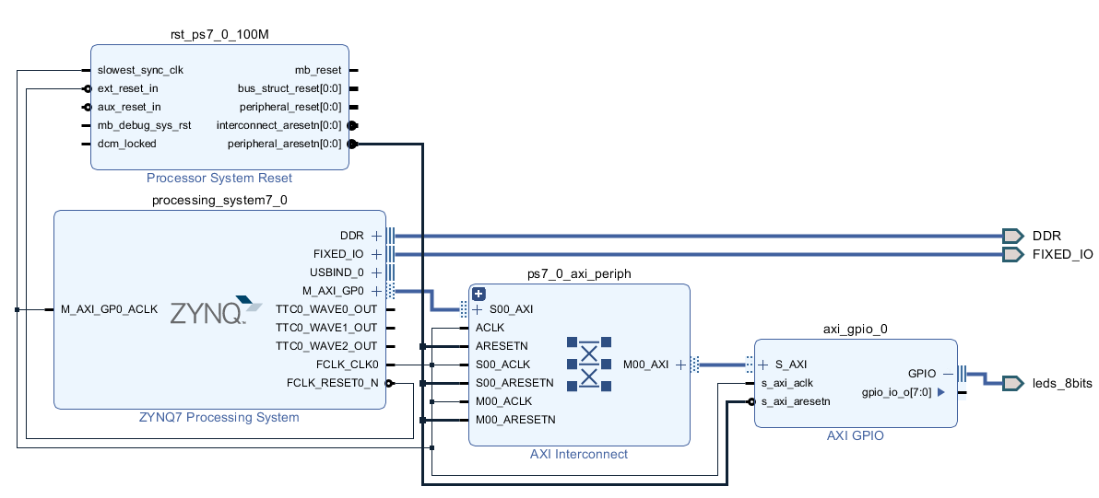

Figure 8.9. Simple example of a General Purpose IO interfaced with the ZYNQ PS using the AXI Interface.

The GPIO component in this example is also used within the Top Level of the architecture for controlling the LEDs. GPIO blocks are a simple network of registers and tri-state buffers as seen in Figure 8.10. The different registers serve different purposes for controlling the flow of data within these components:

* GPIO_DAT  
  A register which controls the input to the Tri-state Buffers. As these register values change/new values loaded into the registers, the LED (for this example) will change with them.
* GPIO_DATA_IN  
  A register which stores the current output of the tristate buffer. If this block was configured to for input, then the values this IO port reads will be stored to this register.
* GPIO_TRI  
  A register which controls the state of the Tristate buffers and therefore the state of the GPIO block. This buffer decides which pins are input pins or output pins.

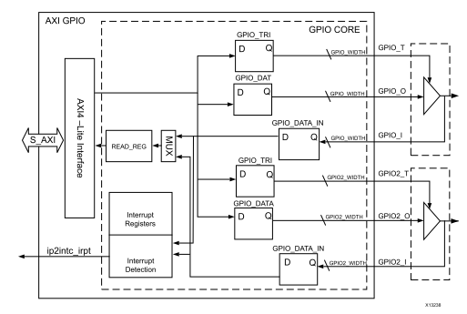

Figure 8.10 General-Purpose IO IP Block internals[36]

For this project the GPIO is configured as an output component, and requires only 4 bits (1 bit per LED), therefore the four bits within the GPIO_TRI are “1111”, which sets all tristate buffers to active or on, allowing the Processing System to send transactions which will change the state of the LEDS.

However, in order to decide what register the ZYNQ PS is writing to, it must specify one of the register space addresses as seen in Table 8.1 within the Address channel of the transaction. For the GPIO example, according to Figure 8.8, the GPIO is assigned address ranges 0x4120_0000 to 0x4120_0FFF, and according to Table 8.1, it uses only 0x0120 address locations (0xEDF address unoccupied). If the ZYNQ PS wishes to write a transaction to the registers controlling the tristate buffers, it must write to the address 0x4120_0004.

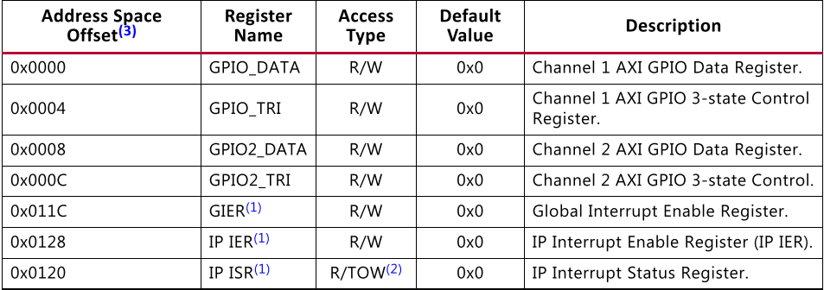

Table 8.1. General Purpose IO Register Space[36].

Both FIR and FFT Accelerators use four channels in order to introduce hardware redundancy into the system. By introducing such redundancy, when the classifier generates an output, the outputs of each channel will be compared in order to determine if an SSVEP has been detected or not. This will be covered further in a later chapter on Signal Processing.

The four channels for each Accelerator are grouped together into a set of Hierarchies which are used to help make the system more modular. Modularising the system takes advantage of the FPGA’s facilitation for rapid prototyping and reconfigurability. Having the system broken into modules also makes developing drivers more efficient. Instead of a large body of code being developed for the entire system, each module can have its own separate drivers which helps to loosely couple all components.

### FFT Hierarchy

The FFT Hierarchy as seen in Figure 8.11 handles the communications between the four FFT Channels and the ZYNQ PS. There is very little functionality in this hierarchy bar routing general purpose transactions to the configure the Direct Memory Accesses within the channels, and routing the data streams from the PS to the specified DMA.

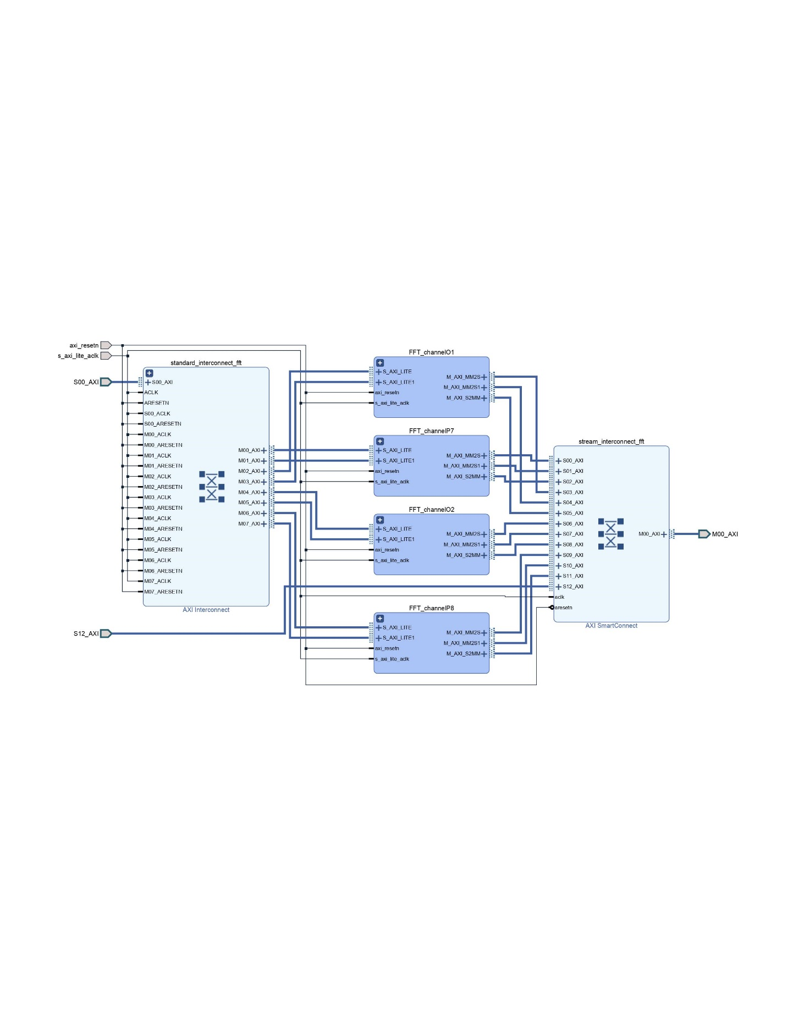

Figure 8.11 FFT Hierarchy containing the Four channels and two interconnects for the General Purpose and High-Performance Interfaces.

### FFT Channels

The FFT Channels were one of the primary focuses when developing the Hardware Accelerated BCI. One of the main objectives of this project was to develop a system which can accelerate the detection of SSVEPs using the parallel processing offered by the Programmable Logic. One such operation within the detection of SSVEPs which can benefit from Hardware Acceleration is the Fast Fourier Transform.

The FFT Channels as seen in Figure 8.12 contain two DMAs, a Data Width Converter and the FFT Processing core. The two DMAs are responsible for streaming data to and from the FFT processing core, where one DMA streams the frames of data from the DDR to the processor, and vice versa, while the other DMA is responsible for handling the run time configuration of the FFT core.

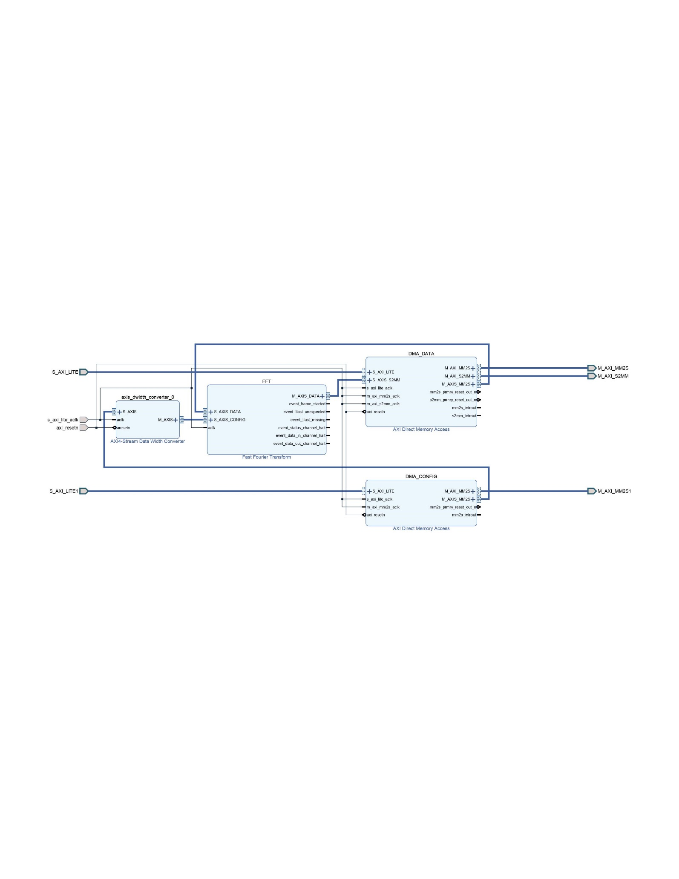

Figure 8.12 FFT Channel containing the Direct Memory Access Components and the FFT Processing Core.

The Fast Fourier Transform Processing Core is the central component for channels within the FFT Hierarchy. Each of these processing cores are utilised to offload the processing of Fourier Transforms in order to take advantage of the Programmable Logics ability to perform multiple computations at once, allowing for higher throughput.  
The IP block for the FFT in Figure 8.13 contains a set of AXI channels and event related ports. Similar to other IP blocks, the AXI channels handle the streaming of data in and out of the core where the channels marked S_AXIS are slaves in the Master Slave handshake, and M_AXIS are the masters. In order for the FFT to begin receiving any frames of data, it must first tell the connected master (a DMA in this instance) that it has finished the previous frame and is ready to receive the next frame for processing. The Master Interface on the output will be in charge of asking the connected Slave interface (a DMA) if it is ready to receive the output of the processor, and once the Slave has asserted that it is ready, the Master Interface can stream the output to the DMA.   
The event related ports serve a different purpose than the AXI Streaming channels. Instead these ports assert interrupts when a specific event occurs, for example a frame begins, the event_frame_started pin will be asserted. These interrupts can help with making the system more asynchronous, which helps with driving the system away from its synchronous nature.

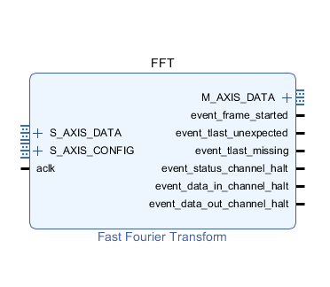

Figure 8.13. FFT Processing Core IP Block.

The AXI Interfaces require the data it receives or sends to be formatted correctly allowing it to correctly interpret what data it is receiving. The Configuration channel, which allows the developer to alter the Cores state of operation, can alter:

* NFFT  
  The number of samples per frame which can be processed. This channel reads in n where $2^{n}=NFFT.$
* FWD/INV  
  Specifies if the Processing Core will perform a forward Transform or an inverse transform, which makes the core either convert from the time domain to the frequency domain or vice versa.
* SCALING_SCHED  
  Specifies how much the values will be scaled at each FFT stage in order to avoid a bit overflow. These can be caused when a number represented by n bits becomes a number represented by n+1bits after a mathematical operation, i.e. multiplication.

These configuration setting as seen in Figure 8.14 must reach the 8 bit mark between sections, which explains the need for a pad of zeros introduced to the packet.

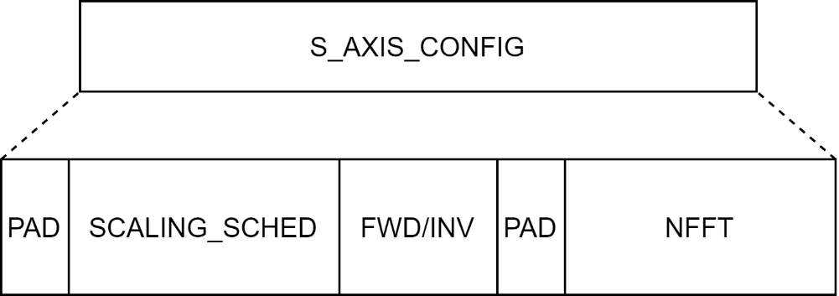

Figure 8.14 FFT Configuration Channel Transaction Format.

The Input and Output AXI channels require a different format to the Configuration Channel. Instead of configuration settings, these channels will be streaming in EEG signal data, and streaming out the frequency content of the signals in the form of complex numbers. Since the processing core can be configured to perform a forward or inverse transformation, both the Input and Output channels will share the same format as seen in Figure 8.15. This format requires the PS to insert zeros between every sample in each frame, ensuring that the imaginary component of each sample is zero, making the sample completely real. The output frame of the processing core will need to be decomposed from an array of integers to an array of complex number by combining every two values as seen in figure 8.15.

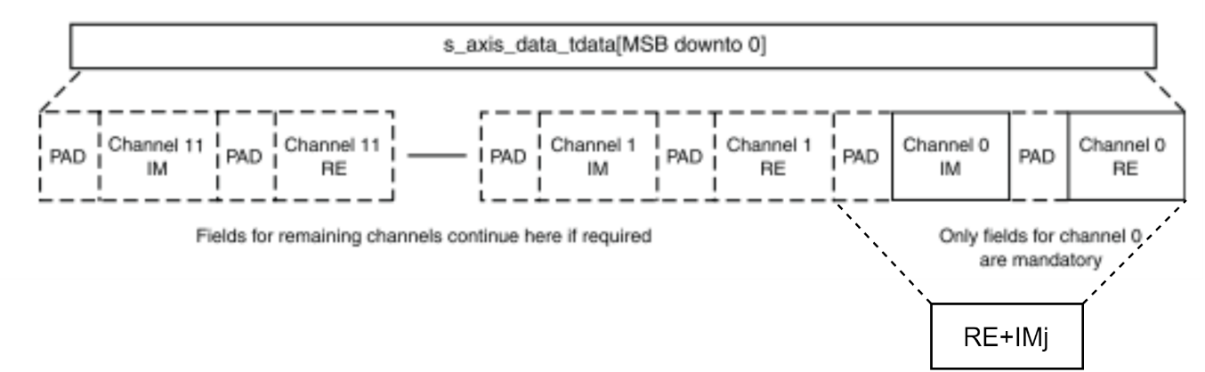

Figure 8.15. FFT Input / Output Data Channel Transaction Format.

The FFT processing core offers multi-channel capabilities which would have made the FFT Hierarchy redundant. However, a single drawback with using a multichannel FFT block, the channels need to share the 64-bit transaction, leading to lower resolution than the single channel IP core. The drawback of using four separate FFT IP cores meant that resources would become scarce because of multiple DMA and FFT instances, however, there was still enough Logic elements and DSP blocks to fulfil the requirements of this project.

The processing core implementation in hardware seen in Figure 8.16 represents a Radix-4 Burst I/O processing engine. The FFT processing core can be implemented as other structures such as Pipelined where a new frame is loaded after each FFT stage has completed or Radix-2 Burst I/O which attempts to reduce resource count by using shared memory storage and accumulators. Both offer complexity and speed over simplicity. The pipelined architecture would require more complex code to operate and with very little documentation on previous examples, it would be more difficult than the Burst IO implementations. The Radix-2 and Radix-4 Burst IO structures require less complicated code in order to operate the processing core, and with more examples implemented with the PYNQ framework, these architectures became more viable.   
The Radix-4 can perform four parallel calculations for each FFT stage as opposed to the Radix-2 which can only perform 2.

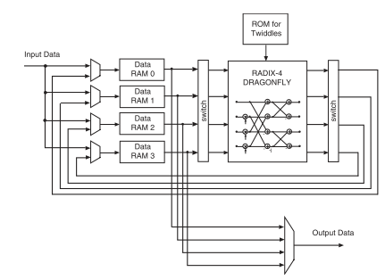

Figure 8.16 FFT Core implemented in Hardware[37].

The Radix-4 Burst IO architecture utilises four DATA RAMs, a single Twiddle ROM and a RADIX-4 DRAGONFLY processor. The DATA RAMs store the frames of data that are to be processed, and after each processing stage the multiplexer (MUX) will route the output of each stage back to the RAMs for the next stage. The ROM of Twiddle Factors (weights represented by $W_{N}^{kn}$) store all of the weights used for the DFT calculations performed by the Dragonfly Processor. The NFFT value specified in the Configuration transaction is utilised in generating these twiddle factors:

$${Twiddle Factor= W}_{N}^{kn}= e^{-jn(\frac{2π}{N}k)} (8.1)$$

Where N is the NFFT, k output position, and n is the sample number.

Finally, the Dragonfly Processor performs the DFT by decomposing it in a similar manner to that seen in Figure 7.7, but instead of separating the calculations at each stage into odd and even sample numbers, the calculations are broken as:

$$DFT\left(k\right) = \sum_{n=0}^{N-1}{x\left(n\right)}W_{N}^{kn} (8.2)$$

$$FFT\left(k\right) = \sum_{n=0}^{\frac{N}{4}-1}{x\left(n\right)}W_{N}^{kn}+\sum_{n=\frac{N}{4}}^{\frac{2N}{4}-1}{x\left(n-\frac{N}{4}\right)}W_{N}^{kn}+$$

$$\sum_{n=\frac{2N}{4}}^{\frac{3N}{4}-1}{x\left(n-\frac{2N}{4}\right)}W_{N}^{kn}+\sum_{n=\frac{3N}{4}}^{N-1}{x\left(n-\frac{3N}{4}\right)}W_{N}^{kn} (8.3)$$

Where each summation can be broken down even further in the same manner recursively until there are a sequence of 4-point DFT operations. The levels of decomposition are the stages of each FFT operations, where the DFT equation in Eq. 8.2 is the final stage, and the first sequence of decomposed DFTs in Eq. 8.3is the second last stage.

If the complex multiplications were implemented in Software, the real components and the imaginary components would be multiplied one after another, which can take a hit on system performance for large numbers of complex multiplications per stage. Implementing these complex multiplications in hardware however offers greater system performance by implementing the arithmetic in Combinational Logic Blocks (CLB). However, these CLBs still have overheads with multiplications because they require N-1 clock cycles for N bit words, and with two 32 bit words, CLB multiplication requires 31 clock cycles. A second option would be to use a 3-multiplier structure component [37] which makes use of the DSP48 blocks within the Programmable Logic which have dedicated Multiplier components optimised to perform multiplications faster than CLB implementations. These 3-multiplier structure complex multipliers implemented within the FFT cores helped improve performance in the BCI System.

The FFT core can be further optimized by moving the butterfly arithmetic (the addition, subtraction, and multiplication between stages) to DSP slices which have dedicated optimised adders, and optimised multipliers.

Between each stage the values within the DATA RAMs are updated to the current outputs from the Dragonfly processor for use as inputs to the following stages. Once all of the stages have been completed and combined at the end, the output is multiplexed into a single Stream which will be sent to the DMA.

The Direct Memory Accesses (DMA) within the FFT channels serve as support infrastructure for moving the data between the FFT Processing Core and the Processing System. The DMA in Figure 8.17 provides high-bandwidth direct memory access between AXI-4 memory mapped and AXI-4 streamed interfaces[38], allowing the Processing System to offload the task of handling such high rate data transfers in order to continue with other tasks.

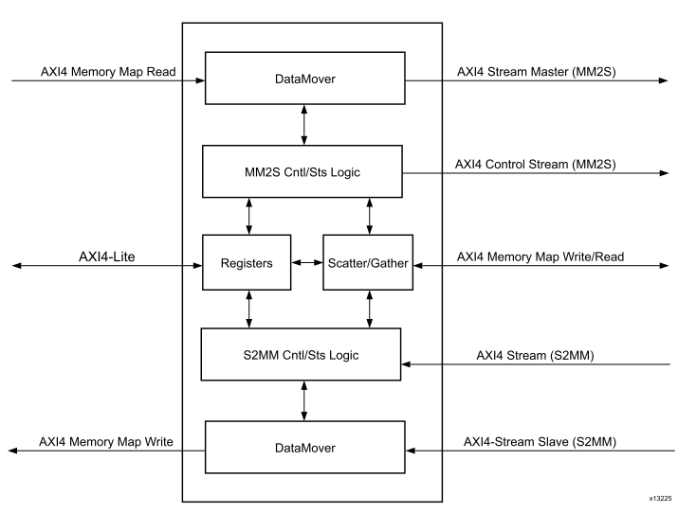

Figure 8.17. Direct Memory Access

To initiate any Streaming transactions that require the use of DMAs, the Processing System must first write the specified base address and length of the buffer of data to the DMA registers, followed by explicitly telling the DMA to begin.

These registers, just like the GPIO, have their own address space that allow the Processing System to memory map directly by specifying the correct address offset from Table 8.2. Each of these registers are controlled by using the AXI_Lite interface because they only require single burst transactions to either write to or read from them.

|  |  |  |
| --- | --- | --- |
| **Address Space Offset** | **Name** | **Description** |
| 00h | MM2S_DMACR | MM2S DMA Control Register |
| 04h | MM2S_DMASR | MM2S DMA Status Register |
| 08h – 14h | Reserved | N/A |
| 18h | MM2S_SA | MM2S Source Address. Lower 32 bits of Address |
| 1Ch | MM2S_SA_MSB | MM2S Source Address. Upper 32 bits of Address |
| 28h | MM2S_LENGTH | MM2S Transfer Length |
| 30h | S2MM_DMACR | MM2S DMA Control Register |
| 34h | S2MM _DMASR | MM2S DMA Status Register |
| 38h – 44h | Reserved | N/A |
| 48h | S2MM _SA | MM2S Source Address. Lower 32 bits of Address |
| 4Ch | S2MM _SA_MSB | MM2S Source Address. Upper 32 bits of Address |
| 58h | S2MM _LENGTH | MM2S Transfer Length |
| Table 8.2. Direct Memory Access Address Space. | | |

The Control registers are the main entry point for telling the DMA to start or stop and enables interrupts. The Status registers allow the developer to read what state the DMA is in be it running, idle or halted, and if any error flags have been asserted.

The AXI_Lite interface is used for writing control data to the DMA and the AXI4 memory mapped and AXI4 streamed interfaces are then used to handle the transfer of data itself. In the previous context where the DMA is receiving transactions from the Processing System, it is the slave. However, once the Processing System has told the DMA where in the DDR to read from and the number of samples, the DMA then becomes the master in Figure 8.18, and can initiate AXI Transactions with the Processing System.

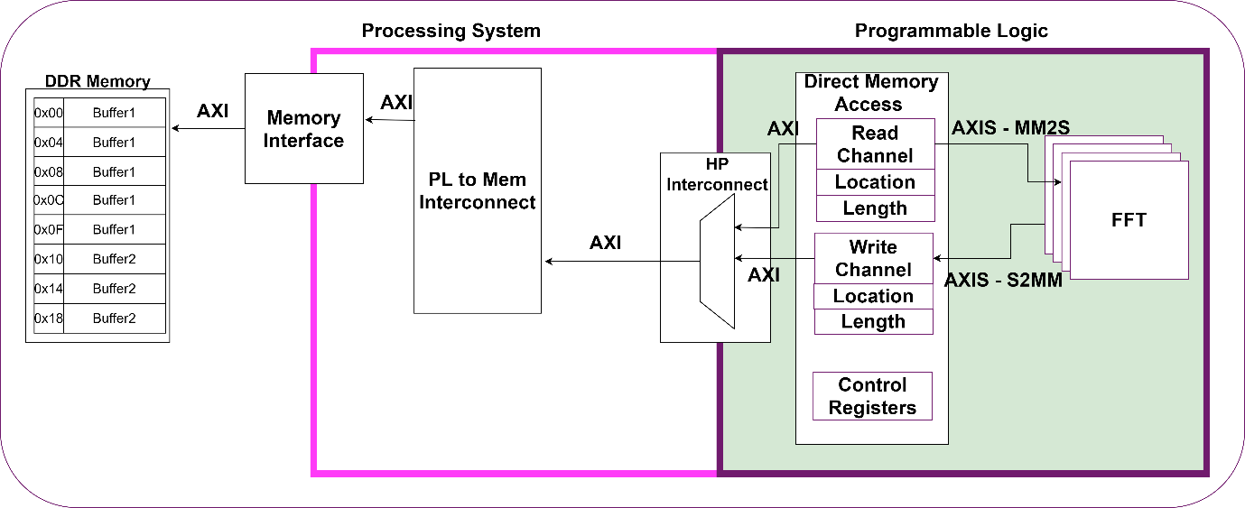

Figure 8.18 Direct Memory Access Data routing data between the DDR and the FFT.

The DMA will use the AXI Memory Mapped Interface for directly addressing each sample within the External DDR Memory, and stores the data within a FIFO buffer before finally streaming the data to the FFT. The Interconnect between the DMA and the Processing System’s High-Performance Interface routes all transactions initiated by the DMA to the External DDR Memory.

Once all samples have been read from the External Memory and the buffer is full, the DMA will then send the frame of data as a single stream to the FFT over the MM2S channel (Memory Map to Stream). The MM2S converts Memory Mapped Transactions to Streamed Transaction by grouping all of the transactions in a buffer as seen in Figure 8.19, and once all the data has been read it, it sends all of the data as a single transaction to the FFT.

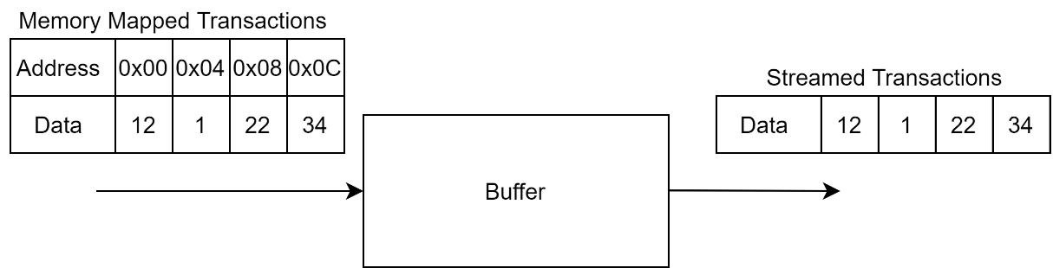

Figure 8.19 Memory Mapped to Stream Conversion

Once the FFT has finished processing the frame, the stream of data is sent back to the DMA over the S2MM channel (Stream to Memory Map). The S2MM channel as seen in Figure 8.20 groups the streamed data into a single buffer, and using the base address defined in the S2MM_SA registers, the DMA memory maps the frame back to the allocated buffer within the External Memory.

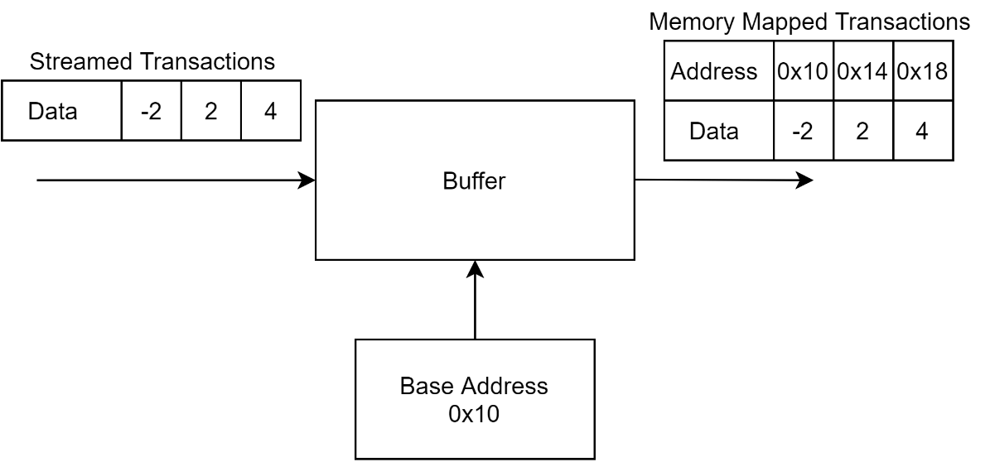

Figure 8.20. Stream to Memory Mapped Conversion.

### FIR Filter Hierarchy

The FIR Filter Hierarchy, similar to the FFT Hierarchy is responsible for routing different transactions to the specific channel from the Processing System. The interconnects in Figure 8.21 serve the DMAs within the FIR Channels, but one is for routing transactions that contain the source address of the buffers, their length, and access the DMA status and control registers. The second interconnect is for routing the AXI4 memory mapped transactions between the External DDR memory and the DMAs that requested the data.

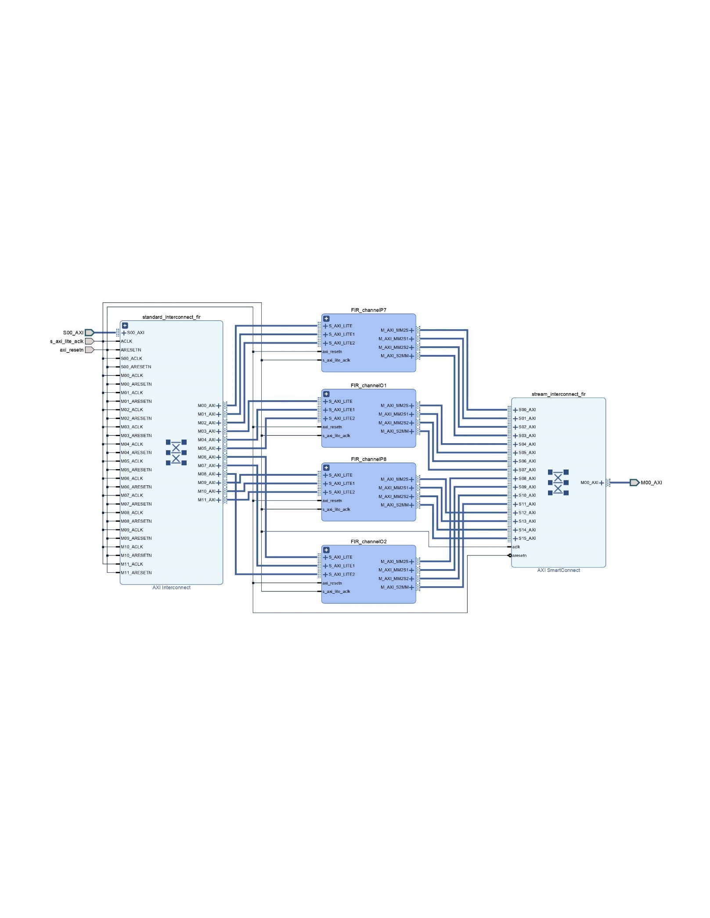

Figure 8.21 FIR Filter Hierarchy containing the four filter channels and the Interconnects for routing them.

### FIR Filter Channels

The FIR Filter was another primary component for the Brain to Computer Interface required for filtering all noise from the signals. The filtering stage of the algorithm is not as a computationally expensive as the FFT, but for more accurate filters, the more coefficients the better. By implementing the filter in hardware, all of the Multiply and Accumulate (MAC) operations can be performed in one clock cycle allowing for a higher accuracy and higher throughput.

The Filter channel in Figure 8.22 makes use of three DMAs for controlling the FIR Filter compiler. One DMA streams in the data to be filtered, one DMA streams in a new set of coefficients and the final DMA streams in a synchronising packet to trigger the coefficient update.

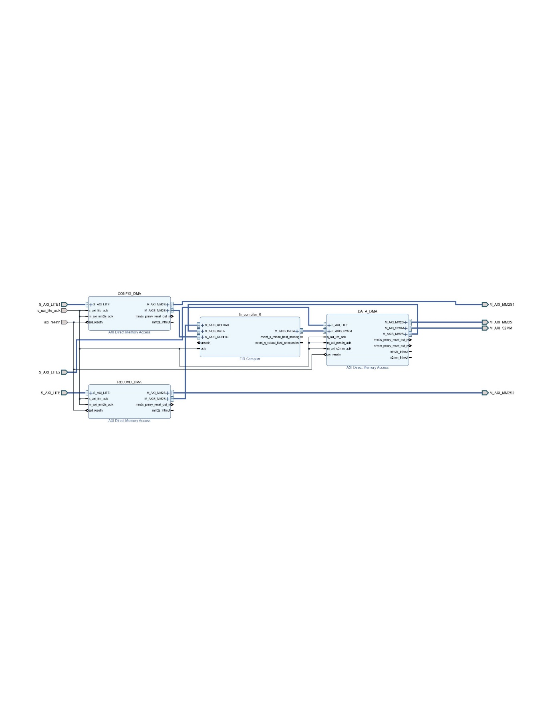

Figure 8.22. FIR Filter Channel containing three DMAs interfaced with the FIR Filter Compiler.

Figure 8.23 represents the FIR Filter IP Block which makes use of three AXI Streaming Slave interfaces and a single Master Interface. The FIR IP Block offers developers the option of reconfiguring the filter at runtime by streaming a set of filter coefficients with the RELOAD channel and using the CONFIG channel to trigger a synchronisation event that updates the registers handling the coefficient values. The DATA channels are the same as the FFT IP block previously covered, but with a different transaction structure. Finally, there are two event related pins which can be asserted and handled by an Interrupt controller which helps to make the systems easier to test and debug. These pins are either asserted if too many samples have been received causing the tlast missing event, or if too few samples were received the tlast unexpected event will be fired.

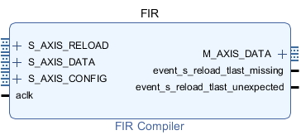

Figure 8.23 FIR Filter IP Block

The input and output DATA Channels follow the same structure for handling the streaming of EEG signal data to be streamed as seen in Figure 8.24. Both channels have a portion of bits that are used for the Data itself, and a smaller portion of bits used for handling bit growth post filtering[39]. When a sample which occupies 26 bits of the 32 bit frame can be passed through the filter, and after the Multiply – Accumulate operations, the resulting value could be represented by a larger portion of bits which make use of the unused bits in order to expand.

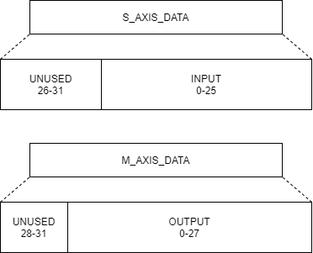

Figure 8.24 FIR Input and Output Data Channels. The output channel uses a portion of the unused bits to handle post filtering bit growth.

The CONFIG channel is used for activating a new filter implementation by triggering a synchronisation event which will change the coefficient values stored in the registers to the new loaded coefficient values[39]. The CONFIG channel blocks the RELOAD channel once all of the coefficient slots have been filled. Once the RELOAD channel is blocked, the CONFIG channel handles a single packet which forces the FIR Compiler to update the Filter Coefficients and the RELOAD channel is then released.

The RELOAD channel is used to load in a new set of filter coefficients in order to implement the frequency response of another filter. The length of this packet is defined by the filter implementation. For the BCI System on Chip, a single rate symmetric filter, which ensures that the input sampling rate is the same as the output sampling rate which makes use of filter symmetry[39]. By exploiting filter symmetry, an N tap filter only requires N/2 coefficients which helps to reduce the complexity of the filter by decreasing the number of multiplies required for each sample.

The standard FIR filter implementation in Figure 8.25 contains a set of delayed samples represented by a $Z^{-1}$ (Z-transform representation $x(n+1$)). Each time a new sample is loaded into the filter the previous samples are shifted to the next register. The products of each sample and their corresponding coefficient are accumulated to create the filtered sample, where the sample is filtered with respect to previous values in order to ensure the output is within the desired frequency response the filter aims to create.

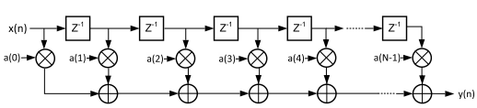

Figure 8.25 Typical FIR Filter with delayed values and coefficients a(k).

The standard FIR filter implementation requires N multiplications and N-1 additions per sample on each clock cycle. For high values of N, the large number of multiplications can begin to affect the timing constraints of the system. By exploiting filter symmetry as mentioned before, the number of multiplications can be halved, which has a great affect on the timing and complexity of the filter. Figure 8.26 represents a symmetric FIR Filter where the samples at mirrored locations are aggregated before applying the coefficient in order to create a weighted sample to be accumulated at the end. As an explanation the mirrored samples are represented as:

$$x\left(0\right), x\left(1\right),x\left(2\right), x\left(3\right), x\left(4\right) ¦ x\left(5\right),x\left(6\right),x\left(7\right),x\left(8\right),x(9)$$

Where the centre is between x(4) and x(5), and x(0) and x(9) would be mirrored versions of each other, and share the coefficient a(0). The mirroring only relates to the sample locations and not the values themselves.

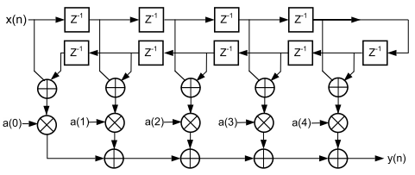

Figure 8.26 Symmetric Filter implementation.

Implementing these FIR filters in software would require a for loop which will loop over each sample, and synchronously sum the two samples, followed by multiplying the aggregate with the coefficient and then adding the result to a running total for the full filter. Each loop needs to execute three mathematical operations per coefficient, which can take its toll again for larger amounts of coefficients. By implementing a symmetric filter in hardware each aggregation and multiplication step before the accumulation can happen simultaneously greatly improving system performance.

Just as the FFT, the FIR then makes use of DMAs for handling the transfer of data between the FIR Compiler and the allocated buffers within the External DDR Memory. All the hardware implemented as described within this section of the report can’t operate independently. Dedicated drivers are required for each layer of the system to format the data, handle the allocation of buffers and to instruct the DMAs to begin accessing these Buffers.

## Hardware Drivers

Instead of having a large codebase composed of large cells within Jupytr Notebooks, an Object-Oriented approach to creating drivers for the BCI System on Chip was established. Jupytr Notebooks is useful for rapid prototyping and quickly debugging code but can become difficult to scale because of its cell-based layout. By creating classes within separate Python Files, the Jupytr Notebooks can be cleaner and easier to analyse the data with. A class-based structure also allows for better dependency Injection where the channel hierarchies can be replaced with a new Filter or FFT implementation without changing the entire codebase.

### BCI Overlay

The BCI Overlay is an extension of the Overlay Class provided by the PYNQ codebase designed specifically for allowing python developers to harness the power of hardware acceleration. This class is designed to abstract all of the lower level hardware to software developers with little Digital Design and Hardware experience. This class is the main entry point for developers and it creates instances of the lower level drivers further abstracting any of the lower level complexity from developers.

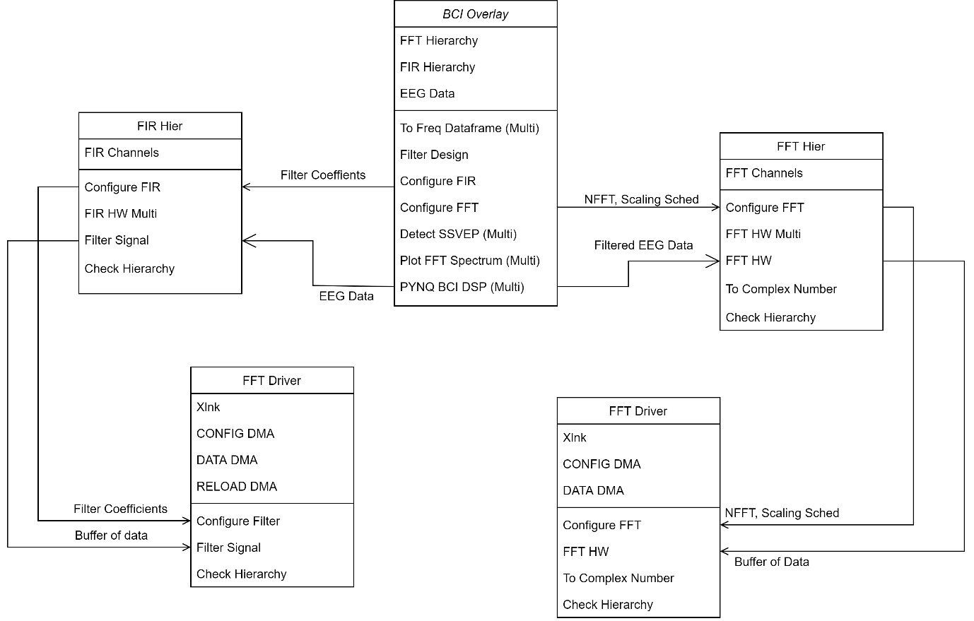

Figure 8.27. UML Class diagram with all driver classes and object relations between them.

Figure 8.27 represents the UML class diagram that offers a representation of how the various driver classes interact with their lower levels. Each of the class blocks display the objects they refer to on the top and the methods they implement on the bottom.

The BCI Overlay doesn’t have direct access to the underlying hardware, but instead holds a reference to the Hierarchies, which in turn have access to the DMAs used for streaming the data.

Before any data can be processed, all the lower level components need to be configured. In order to configure the FIR Compilers, the Overlay creates a set of coefficients using the input specs (lower cut off frequency, upper cut off frequency, and sampling frequency), and passes them to the FIR Hierarchy which then forwards the coefficients to each channel. The same configuration process occurs for the FFT Channels.

Following configuration, the algorithm which will be covered in the next chapter is executed within the BCI Overlay and passes the EEG data to the channels to be processed.

Once the signals have been processed, they are plotted using the Plot FFT Spectrum method and the processed signals are passed to the Detect SSVEP methods in order to finally extract the required features (peaks) from the frequency content of the input EEG data.

### FIR Hierarchy

The FIR Hierarchy’s prime purpose is to forward configuration data to each one of the FIR Channels, ensuring that each channel is configured the same, and to handle the routing of EEG data to the correct channel. Where the BCI Overlay holds reference to the FIR and FFT Hierarchies, the Hierarchies hold reference to the channels associated with them.

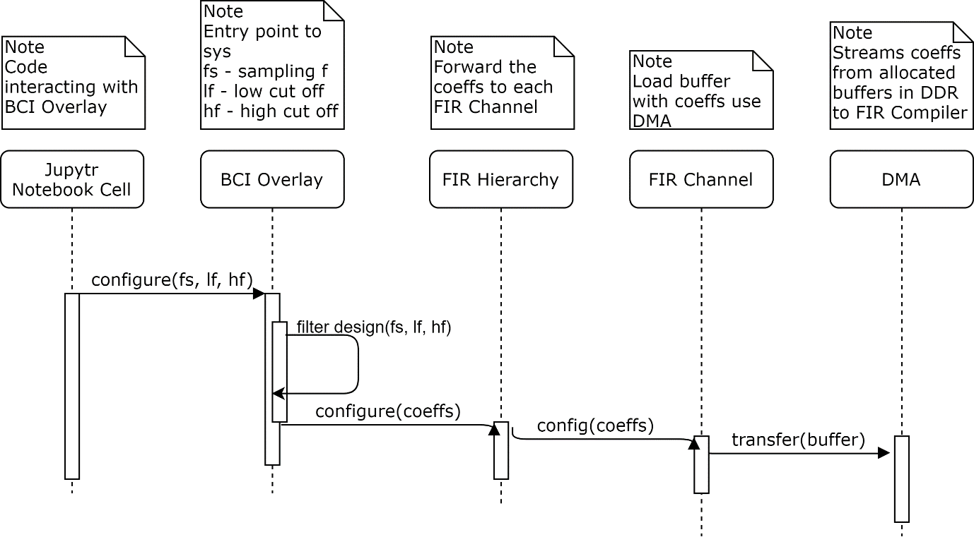

Figure 8.28 UML Sequence Diagram showing the steps required to configure the FIR Channels.

Figure 8.28 represents the sequence of steps required to configure an FIR channel, where the calling code tells the BCI Overlay to configure the filter according to a set of specifications. These specifications are used to create coefficients that define the filter. These coefficients are then forwarded to the FIR Hierarchy which handles the creation of buffers during the configuration process in order to ensure they are ready for transferring the data. Having these buffers allocated at the beginning removes any latencies caused by the transfer of data between the DDR and FIR compiler, reducing any bottlenecks in the system. Once all buffers are created, the coefficients are moved to the buffers which are then forwarded to the FIR Channel, which in turn tells the DMA to begin transferring the coefficients to the FIR Compiler.

The FIR Hierarchy extends the Hierarchy class, which requires it to override the Check Hierarchy method. This method offers dependency injection for the system, where each class that extends Hierarchy can implement an injection policy. For the FIR Hierarchy, this class is injected into the system and attached to an Hardware Hierarchy if “Filter_Hierarchy” is within the Hierarchies path name and if “FIR_” is within its list of IP blocks. The path name, similar to a file path, defines where in the system a Hierarchy or IP block reside, i.e. FFT_Hierarchy/FFT_ChannelO1/DMA_CONFIG defines the path to the configuration DMA within the FFT Channel O1.  
If this check wasn’t performed and was set to return True without any condition, then the driver could be assigned to the wrong hardware hierarchy, which would lead to the code crashing because the driver is pushing data to the wrong IP block. And if the check was to return False, then the BCI Overlay would have no Drivers to call for interacting with the lower level hardware.

### FIR Channel

The FIR Channel Drivers handle the transfers of filter coefficients, and EEG data between the External DDR Memory and the FIR Compiler. Figure 8.29 offers a visual representation of how the BCI System on Chip filters EEG Data. The Calling code within the Juptyr Notebooks cell starts by initiating the algorithm embedded within the pynq_BCI_DSP code (covered in the next chapter).

When the algorithm calls for the data to be filtered, the frames of data are pushed to the FIR Hierarchy, which populates the previously allocated buffers with the EEG frames. The FIR Channel is prompted by the FIR Hierarchy to transfer the data to the DMAs which will stream the data to the FIR Compiler. When all channels have initiated the data transfer between the DMAs and the DDR, the DMA classes block the running of the code, polling the Hardware DMA for the output of the FIR Compiler.

Once the FIR has completed filtering the frame, the DMA will stream the data back to the DDR, where the FIR Channel will extract the data from the buffers and push it back to the FIR Hierarchy. The Hierarchy will group the data from all channels and push the frames back to the BCI Overlay.

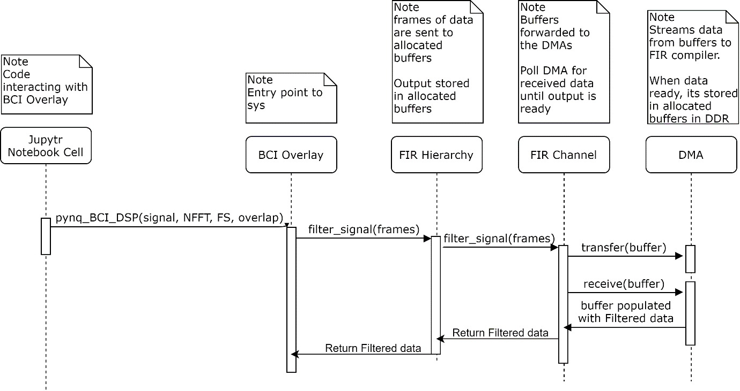

Figure 8.29 UML Sequence diagram displaying the steps taken to filter a frame of EEG data.

The FIR Channel is another Hierarchy of components which are grouped together in order to make development easier and more modular. The FIR Channel class also extends the Hierarchy class, meaning it must override the check hierarchy method and creates its own checks to make sure that this driver class is bound to the correct hardware hierarchy. As long as the path “Filter_Hierarchy/FIR_Channel” is in the hierarchy’s full path and it contains a “DATA_DMA” in the Hierarchy’s list of IP blocks, the Overlay will bind the correct driver code to the correct hardware Hierarchy.

### FFT Hierarchy

The FFT Hierarchy serves the same purpose as the FIR Hierarchy, it handles the configuration of each FFT channel and then routes the data to the correct channel. The BCI Overlay will hold a reference to the FFT_Hierarchy which will in turn hold a reference to all of the channels associated with it. Figure 8.30 displays the steps required to configure an FFT Core, starting from the calling code within the Jupytr Notebook specifying what parameters it wants the FFT to follow. The BCI Overlay will pass these parameters to the FFT Hierarchy which begins with allocating buffers within the external memory to be used by the DMAs to handle all FFT related transactions.

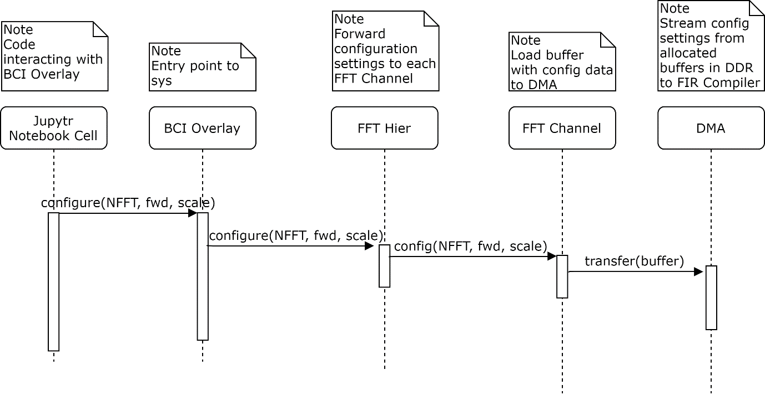

Figure 8.30. UML Sequence diagram displaying the steps required to configure an FFT Core.

When the buffers have been allocated space within the external DDR, the FFT Hierarchy forwards the FFT parameters to the FFT Channel which populates a buffer and streams the parameters to the FFT Core.

Being a Hierarchy, the FFT Hierarchy implements the Check Hierarchy method the same as the FIR Hierarchy by checking its path and what sub-components it utilises.

### FFT Channel

The FFT Channel is the entry point into the FFT related hardware which handles the transfer of the configuration parameters and EEG data between the FFT Core and the External DDR memory. Figure 8.31 offers a representation of how the BCI Overlay interacts with the lower level components in order to utilise an FFT to transform the EEG data from the time domain to the frequency domain.

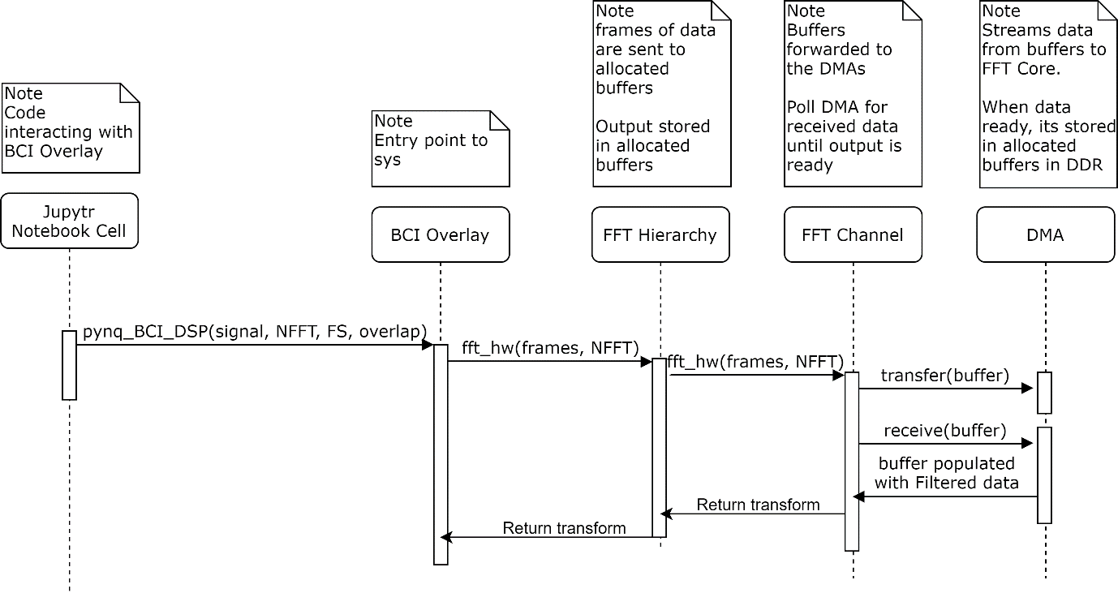

Figure 8.31 UML Sequence diagram displaying the steps required to perform an FFT on a frame of data.

When the algorithm implemented within the BCI Overlay calls for an FFT, the frame of data is first sent to the FFT Hierarchy which populates the allocated buffers with the frames of EEG data. The allocated buffers are then used by the FFT Channel to stream the data from the external DDR memory to the FFT core using the DMA class. Once the transfer of data has been initiated by all of the channels, the DMA class blocks the execution of the code by repeatedly polling the DMA for the output of the FFT. Once the FFT has complete, upon the channels request, the DMA streams the data to the allocated buffers, where the channels then extract the data. The stream of data is an array of integers which need to be converted to an array of complex numbers. All pairs of numbers within the array are coupled together to form the real and imaginary components of the complex numbers.

These complex numbers are then passed up through the different layers to the BCI Overlay, where the final transform will be plotted and used to extract the SSVEPs.

## Testing

The primary objectives of the testing phase of the BCI System on Chip were to determine the accuracy and effectiveness of the hardware implemented FFT and FIR in comparison to their software counterparts.

### Output Comparison Tests

The first round of tests compares the output plots of the Hardware FFT and FIR against the output of their software counterparts. This will help to determine if the Hardware implementation is performing the operation correctly.

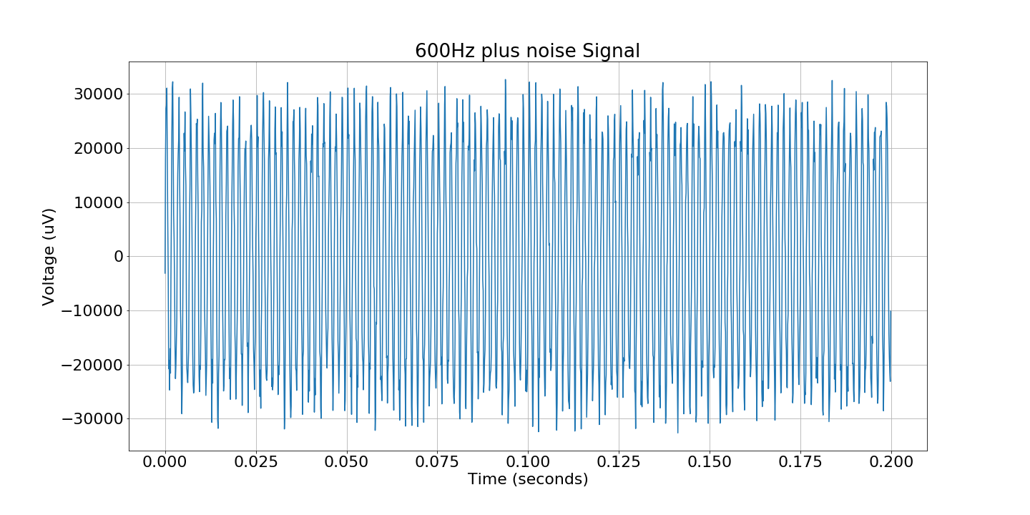

Figure 8.32. The original 600Hz signal embedded in a noisy signal.

The signal in Figure 8.32 being used as the test bench signal is composed of a 600Hz Sine wave polluted by gaussian noise. This signal can be used to determine if the Hardware FFT has a strong 600Hz component with a spectrum of lower magnitude frequency components caused by the noise. When determining the effectiveness of the FIR filter, this signal can be passed through a filter with a band encompassing the frequency component required, and the result should be a sine wave with less variations in amplitude over each period. Secondly, the frequency spectrum of this filtered signal should still have the strong 600Hz component while the surrounding frequency components are attenuated.

#### FFT Tests

The Hardware FFT was configured as a 1024 point forward FFT with a scaling schedule of [1, 1, 2, 2, 2, 2] which as previously mentioned defines how each stage of the Radix-4 FFT is scaled to avoid bit growth. The software FFT used for the comparison was configured the same ensuring the tests were fair.

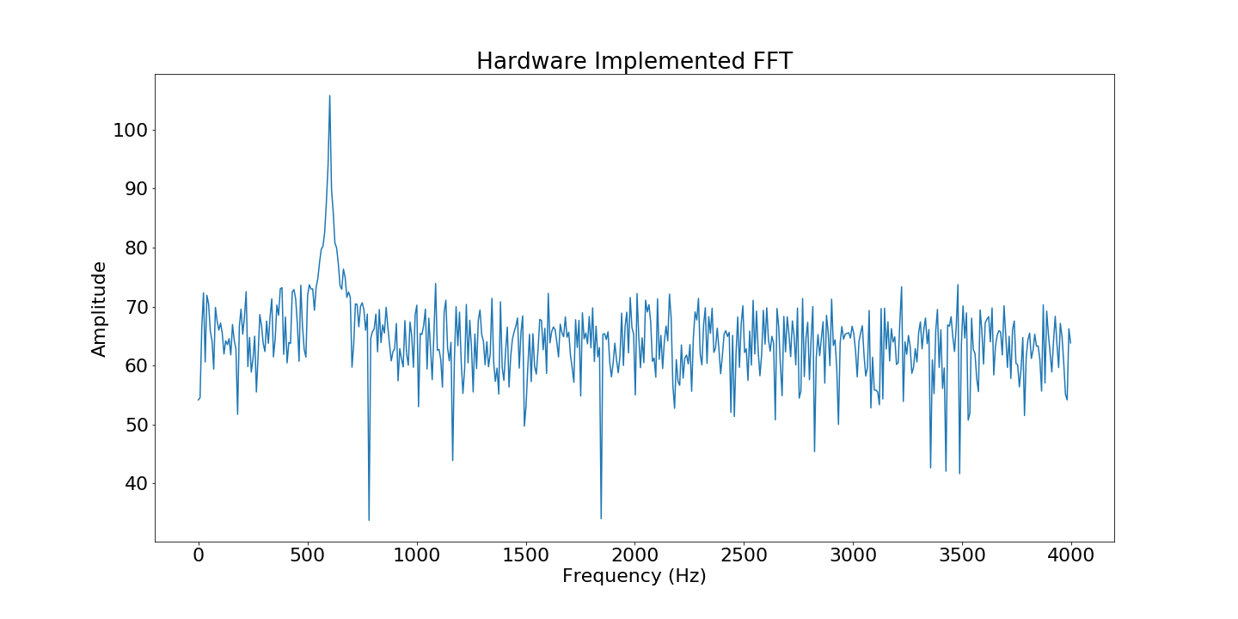

Figure 8.33 Magnitude Spectrum generated by the Hardware FFT of a 600Hz sine wave within a noisy signal.

The Magnitude spectrum generated by the Hardware FFT as seen in Figure 8.33 has a strong and distinct 600Hz frequency component as expected as well as smaller frequency components across the surrounding frequencies. When compared to the Software implementation in Figure 8.34, both plots share the same shape except for the amplitude values, with a strong distinct peak at 600Hz and two distinct troughs at roughly 800Hz and 1800Hz.

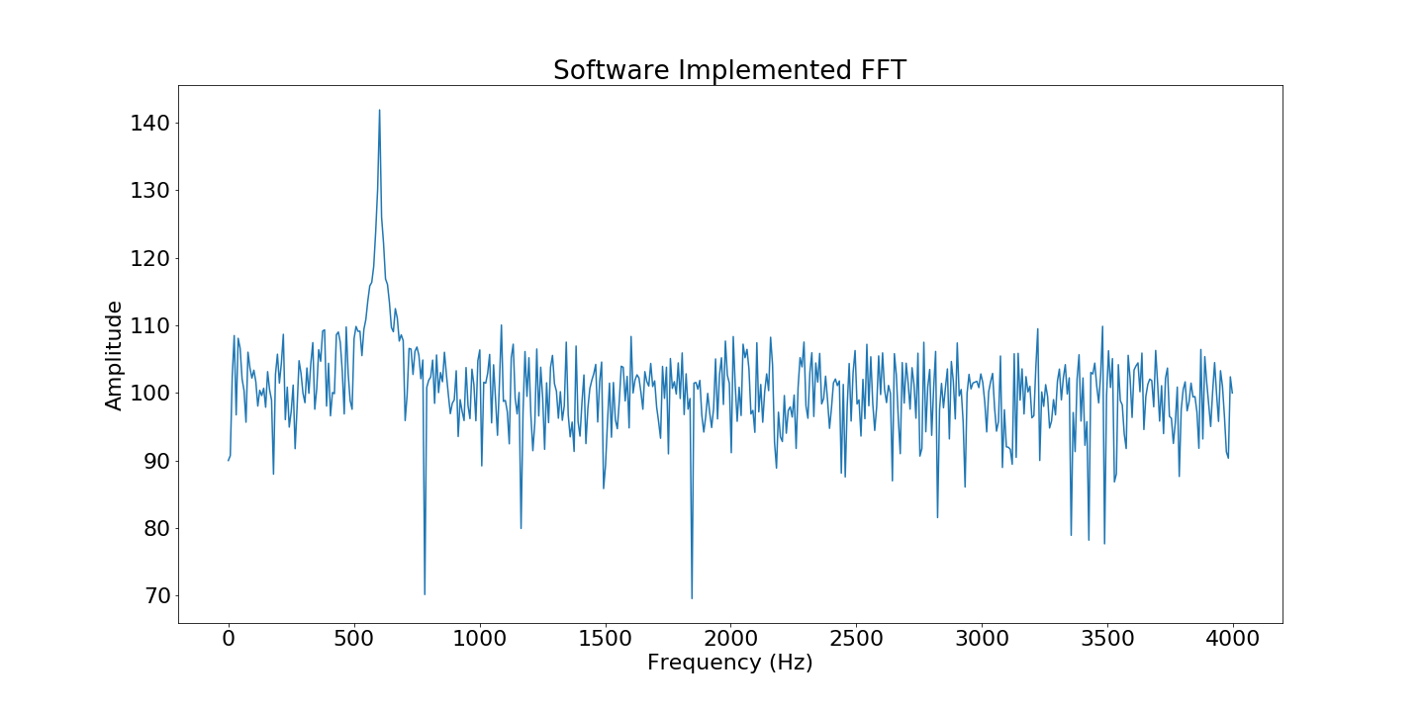

Figure 8.34. Magnitude Spectrum generated by the Software FFT of a 600Hz sine wave within a noisy signal.

When comparing the magnitude values between both implementations the mean difference between both implementations was 36.12. The scaling schedule affects how much the Hardware FFT magnitude values differ from the Software implementation, where different schedules scale the signal differently. Typically the higher the scaling weights for each stage lead to a greater effect the scaling has on the output creating a greater difference between the amplitudes in both implementations.

|  |  |
| --- | --- |
| Scaling Schedule | Mean difference |
| 1, 1, 2, 2, 2, 2 | 36.12 |
| 1, 1, 1, 1, 1, 1 | 24.08 |
| 2, 2, 2, 2, 2, 2 | 36.12 |
| 2, 2, 2, 1, 1, 1 | 18.06 |
| 3, 3, 3, 3, 3, 3 | 60.2 |
| **Table 8.3 Scaling schedules and the difference they cause between Software and Hardware FFT output** | |

#### Fir Tests

The FIR filter was configured as a 150-tap band pass filter allowing frequencies between 595Hz and 605Hz, both of which are surrounding the primary 600Hz component. Using these specifications and the sampling frequency of the signal, the coefficients were generated using python’s scipy package[40]. These coefficients are represented by the Magnitude Response in Figure 8.35.

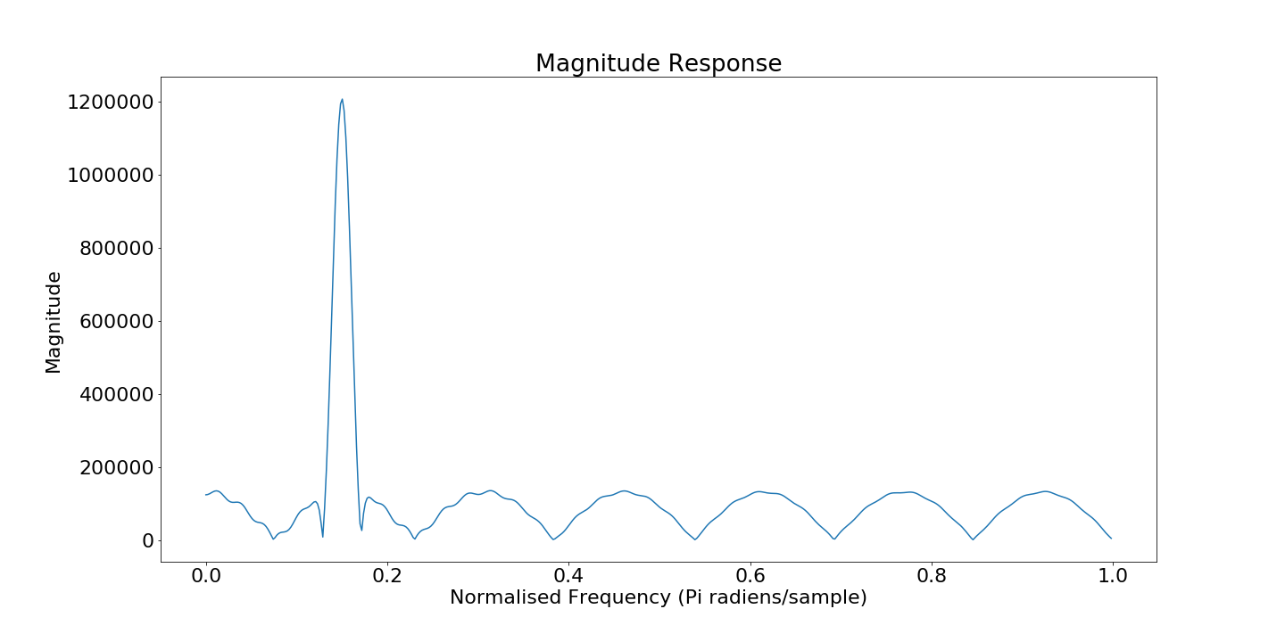

Figure 8.35 Magnitude response of the FIR Filter according to the generated coefficients specified by a lower cut off frequency of 595 Hz and upper cut off frequency of 605 Hz

Figure 8.36 shows a plot of the signal post Hardware filtering. The first thing to be noticed is that the first 170 samples from the filter are increasing in amplitude until they reach steady state. This is because the filter uses 150 coefficients, and it takes 150 samples to shift through the registers until the filter is fully initialised.

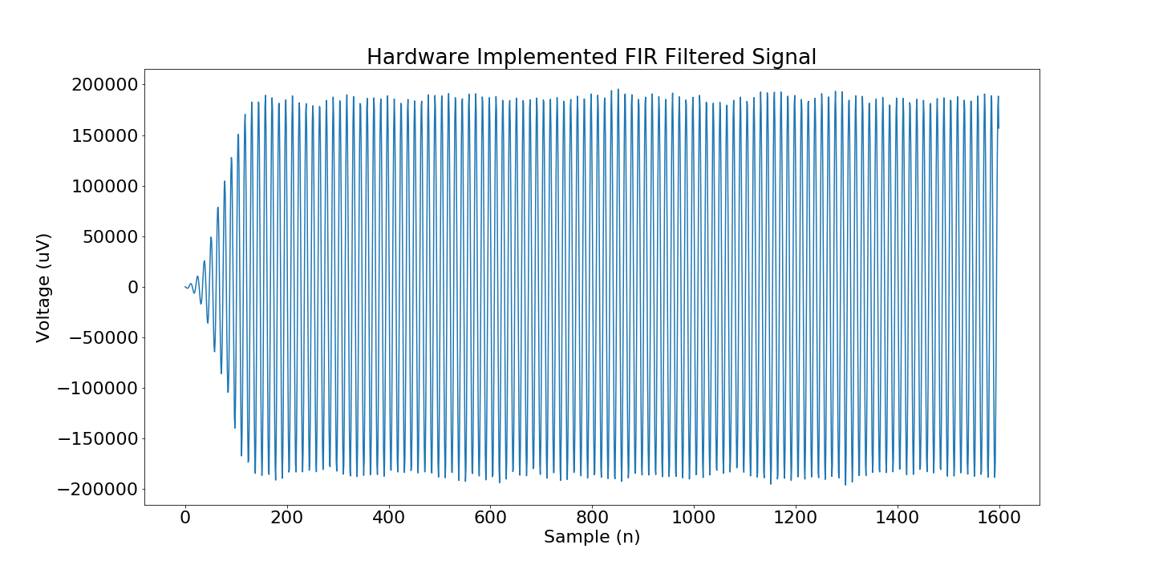

Figure 8.36 Filtered Signal generated by Hardware implemented FIR Filter

The next thing to notice is the low frequency oscillations in the signals is reduced. The noise within the signal which caused the amplitude to fluctuate between periods in figure 8.32 is removed by the bandpass filter, as seen by the near constant amplitudes in figure 8.36. The software implementation in Figure 8.37 shares the same shape as the Hardware implementation except a large scaling difference between the signal amplitudes. The Hardware implementation uses scaling factors to ensure that the output sample values don’t exceed the number of bits required, leading to a scaled version of the software filters output.

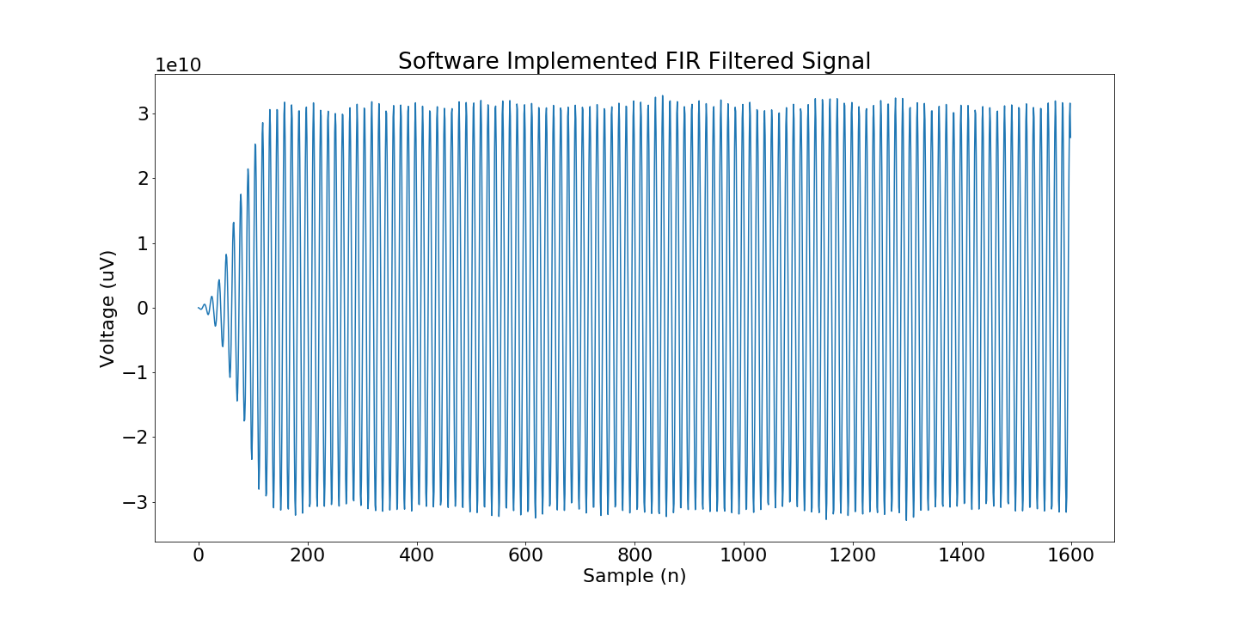

Figure 8.37. Filtered Signal generated by Software implemented FIR Filter

In order to determine the effectiveness of the filter in removing the noise surrounding the 600Hz signal, the power spectrum of the filtered signal was plotted in Figure 8.38 to visually determine if the noise has been attenuated or not. When compared to the frequency spectrum of the unfiltered signal in Figure 8.34 retained the strong, distinct 600Hz component, but the surrounding frequency components are attenuated. The ripples surrounding the 600 Hz component in the Magnitude response in Figure 8.35 are present in the Frequency Spectrum in Figure 8.38 where small groups of high frequency components were retained post filtering.

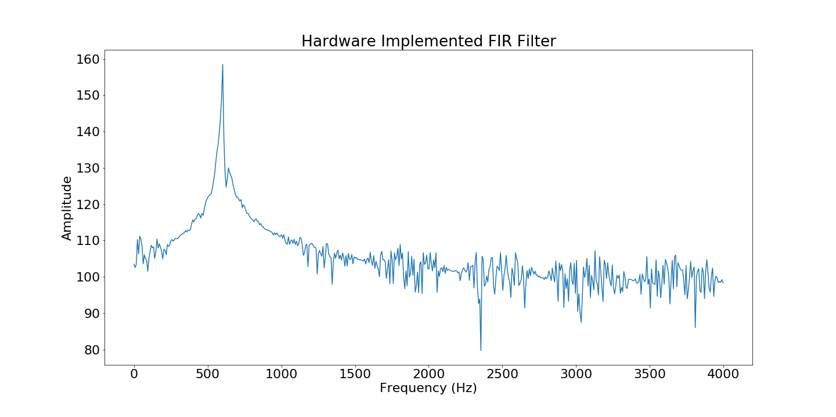

Figure 8.38. Frequency Spectrum of Hardware Filtered Signal.

According to these comparisons, the Hardware implemented FFT and FIR Filter are capable of performing the necessary computations accurately despite being implemented in fixed point, whereas the Software implementations implement floating point operations.

### Runtime Comparison Tests

The second round of tests aim to compare the time required to perform computations required to transform a signal using an FFT and filter a signal using an FIR Filter.

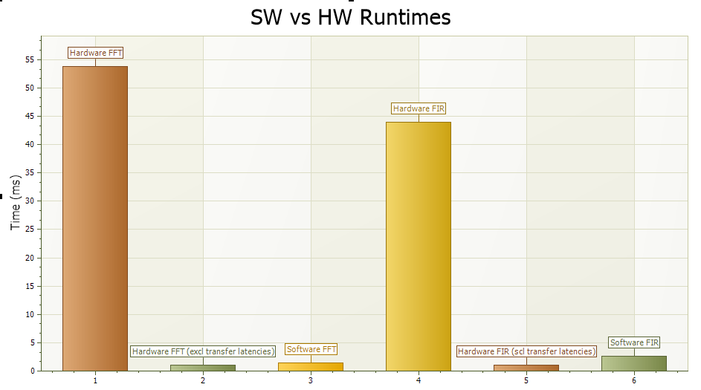

Figure 8.39 Comparison of execution times between the Hardware and Software implementations of the FFT and FIR.

Figure 8.39 represents a comparison between the execution times of the Hardware and Software implementations of the FFT and FIR Filter. The runtimes measured by starting a timer before the operation and terminating it when the operation completes was performed 10 times per operation and the average of each test was added to the plot.

It is obvious that the Hardware implementations are far slower than the Software implementations, which is questionable. In order to determine the cause of this excessive difference, the time measured between the DMA initiating streaming and the receiving the data within the FIR_Driver and FFT_Driver classes is used. The time between these two events excludes any latencies caused by formatting the data and populating the buffers. With these new measurements the Hardware implementations themselves are marginally faster than the Software implementations when all data preparations are excluded.

There is an obvious bottleneck in the system which is causing latencies which have a devasting impact on the Hardware execution times.

# Signal Processing Algorithms

The second objective of this project was to utilise the developed BCI System on Chip to implement an accurate SSVEP based brain to computer interface. The Hardware accelerators embedded within the BCI System on Chip are to be utilised within the algorithm for filtering and transforming the signals from the time domain to the frequency domain.

Matlab and python scripts were firstly developed in order to create prototypes of the algorithm necessary for extracting the relevant information from the EEG signals. Starting with Matlab and its library of readily available BCI tools such as biosig [41] and EEGLab which offers tools for easily opening EEG files. The primary reason for beginning all algorithm prototypes in Matlab was experience. Prior to this project, more time had been spent using Matlab throughout the course of my degree. The algorithms then had to be ported over to Python for integration with the Drivers used for handling the Hardware within the Programmable Logic.

## Epoching

For any signal processing algorithm, the large block of signal data is broken down into frames of data as seen in Figure 9.1 which will be processed one after another. By breaking a large signal into smaller frames, higher resolution signal processing can be performed on a frame in order to detect a specific frequency at that point in time.

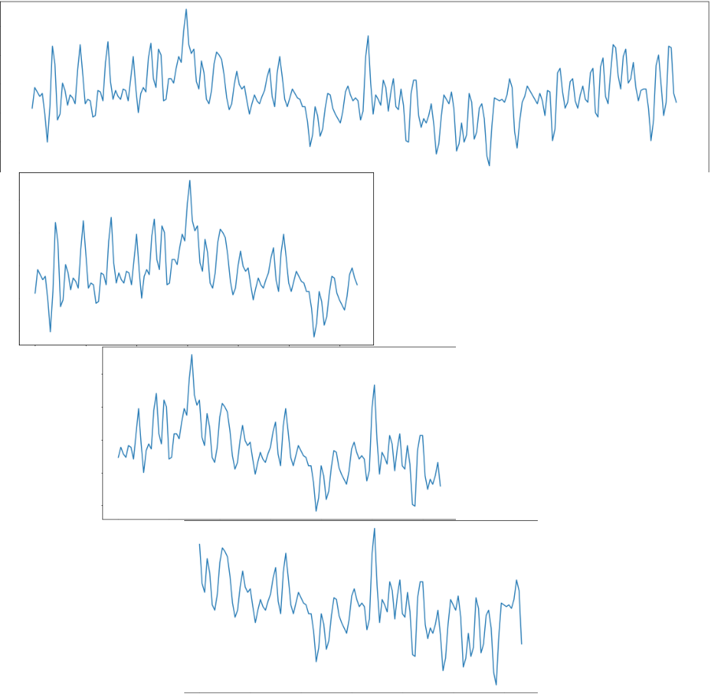

Figure 9.1 Signal being broken down into frames.

In the context of SSVEP detection, where each frame of data (aka Epoch) holds 4 seconds of data for example, the frequency of the SSVEP at that moment in time can be detected more clearly than if the whole 10 minutes of EEG data was processed. With each passing second, old samples are shifted out of the epoch and new samples are shifted in as seen in Figure 9.2.

As a subject begins to focus on a flashing stimulus, the event won’t be present within the data immediately. Instead by breaking the data into epochs and processing them one at a time, the Event related data will become more prominent after each new frame of data is shifted into the epoch. 3 seconds after the subject began to focus on the flashing stimulus, the Event data is more prominent than the surrounding random EEG samples in this epoch, leading to an accurate detection of an SSVEP, where the SSVEP is the event.

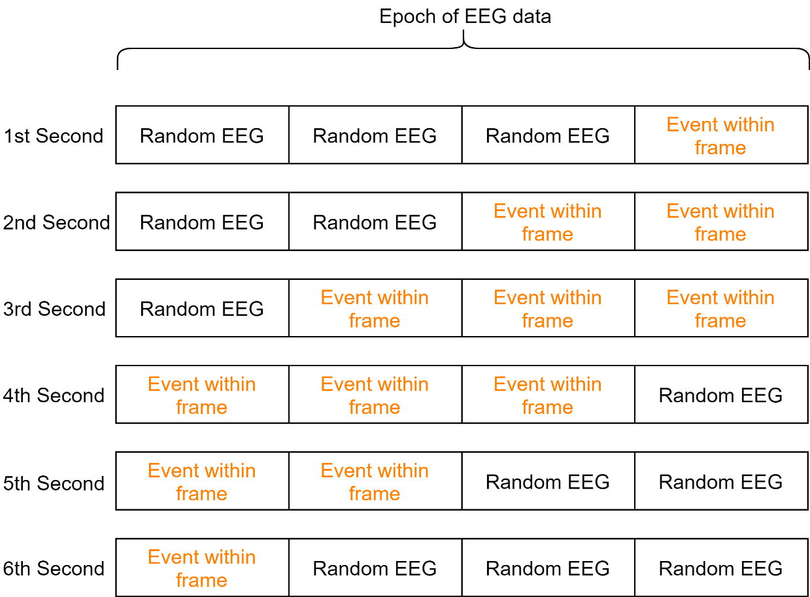

Figure 9.2 Epoch structure for BCI with event related data occurring.

By having an overlap between epochs, any relevant information is passed between frames allowing greater accuracy in event detection, but with a trade-off for greater latency. Figure 9.2 elaborates on this by demonstrating how Event related data found in the first epoch is used in consecutive epochs making it easier to extract the relevant event information from the surrounding random EEG samples.

The sampling rate used for the Algorithm detailed in this report is 128Hz, matching the sampling rate of the acquisition headset was used for recording the EEG data. For every second of recording, 128 samples of EEG data are recorded.

Epochs of 512 samples (4 seconds of data) used in the algorithm offered an effective trade-off between time and resolution. Longer epochs would require more time to process the greater number of samples, but offer higher resolution in the frequency domain. Smaller epochs are faster to process but offer lower resolution in the frequency domain making it more difficult to extract the necessary features from the signal frequency content.

With a sampling rate of 128 Hz and an epoch with 512 samples offers frequency resolution of:

$$resolution=\frac{samples per second}{samples per epoch}= .25 Hz$$

## Filtering

After the epochs have been extracted from the larger signal, the next thing is filter them and make sure any noise caused by low frequency eye artefacts and high frequency muscle activity is removed. The unfiltered epoch in Figure 9.3 suffers from low frequency oscillations that affect the overall shape of the signal, and high frequency artefacts that make the oscillations seem more clustered together.

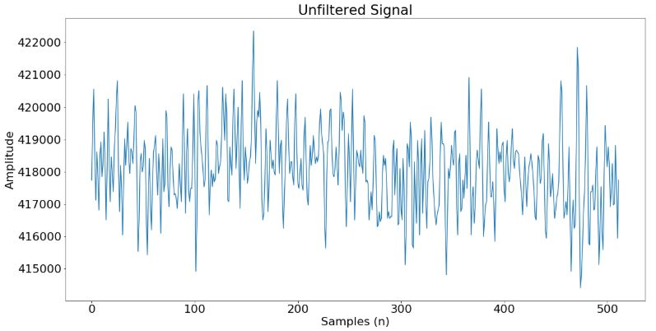

Figure 9.3. Unfiltered Epoch of EEG data to be processed.

Without removing these frequencies, the power will be distributed over almost all frequencies, drowning out the important stimulus frequencies. By filtering between 5Hz and 30Hz, the spectrum of the signal should take the form of the magnitude response in Figure 9.4, concentrating the signal power over these frequencies, reducing the drowning effect of the other frequencies.

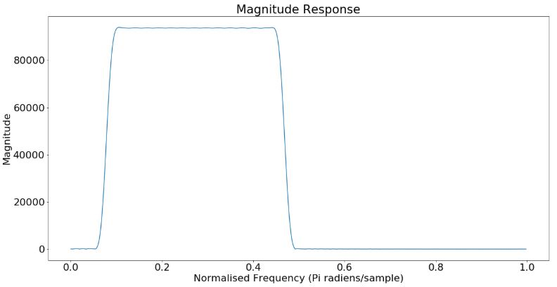

Figure 9.4. Magnitude Response of Filter used in BCI.

The output of the filter in Figure 9.5 no longer contains the low frequency oscillation or the high frequency noise, making for a clearer signal, which should make the feature extraction stage easier.

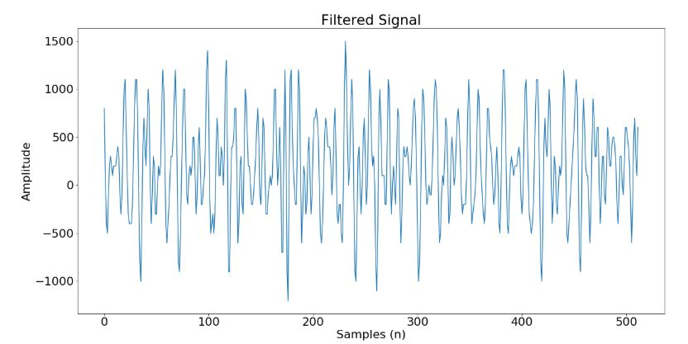

Figure 9.5. Filtered Signal

## Feature Extraction

Before filtering the signal, the PSD of the signal in Figure 9.6 has an even distribution of power across all frequencies. Within this plot there should be a 7.5Hz and 15Hz components because the subject has been focusing on the stimulus for 4 seconds. Without the previous filtering-stage the possibility of detecting the SSVEP would be very low.

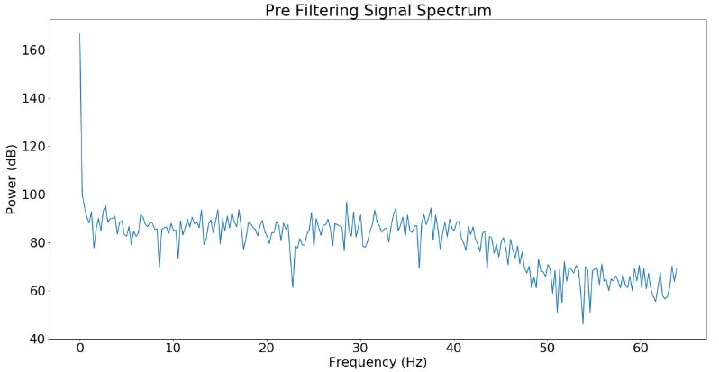

Figure 9.6. Original Signals Power Spectrum

By filtering the signal and concentrating the signal power between 5Hz and 30Hz, the desired frequency components become far more prominent in the signal. The power spectrum in Figure 9.7 is shaped by the bandpass filter, where the spectrum resembles the magnitude response of the filter in Figure 9.4 making SSVEP detection easier. The frequency content of this spectrum contains the strong 7.5Hz and 15Hz components caused by the subject focusing on the 7.5 Hz stimulus.

The SSVEP detection algorithm makes use of a 512 point forward transform that follows a scaling schedule of [2, 3, 3, 3, 3, 3] which scales the first stage of the FFT by 2 and the remaining stages are scaled by 3 ensuring that no output sample suffers extreme bit growth causing an overflow.

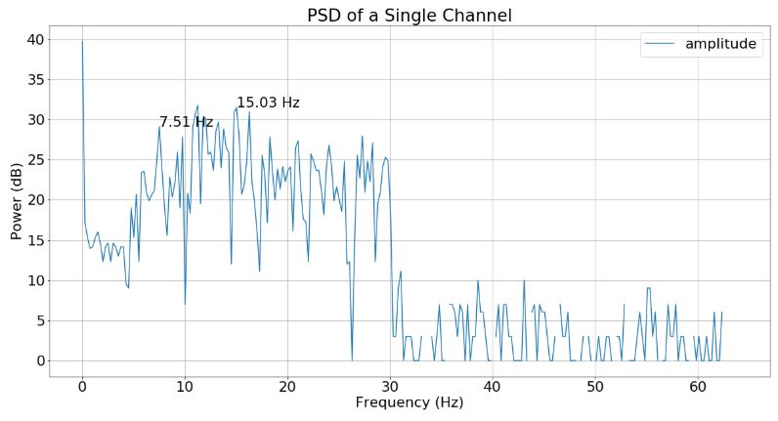

Figure 9.7. Power Spectrum of signal post filtering.

The relevant features required for feature classification in this system are the energy values at the stimulus frequencies and their first harmonics. Using both the fundamental and the first harmonic helps to clarify which stimulus frequency is the strongest in the signal.

A scenario where using both frequencies is beneficial is when the subject is focusing on the 7.5Hz stimulus, but the strongest component is 12 Hz caused by the 12Hz stimulus in the subjects peripheral vision.  
The average of the energy at 7.5 Hz and 15 Hz is higher than the average of the energy at 12 Hz and 24 Hz due to 24 Hz having significantly less energy than the other three.

The energy values are taken from the fundamental frequencies and passed to the feature classification stage where the signal can be classified.

## Feature Classification

The features of the signal that are extracted from the frequency content of the signal are used to determine which class the signal belongs to. Table 9.1 contains the energy values at each of the stimulus frequencies and their first harmonics for the Power Spectrum in Figure 9.7. The average of each stimulus frequency and harmonic pair are determined and used as the final classifier. The stimulus frequency with the largest average value that exceeds the threshold, 900, will be selected as the classified output.

|  |  |  |  |
| --- | --- | --- | --- |
| Class | Fundamental | 1st Harmonic | Average Energy |
| Class 1 (12Hz) | 1037 | 481 | 759 |
| Class 2 (10Hz) | 5 | 233 | 119 |
| Class 3 (8.57Hz) | 193 | 40 | 116.5 |
| Class 4 (7.5Hz) | 818 | 1413 | 1115.5 |
| Class 5 (6.66 Hz) | 98 | 932 | 515 |
| Table 9.1 Classes and their associated energy values for a particular frame while a subject focuses on a 7.5Hz stimulus | | | |

Figure 9.7 demonstrates that the strongest component visually is the 7.5 Hz and 15 Hz components, which is further back up by the results in Table 9.1 where Class 4 has the largest average energy value.

## Code Implementation

The code for implementing the SSVEP detection algorithm as seen in Figure 9.8 is composed of a single loop that breaks the signal into frames (or epochs) with 512 samples, sends the frames to the filter for pre-processing, transforms the filtered frames to the frequency domain and then either plots the results and extracts SSVEPs from the signal.

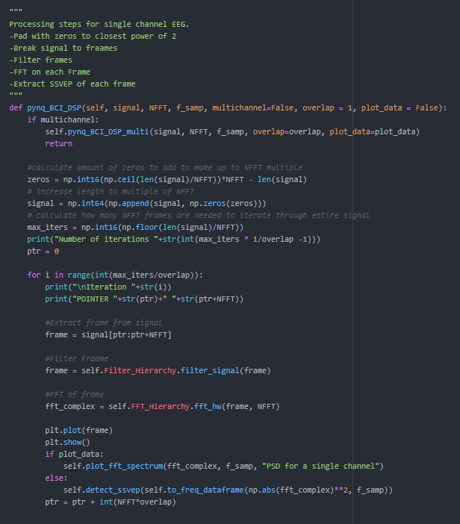

Figure 9.8. Method in the class BCIOverlay which implements the SSVEP detection algorithm

The code for detecting SSVEPs contains three simple operations, extraction, averaging, and comparisons in order to determine if there is an SSVEP present in the signal. Firstly, the extraction stage involves creating an array of peaks at the stimulus frequencies and their first harmonics.

Post extraction these two arrays are summed then halved to get an array of average values. If the maximum average exceeds the threshold 900, the frequency where the peak is located will be returned as the detected SSVEP stimulation frequency.

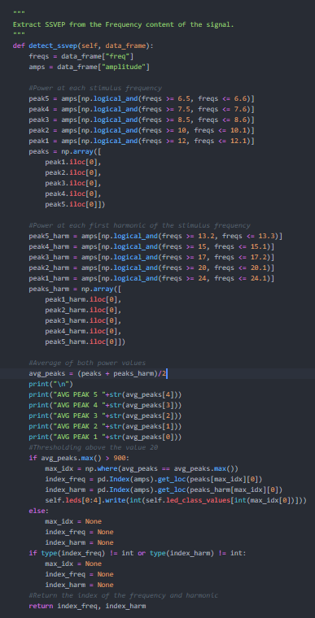

Figure 9.9 Method in BCIOverlay that extracts and classifies SSVEPs.

The result of the SSVEP detection are memory mapped to the GPIO block handling the LEDs, asserting the light associated with the classified signal as seen in Figure 9.10.

For the scope of this project and to further simplify the application of a Brain to Computer Interface, only LEDs are controlled by the detection of SSVEPs. However for a more complex system, the GPIO block can be replaced with an Arduino or Raspberry PI peripheral controller in order to interface with external system, and use the SSVEPs as the primary controller.

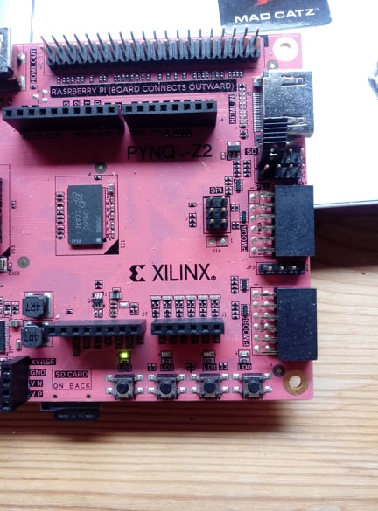

Figure 9.10. Light belonging to class 4 asserted as a result of feature classification.

## Data Type Considerations

Hardware based Signal Processing Algorithms require fixed-point data formats instead of the floating-point alternatives that the Software implementations use. Converting the recorded EEG samples directly from floating point samples to fixed point integer samples, each floating-point value is rounded to the nearest whole number. The floating-point samples in Figure 9.11 would be rounded to the nearest whole number, losing the data offered by the fractional part of the values.

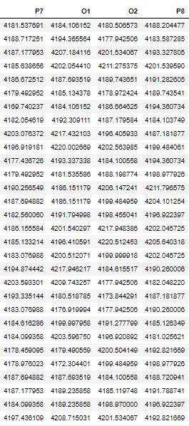

Figure 9.11. First 30 samples of EEG data recorded on channels P7, P8, O1, and O2

In order to avoid this loss of valuable information from rounding the samples to the nearest whole number, the values can be multiplied by 100 bringing the two decimal places into the integral part of the number. Scaling the data in such a method make use of the 32 bits offered where the numbers within the thousands can be scaled up without causing an overflow on the output.

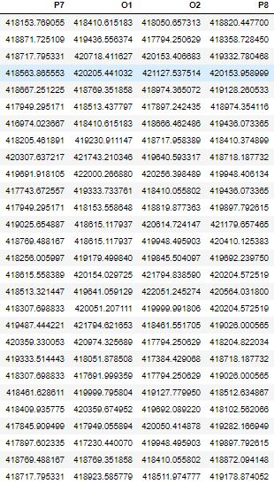

Figure 9.12. First thirty samples after being multiplied by 100, moving two decimal places from the original samples into the integral part of the samples.

After the samples have been scaled up to allow for more accurate processing of the EEG samples, the collection of samples are converted to 32bit values and sent to the SSVEP detection algorithm using the BCI Overlay.

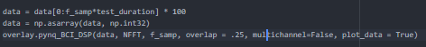

Figure 9.13. Code snippet for beginning execution of SSVEP detection algorithm.

Developers have the option to configure the algorithm to handle multiple channels of data, plot the data for analysis, or just perform real-time processing.

## Four Channel Model

The BCI System on Chip is an example of a Realtime System which requires accuracy, where an correct output could lead to devastating results[42]. Introducing redundancy to a real time system allows for greater reliability by duplicating critical components. The outputs of these components can be compared in order to determine if they all detected the same event or if there is a fault in the system.

SSVEPs are present primarily in the occipital cortex [21] which, according to the international 10-20 electrode system include the electrodes O1, O2, P7, and P8. These specific electrodes are the only occipital electrodes present on the EPOC Headset as seen in Figure 9.14.

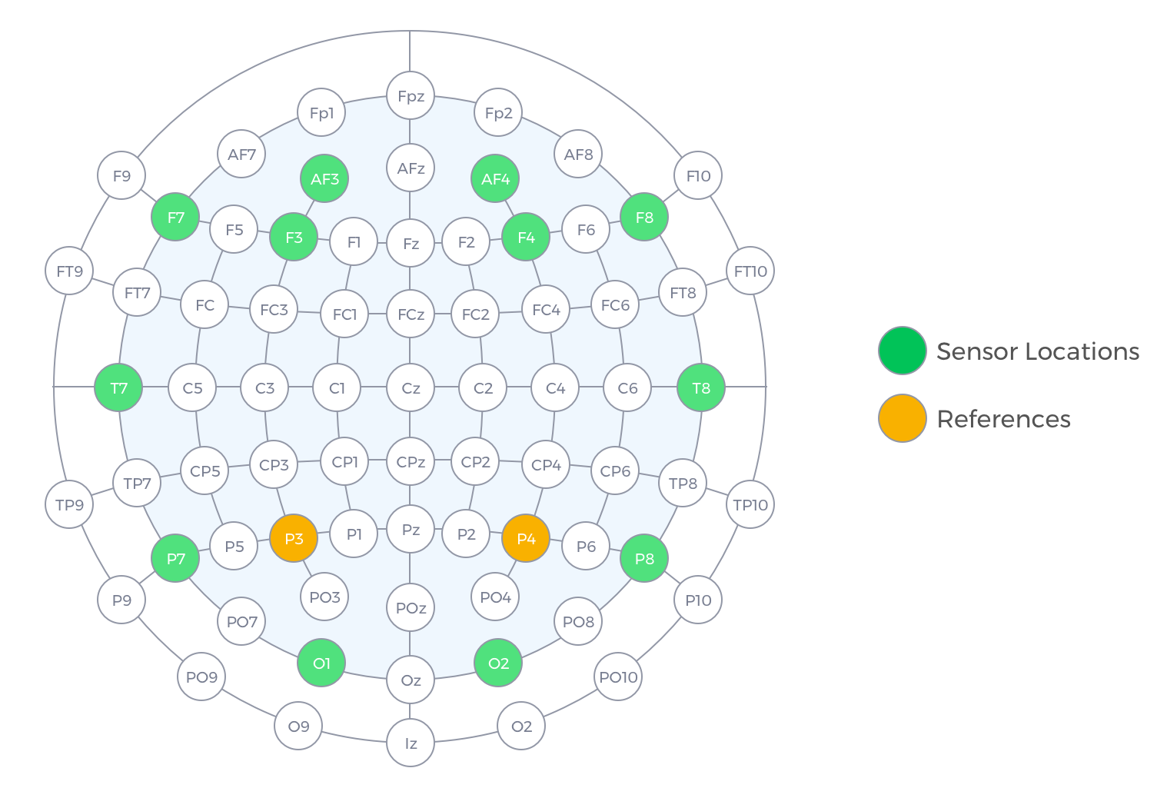

Figure 9.14. Electrode Placement for SSVEP detection according to the 10-20 model[43].

Introducing Hardware redundancy to the system by creating a processing channel for each of the four aforementioned electrodes will aid in making the detection of SSVEPs more reliable. A single channel can detect SSVEPs with poor accuracy, misclassifying surrounding noise as a stimulus frequency, but multiple channels can be used to filter out these misclassifications by using a voting mechanism to determine if the event detected on one channel has been detected by others.

SSVEP related signals aren’t immediately present at the location of a single electrode but are present in the region enclosed by the four electrodes at the rear of the head. Using more than one electrode, the BCI System on Chip can more reliably detect SSVEPs and further remove any negative effects caused by surrounding temporal noise. This temporal noise within the EEG signals recorded at each electrode can be caused by surrounding neural activity not removable by the filter, but by using more than one channel, their effects can be diminished.

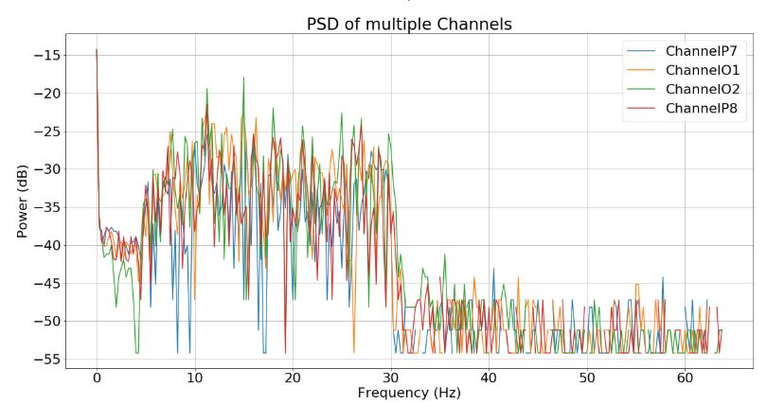

Figure 9.15. Power Spectrum for Channels P7, O1, O2, P8.

The power spectrum of all four channels in Figure 9.15 demonstrates how more than one channel can reduce the effects of surrounding noise. Each channel will generate its own power spectrum, and each channel will contain different dominant frequency components, for example Channel P8 has a strong 12Hz frequency component, despite the subject focusing on a 7.5Hz stimulus. Channel P8 by itself will incorrectly classify this frame as belonging to class 1 (classes listed in table 9.1), however when compared to the surrounding channels, 7.5Hz and 15Hz are dominant in the other channels.

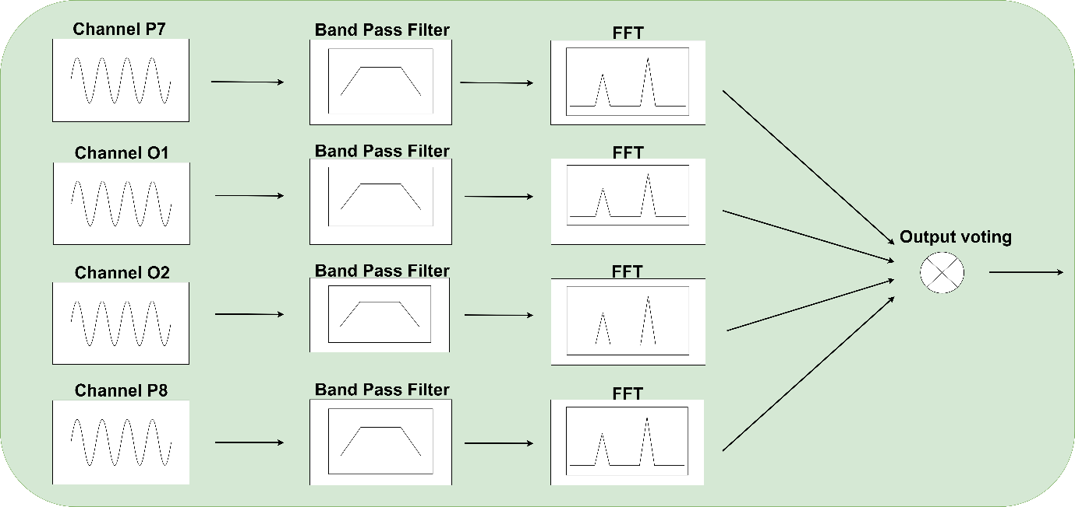

Figure 9.16. Multi-Channel SSVEP detection Algorithm.

The output of each channel is input to a Formalised Majority Voter (FMV) which votes for the input that has accumulated more than a 50% majority[44]. If three channels classify the epoch as belonging to the same class, then the result generated by these three channels is voted by the FMV. If all channels classify the signal differently, then the FMV will have no output. This approach is used to catch any misclassifications made by channels individually, making the generated output more reliable.

## Testing

The BCI System on Chip used for accelerating the filtering and transformation of signals needs to be compared against software implementations in order to determine if the claim that Hardware implemented systems are faster is true. Secondly, the claim that using a multi-channel system needs to be tested against its single channel counterpart in order to clarify if the use of redundant channels helps the system or if they an unnecessary use of Hardware resources.

### Multichannel vs Single channel

In order to effectively compare the accuracy of both the Multichannel and Single channel implementations both methods are given an SVVEP dataset to process, and every time a signal is classified a counter is incremented by 1. At the end of the test the total number of classifications is used to detect the accuracy of both implementations.

Both systems were given 60 seconds of EEG data recorded from the electrode O2 for the single channel system, and electrodes P7, O1, O2, and P8 for the multichannel system. 60 seconds (7680 samples) were processed and every time the algorithm detected an SSVEP the total classification counter was incremented. All correct classifications were counted manually by scrolling through the algorithm’s printed log and checking how many classifications were correct. The results for both tests were then added to Table 9.2, which offers the results of the test.

|  |  |  |  |  |  |
| --- | --- | --- | --- | --- | --- |
| Method | Total Frames | Total Classifications | Correct Classifications | Incorrect Classifications | Accuracy |
| Single | 60 | 33 | 15 | 18 | 45% |
| Multi | 60 | 17 | 13 | 4 | 76% |
| Table 9.2 Accuracies of Hardware and Software implementations. | | | | | |

Next, Single Channel and the Multichannel method were compared by giving both methods 80,000 samples of white noise. These signals contain no SSVEPs because they have no relevance to EEG signals, they are completely random numbers generated using a Gaussian distribution. The total number of frames and the number of false positives are presented in table 9.3 as well as the system accuracy when processing white noise data.

|  |  |  |  |
| --- | --- | --- | --- |
| Method | Total Frames | False Positives | Accuracy |
| Single | 2500 | 2420 | .03% |
| Multi | 2500 | 150 | 94% |
| Table 9.3 False positives generated while both systems process white noise signals | | | |

Finally, the single and multichannel systems’ execution times are compared in order to determine how much longer it takes for a multichannel system to process a single frame of data, and if it reaches the timing constraint of a second per frame. Both methods were given 60 seconds of EEG data to process, and the time to process each frame was measured. Once the test had terminated, the average time to execute a single frame of data was plotted in Figure 9.17.

From analysing the results for these three experiments, it is obvious that the Multichannel method of processing EEG data is far more accurate than the Single channel method which scores poorly on both accuracy tests. The multichannel method achieves an accuracy of 76% when processing EEG samples, and is less susceptible to detecting false positives when processing random samples unlike the single channel method which generated an output for almost every random sample it processed.

The single channel method however is much faster at processing each frame, but its faster execution isn’t enough of a trade-off for its poor accuracy. The multichannel method despite taking more than twice as long to execute meets the timing constraints of a second. If the multichannel method exceeded these constraints the system would no longer be a real-time system as it no longer processes each frame containing one second of data before the next frame arrives.

### Hardware Execution vs Software Execution

In order to effectively compare the execution time required for both the Hardware and Software implementations of the SSVEP detection, the time required to process a single epoch of signal data was measured.

Each implementation of the SSVEP detection algorithm were given 60 seconds of EEG data and for each frame the time taken to process it was measured, and after the test terminated, the average time to process a single frame of data was plotted in Figure 9.17.

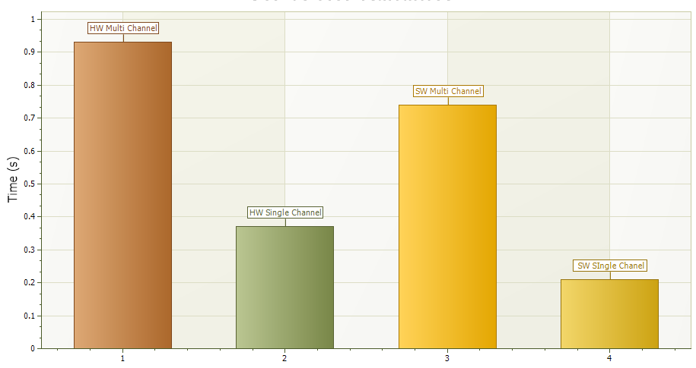

Figure 9.17 Execution times in seconds for each implementation to process an entire frame.

Comparing both the multi and single channel methods implemented in both hardware and software showed how well both implementations performed in comparison to the other, and offered further evidence on which implementation performed better.

The results of this yielded surprising results where the Software implementations out-performed the Hardware implementations in processing the frames, contradicting the very basis of the project outlined in this report.

# Conclusions

The primary aims of the project as previously stated were to develop a System on Chip approach for implementing a Brain to Computer Interface in order to detect Steady State Visually Evoked Potentials. By developing this system in Hardware, the processing of each frame should have been significantly faster than Software implementations of the algorithm.

In completing this project, a deeper understanding of System on Chip design, Signal Processing, Brain to Computer Interfaces, and python programming was developed. Desiging System on Chip projects require an understanding of the lower level transactions, data formats, and IP implementations in order to piece each component together to create a complex network working together to complete a task.

Following hardware design and synthesis using the Vivado design suite, the system will remain in an idle state until firmware drivers are developed for controlling the transaction routing infrastructure. Jupytr notebooks was used in order to create quick prototypes of the drivers before moving all the classes to separate files which can be imported like normal python modules.

The Firmware modules are then used to implement an SSVEP based Brain to Computer Interface which makes use of the Hardware implemented Filters and FFTs. By porting the algorithm developed in Matlab to python to take advantage of the acceleration offered by the Hardware, the system becomes a Hardware Accelerated SSVEP based Brain to Computer Interface.

However, from the testing phases for the Hardware Architecture and the overall system, the hardware implementation as in fact not faster than the software implementation. In all tests comparing the execution times between the both implementations, the Hardware was slower than the Software except for one test. The hardware accelerators were faster than the software functions when all latencies caused by formatting the frames and populating the buffers were excluded. There is a significant bottle neck in the system, preventing it from surpassing a software implemented SSVEP based BCI with regards performance.

This doesn’t mean that FPGAs perform worse than CPUs in general, but do not have an advantage for lower sampling rate applications. The Zynq 7000 chip used for implementing the BCI System on Chip has been used in the past for implementing a Radio Frequency transceiver which requires high sampling rate datasets to be processed quickly with short time constraints[45].

In conclusion, the project failed to implement a Hardware Accelerated Brain to Computer Interface because the acceleration offered by the hardware was lost to poor firmware design which introduced latencies into the system. However, a Hardware Implemented SSVEP based Brain to Computer Interface was successfully capable of processing incoming frames of data before a second elapses, making it still a viable option when creating Brain to Computer Interfaces in the future.

# Future Scope

The latencies introduced in the system are a direct result of the buffers being populated and passed to the DMAs one after another. Coupled with the synchronous approach for controlling the DMAs, the code then continuously polls the DMA for the processing core output.

Taking an asynchronous approach and spawning threads for each channel to handle the population of buffers and control the DMAs. Instead of blocking the code while the processing cores operate, implement call back methods, events and interrupts to alert the code that the data is ready for retrieval.

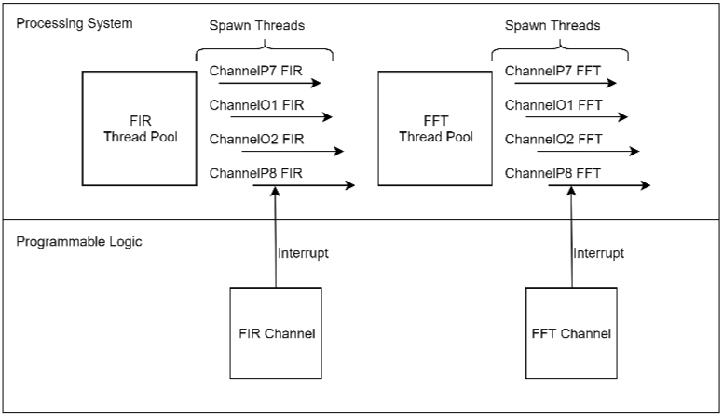

Figure 11.1 Improved SSVEP based BCI

Figure 11.1 offers a representation of how this new system implementation would operate at a higher level. When the processing cores are complete, they can fire a Hardware Interrupt that can be converted to Python event. This event when called will alert the call back method that the processing core has completed, and the call back will halt the main code operation in order to retrieve the data form the DMA and then begin the next step in the algorithm.

# Appendices

## Git Hub Repository

## Risk Assessment

**Facilities used:** Project Laboratory RM3003, Laboratory RM3002, Laboratory RM3001

**Equipment used:** Personal Laptop, PYNQ Z2 Board

**Risks Based on Assessment of Required Equipment and Facilities**

|  |  |  |  |
| --- | --- | --- | --- |
| **Hazard(s)** | **Likelihood**  (With Controls in place) | **Severity**  (With Controls in place) | **Controls**  **(**State if normal Laboratory controls are sufficient per Safety Statement.) |
| **Slip, trip for fall** | 1 | 1 | Any cables from surrounding equipment, laptops connected to electric outlets should not impede access routes. Any bags should be kept under the table to prevent tripping, and all tools should be kept on the worktops. |
| **Electrical Exposure** | 1 | 2 | Any cables used in experiments must be coated to avoid contact with open wires. All faults need to be reported to avoid possibly injury in the future. No power supplies should be left on to avoid accidents. |
| **Tool Faults** | 1 | 1 | Any issues with tools could prove dangerous if not reported. Any power supplies that are not working should be handled by trained staff to avoid injury due to negligence. |

|  |  |
| --- | --- |
| **Likelihood:**  1= Very Unlikely/Yearly  2= Unlikely/During a Semester  3= Likely/Weekly  4= Very Likely/Daily | **Severity:**  1= Slight Harm  2= Moderate Harm  3= Extreme Harm |

|  |  |  |  |  |
| --- | --- | --- | --- | --- |
|  | | **Severity** | | |
| 1 | 2 | 3 |
| **Likelihood** | 1 | **xx** | **x** |  |
| 2 |  |  |  |
| 3 |  |  |  |
| 4 |  |  |  |

# References

[1] S. M. T. Müller, W. C. Celeste, T. F. Bastos-Filho, and M. Sarcinelli-Filho, “Brain-computer interface based on visual evoked potentials to command autonomous robotic wheelchair,” *J. Med. Biol. Eng.*, vol. 30, no. 6, pp. 407–416, 2010, doi: 10.5405/jmbe.765.

[2] M. Authors, C. Cullinan Christopher Wyant Timothy Frattesi Advisor, and X. Huang, “Computing Performance Benchmarks among CPU, GPU, and FPGA.”

[3] J. Pierzchlewski, P. P. Paweł´sniatała, B. Zej Nowakowski, A. Rybarczyk, and W. Wencel, “FPGA Chip as a System Master for Hardware Aided Parallel Computing,” 2006.

[4] Z. İşcan and V. V. Nikulin, “Steady state visual evoked potential (SSVEP) based brain-computer interface (BCI) performance under different perturbations,” *PLoS One*, vol. 13, no. 1, p. e0191673, Jan. 2018, doi: 10.1371/journal.pone.0191673.

[5] T. Pontes, R. Braga, C. Becker, E. Costa, and S. Almeida, “FPGA Implementation of Neural Network for EEG Signal Processing.”

[6] R. Singla, “SSVEP-Based BCIs,” in *Evolving BCI Therapy - Engaging Brain State Dynamics*, InTech, 2018.

[7] R. Aldea and M. Fira, “Classifications of Motor Imagery Tasks in Brain Computer Interface Using Linear Discriminant Analysis,” *Int. J. Adv. Res. Artif. Intell.*, vol. 3, no. 7, pp. 5–9, 2014, doi: 10.14569/ijarai.2014.030702.

[8] J. J. Shih, D. J. Krusienski, and J. R. Wolpaw, “Brain-computer interfaces in medicine,” *Mayo Clinic Proceedings*, vol. 87, no. 3. Elsevier Ltd, pp. 268–279, 2012, doi: 10.1016/j.mayocp.2011.12.008.

[9] T. Al-ani and D. Tr, “Signal Processing and Classification Approaches for Brain-Computer Interface,” in *Intelligent and Biosensors*, InTech, 2010.

[10] A. Onishi and K. Natsume, “Overlapped partitioning for ensemble classifiers of P300-based brain-computer interfaces,” *PLoS One*, vol. 9, no. 4, 2014, doi: 10.1371/journal.pone.0093045.

[11] A. Lenhardt, M. Kaper, and H. J. Ritter, “An adaptive P300-based online brain-computer interface,” *IEEE Trans. Neural Syst. Rehabil. Eng.*, vol. 16, no. 2, pp. 121–130, Apr. 2008, doi: 10.1109/TNSRE.2007.912816.

[12] C. Han, G. Xu, J. Xie, C. Chen, and S. Zhang, “Highly Interactive Brain-Computer Interface Based on Flicker-Free Steady-State Motion Visual Evoked Potential,” *Sci. Rep.*, vol. 8, no. 1, pp. 1–13, Dec. 2018, doi: 10.1038/s41598-018-24008-8.

[13] S. K. Andersen and M. M. Müller, “Driving steady-state visual evoked potentials at arbitrary frequencies using temporal interpolation of stimulus presentation,” *BMC Neurosci.*, vol. 16, no. 1, Dec. 2015, doi: 10.1186/s12868-015-0234-7.

[14] S. Kamran Haider, M. I. Daud, A. Jiang, and Z. Khan, “Evaluation of P300 based Lie Detection Algorithm,” *Electr. Electron. Eng.*, vol. 2017, no. 3, pp. 69–76, 2017, doi: 10.5923/j.eee.20170703.01.

[15] Q. Liu, K. Chen, Q. Ai, and S. Q. Xie, “Review: Recent development of signal processing algorithms for SSVEP-based brain computer interfaces,” *J. Med. Biol. Eng.*, vol. 34, no. 4, pp. 299–309, 2014, doi: 10.5405/jmbe.1522.

[16] V. P. Oikonomou *et al.*, “Comparative evaluation of state-of-the-art algorithms for SSVEP-based BCIs,” Feb. 2016.

[17] “FIR Filter Properties - dspGuru.” [Online]. Available: https://dspguru.com/dsp/faqs/fir/properties/. [Accessed: 17-Apr-2020].

[18] A. V. Anand, “A brief study of discrete and fast fourier transforms,” p. 11, 1965.

[19] V. K. Ingle and J. G. Proakis, *Digital signal processing using MATLAB*. Cengage Learning, 2012.

[20] G. Plonka, D. Potts, G. Steidl, and M. Tasche, “Discrete fourier transforms,” *Appl. Numer. Harmon. Anal.*, pp. 107–157, 2018, doi: 10.1007/978-3-030-04306-3_3.

[21] J. Bieger and G. Garcia-Molina, “Light Stimulation Properties to Influence Brain Activity: A Brain-Computer Interface Application Brain computer interface View project,” 2010.

[22] J. S. Shan, S. H. Abbas, D. Kang, and J. Lee, “Using Field Programmable Gate Array Hardware for the Performance Improvement of Ultrasonic Wave Propagation Imaging System,” *J. Korean Soc. Nondestruct. Test.*, vol. 35, no. 6, pp. 389–397, Dec. 2015, doi: 10.7779/jksnt.2015.35.6.389.

[23] “NVIDIA’s GPUs versus FPGA’s | Haltian.” [Online]. Available: https://haltian.com/news/fpga-vs-gpu/. [Accessed: 24-Apr-2020].

[24] A. Saidi, S. Ben Othman, W. Kacem, and S. Ben Saoud, “FPGA implementation of EEG signal analysis system for the detection of epileptic seizure,” in *2018 International Conference on Advanced Systems and Electric Technologies, IC_ASET 2018*, 2018, pp. 415–420, doi: 10.1109/ASET.2018.8379892.

[25] K. K. Shyu, P. L. Lee, M. H. Lee, M. H. Lin, R. J. Lai, and Y. J. Chiu, “Development of a Low-Cost FPGA-based SSVEP BCI multimedia control system,” *IEEE Trans. Biomed. Circuits Syst.*, vol. 4, no. 2, pp. 125–132, Apr. 2010, doi: 10.1109/TBCAS.2010.2042595.

[26] L. Crockett, R. Elliot, M. Enderwitz, and B. Stewart, “The Zynq Book,” p. 484, 2014.

[27] “PYNQ Overlays — Python productivity for Zynq (Pynq).” [Online]. Available: https://pynq.readthedocs.io/en/latest/pynq_overlays.html. [Accessed: 08-Jan-2020].

[28] Xilinx Inc., “DSP48E1 Slice User Guide,” *Xilinx*, vol. 479, pp. 1–56, 2017.

[29] “Hello PYNQ — The PYNQ Edition of the MicroZed Chronicles! - Hackster.io.” [Online]. Available: https://www.hackster.io/news/hello-pynq-the-pynq-edition-of-the-microzed-chronicles-55353a56c678. [Accessed: 07-Jan-2020].

[30] “Creating Overlays — Python productivity for Zynq (Pynq) v1.0.” [Online]. Available: https://pynq.readthedocs.io/en/v1.3/10_creating_overlays.html. [Accessed: 07-Jan-2020].

[31] Xilinx, “AXI Reference Guide [UG761 v13.1],” vol. 761, pp. 1–80, 2011.

[32] A. R. M. Limited, “AMBA AXI Protocol Specification,” *Change*, 2004.

[33] “Why and When Are EEGs Recommended for Children with Autism?” [Online]. Available: https://www.corticacare.com/care-notes/why-and-when-are-eegs-recommended-for-children-with-autism-2. [Accessed: 07-Jan-2020].

[34] “A Performance and Energy Comparison of FPGAs, GPUs, and Multicores for Sliding-Window Applications,” 2010.

[35] “MAMEM EEG SSVEP Dataset III (14 channels, 11 subjects, 5 frequencies presented simultaneously).” [Online]. Available: https://figshare.com/articles/MAMEM_EEG_SSVEP_Dataset_III_14_channels_11_subjects_5_frequencies_presented_simultaneously_/3413851. [Accessed: 26-Apr-2020].

[36] Xilinx Inc., “AXI GPIO v2.0 IP Product Guide,” *WD info*, p. 2004, 2003, doi: 10.1002/ejoc.201200111.

[37] Xilinx Inc., “Fast Fourier Transform v9.1 Logicore,” 2019.

[38] Xilinx Inc., “AXI DMA v7.1,” 2019.

[39] Xilinx, “LogiCORE IP FIR Compiler v7.1,” *J. Med. Philos.*, vol. 39, no. 4, p. NP, 2014, doi: 10.1093/jmp/jht073.

[40] “SciPy.org — SciPy.org.” [Online]. Available: https://www.scipy.org/. [Accessed: 19-May-2020].

[41] “BioSig.” [Online]. Available: http://biosig.sourceforge.net/. [Accessed: 17-May-2020].

[42] “Real Time Systems - GeeksforGeeks.” [Online]. Available: https://www.geeksforgeeks.org/real-time-systems/. [Accessed: 18-May-2020].

[43] “EPOC+ Headset Details - EPOC+.” [Online]. Available: https://emotiv.gitbook.io/epoc-user-manual/using-headset/epoc+_headset_details. [Accessed: 18-May-2020].

[44] M. Schukat, “Dr. Michael Schukat, 2019 / 20,” 2019.

[45] “Xilinx/PYNQ_RFSOC_Workshop: Open-sourcing the PYNQ & RFSoC workshop materials.” [Online]. Available: https://github.com/Xilinx/PYNQ_RFSOC_Workshop. [Accessed: 19-May-2020].